Press release
EUREKA Innovation Days, Helsinki, 23 May

Philips wins two awards at EUREKA Innovation Days in Helsinki for its impact on minimally invasive surgery
A grandfather with a failing heart valve is struggling with daily routines, such as climbing the stairs or walking to a nearby grocery store. He would benefit from a heart valve replacement, but open-heart surgery is very risky. Even a person with a physically strong condition typically needs six months to recover from it. So what can be done to enhance his quality of life, while reducing the associated risks, cutting his rehabilitation time, and lowering the cost of his care?
This is a question that is becoming increasingly central in a world in which the number of people suffering from chronic diseases, such as heart failure, is rising and the world’s population is growing and ageing. It is a situation compounded by healthcare staff shortages and rising healthcare costs, which now amount to approximately 6.4 trillion euros per year.
This scenario set the background against which the ITEA ‘MEDIATE’ project, led by Philips in collaboration with partners including Barco, Elekta, SurgiQual Institute and Digisens, set out to support healthcare professionals in the transition from invasive open surgery to minimally invasive, image-guided interventions. The target was not only heart valve replacement but also a number of other cardiovascular and oncology treatment procedures.
Together with the other project partners, Philips created new and improved imaging procedures, smart tools and an integrated systems architecture in compliance with international standards. These have been designed to enhance the efficiency, ease of use, and accuracy of minimally invasive procedures.
EUREKA Innovation Award and ITEA Award of Excellence
Thanks to its significant impact, the MEDIATE project has won the prestigious 2018 EUREKA Innovation Award in the category ‘Innovations of Tomorrow’, announced today by the 2018 Millennium Technology Prize Winner, Tuomo Suntola, during the EUREKA Innovation Days in Helsinki. In addition, the MEDIATE project led to a follow-up ITEA project called BENEFIT, which will receive the 2018 ITEA Award of Excellence tomorrow (24 May) during the ITEA Event 2018, part of the EUREKA Innovation Days.

The BENEFIT project, which aims to support clinicians in selecting the optimal diagnostic and treatment pathway for patients, builds on the tools and integrated architecture developed in the MEDIATE project. Together with the project partners, Philips has developed software analysis and imaging methods, navigation tools, and a structured database that gathers patient and treatment information. These will help healthcare professionals before and during minimally invasive interventions by presenting quantified information, personalising models of diseased organs and implantable medical devices, and offering treatment alternatives. Based on this architecture, Philips has introduced new tools with significantly higher accuracy for the treatment of cranial aneurysms and liver tumours.
“I am convinced that the worlds of surgical procedures and image-guided minimally invasive treatments will ultimately converge, enabled by innovations in real-time imaging systems, smart devices and software,” said Bert van Meurs, Business Group Leader Image Guided Therapy at Philips. “This will benefit both patients and care providers. We are very proud to receive these awards for the work we have carried out with our partners, contributing to improving the quality and efficiency of healthcare.”
Philips will continue to build on its proven track record of improving minimally invasive surgery in collaboration with partners to improve patients’ lives and support cost reduction in healthcare.
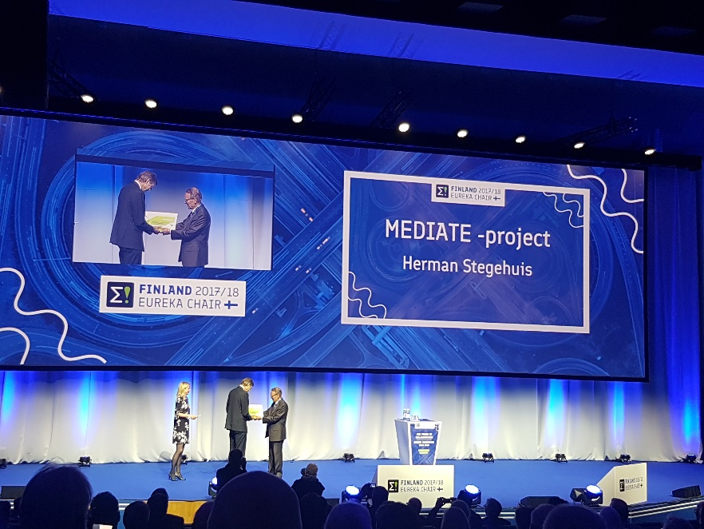
More information about the MEDIATE and BENEFIT projects can be found on the ITEA website.

About ITEA
ITEA is a transnational and industry-driven R&D&I programme in the domain of software innovation. ITEA is a Cluster programme of EUREKA, an intergovernmental network for R&D&I cooperation, involving over 40 countries globally. ITEA enables an international and knowledgeable community to collaborate in funded projects that turn innovative ideas into new businesses, jobs, economic growth and benefits for society. ITEA is open to large industry, small and medium-sized enterprises (SMEs), start-ups, academia and customer organisations and its bottom-up project creation ensures that the project ideas are industry-driven and based on actual customer needs. The ITEA programme is publicly funded on a national level; each ITEA project partner can apply for funding from their own national Public Authority.

Press contact:
Linda van den Borne
linda.van.den.borne@itea3.org
+31 88 00 36 16

