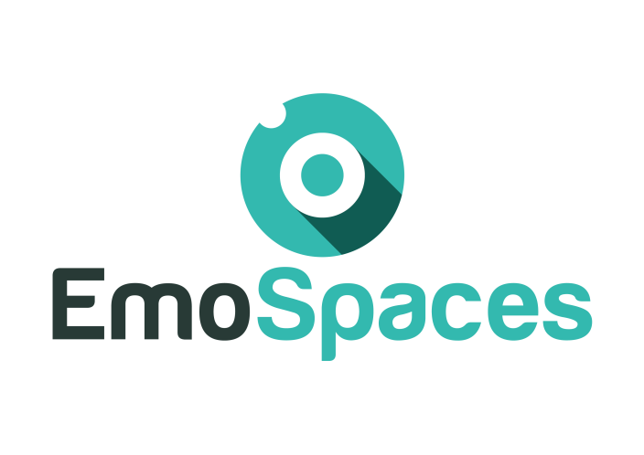
Enhanced Affective Wellbeing based on Emotion Technologies for adapting IoT spaces

D1.1 Report in use cases and scenarios

Deliverable ID: | D1.1
Work package/Task: | WP1
Responsible partner: | THALES
Contributing partner(s):ALL | ALL
Dissemination level: | EmoSpaces consortium

This page is intentionally left blank.

Index

Index
1. Introduction 9
2. Scope and deliverable objectives 9
2.1. Scope 9
2.2. Deliverable context 9
2.3. Scope and deliverable objectives 10
3. Preliminaries 10
3.1. Definition of emotion 10
3.2. Context awareness 12
3.3. Emotion detection, affective computing and emotion-oriented services 12
3.3.1. R&D projects on Affective computing 13
3.3.2. Existing affective computing solutions 16
4. The EmoServices and the EmoSpaces platform 21
5. EmoService A1 – Wellbeing coaching 22
5.1. End-Users and stakeholders description 22
5.1.1. User institutions 23
5.1.2. Context of use 24
5.2. Landscape of existing applications 24
5.2.1. E-health business overview 24
5.2.2. Wellbeing coaching services 25
5.2.3. Wellbeing coaching diabetes applications 30
5.3. Expected benefits to the End-users and innovation expectations 31
5.4. EmoSpaces use cases and scenarios 33
5.4.1. Use case - Lifestyle coaching to control weight (A1.1) 33
5.4.2. Use case - Coaching by detection of abnormal behaviours (A1.2) 35
5.4.3. Use case - Coaching in critical situations (A1.3) 38
6. Use case: Social Integration (A2) 40
6.1. Description 40
6.1.1 Data sources 42
6.1.2 Contextual information 44
6.1.2.1 User profile 44
6.1.2.2 Physical space modelling 44
6.1.2.3 Virtual space modelling 44
6.1.3 Requirements 44
6.1.4 Devices 45
6.1.4.1 IoT sensors 45
6.1.5 Expected results 45
6.2. End-users and stakeholders description 46
6.3. Landscape of existing applications 47
6.4. Expected benefits to the End-users and innovation expectations 48
7. Monitoring and providing services to depressive disorder people (A3) 50
7.1. Description 50
7.2. End-users and stakeholders description 51
7.3. Landscape of existing applications 51
7.4. Expected benefits to the End-users and innovation expectations 56
7.4.1. Use Case Scenario: Smart space of depressive disorder 57
7.4.2. Required VOs List in to monitor user depressive disorder order in smart home based on user’s activities & emotions 61
7.5. Patient Questionnaire to Detect Depressive disorder 65
7.5.1. Complete List of CVOs & VOs & data sources for Monitoring depressive disorder 68
7.5.2. Ontology Model to Monitor Depressive Disorder 69
7.5.3. Services for Depressive Disorder 70
8. EmoService B – Sound optimisation for wellbeing 72
8.1. End-users and stakeholders description 73
8.1.1. User groups 73
8.1.2. Context of use 74
8.2. Landscape of existing applications 74
8.2.1. Multi-room audio systems 74
8.2.2. Intelligent music player 77
8.2.3. Online music websites and offline application using mood analysis 78
8.3. Expected benefits to the End-user and innovation expectations 81
8.4. EmoSpaces Use cases and scenarios 83
8.4.1. Use case - Context aware sound optimization on home devices (B1) 85
8.4.2. Use case - Context aware sound optimization on wearable devices (B2) 87
9. EmoService C – E-Learning 88
9.1. Description 88
9.2. End-users and stakeholders description 88
9.3. The challenges they face 91
9.4. How your proposed product will help solve these challenges 92
9.5. Landscape of existing applications 92
9.6. Expected benefits to the End-users and innovation expectations 95
9.7. EmoSpaces use cases and scenarios 96
9.7.1. Use case – E-learning (C1) 96
10. EmoService D – E-Retail 97
10.1. Description 97
10.2. End-users and stakeholders description 97
10.3. Landscape of existing applications 98
10.4. Expected benefits to the End-users and innovation expectations 99
10.5. EmoSpaces use cases and scenarios 101
10.5.1. Use case – E-Retail (D1) 101
11. Possible interplay between EmoServices 103
12. Synthesis table of use cases scenarios 104

Document history

Revision | Date | Content description/Modification | Author(s)
V0.1 | 10/10/16 | Creation. Structure proposition | S. Joudrier (Thales)
V0.2 | 28/10/16 | Add use case description | A.Chibani (UPEC)
V0.3 | 04/11/16 | Maidis domain application description | O. Mornard  (Maidis)
V0.4 | 08/11/16 | Align with D1.2 | S. Joudrier (Thales)
V0.5 | 30/11/16 | Integrate Arkamys input related to Service B | S. Joudrier (Thales)
V0.6 | 21/12/16 | Integrate Input from UPEC and Maidis and harmonize deliverable | S. Joudrier (Thales)
V0.7 | 17/01/17 | Changes to Service A  Update of context and deliverable objectives  Link between Service A and B | S. Fiorini  (Lissi – UPEC)  H. Benhadda  S. Joudrier  (Thales)
V0.8 | 20/01/17 | Changes to Service B (Alignment with Service A)  Add synthesis table | S Joudrier (Thales)
V0.81 | 24/01/17 | English review I and formatting | S. Fiorini  (UPEC)
V0.82 | 25/01/17 | English review II | S. Lang  (Maidis)  S. Fiorini  (UPEC)
V1.0 | 01/02/17 | Comments accepted and format review  First release | S.Joudrier (Thales)
V1.1 | 16/05/17 | New structure to add Korean and Spanish use cases  The official release of the deliverable is planned for M14 (July 2017) | S.Joudrier (Thales)
V2.2 | 01/06/17 | “7. EmoService C – Monitoring and providing services to depressive disorder people” by Korean Consortium. | Ilyoung Chong.  (HUFS)
V2.3 | 20/04/18 | 6. EmoService A2 – Autism use case by Spanish Consortium. | J. Felipe Molina  (Answare)
V2.4 | 17/05/18 | 10. EmoService D – E-Retail use case by Spanish Consortium. | ERL
V2.5 | 29/05/2018 | Review/ new comments  - Upgrade to do from:  Answare  ETI/ERL  HUFS  - EXPERIS add use case on e-learning | A.Chietera  (thales)
V2.6 | 31/05/2018 | Answare upgrade | J. Felipe Molina (Answare)
V2.7 | 14/06/2018 | Thales upgrade | A.Chietera  Thales
V2.8 | 16/04/2019 | ITI upgrade (section 4) | Mario Rodrigo (ITI)

Glossary

EmoSpaces | Enhanced Affective Wellbeing based on Emotion Technologies for adapting IoT spaces
ITEA3 | Information Technology for European Advancement 3
Use case | In system engineering, use cases are used at high level and are representing missions or stakeholders goals (i.e. why the system will be used by the End-users)
Use case scenario | More detailed description of use cases, list of actions or event steps typically defining the interactions between a role (e.g. the End-user) and a system (e.g. the EmoSpaces platform)
EmoService | Service enhanced by the EmoSpaces platform

Introduction
As we have moved from the static Web to the Web 2.0 (social networking web) and are now moving towards the Web 3.0 (ubiquitous computing web), there is a growing need for adapting sensor technologies to their users. One of the most relevant aspects for the development of those human centric technologies is human emotion. Nevertheless, there is still a lack of pervasive environments designed to take into account emotional behavior.
EmoSpaces aims at bridging this gap and proposes the development of an IoT Platform that is able to recognize activities, behaviors and emotions, fuse data and user context and personalize the environment according to context around the user.
A wide number of domains can benefit from the application of emotion-aware technologies in IoT environments, such as Ageing, Healthcare, Disaster Management, and Service provision for daily living, marketing, promotion of energy efficiency or leisure and entertainment.

Scope and deliverable objectives

Scope
The consortium will demonstrate the viability of the EmoSpaces platform through the following list of EmoServices related to wellbeing:
EmoService A: Wellbeing coaching application for diabetic elderly people
EmoService A2: Wellbeing coaching application for ASD disorder
EmoService A3: Wellbeing coaching application for depressive disorder
EmoService B: Sound rendering optimization in the context of smart home
EmoService C: Adaptive learning
EmoService D: E-Retail

The objective of this deliverable is to specify the use cases and scenarios developed by the consortium. Use-cases and scenarios will describe how the EmoSpaces platform will be used to deploy and support the EmoServices.

Deliverable context
This document is released by the EmoSpaces consortium.
This release is an intermediate version prepared for the first year review of EmoSpaces (7th of June 2017).
The official version of this deliverable will be released at M14 (July 2017).
D1.1 Report on use cases and scenarios
D1.2 Requirements report
D1.3 Report on ethical and societal issues

Intermediate release
Figure 1 – Context of this deliverable.

Scope and deliverable objectives
This deliverable aims at describing the use cases and scenarios built by the consortium to describe how the EmoSpaces platform will be used to deploy and support the EmoServices.

Preliminaries

Definition of emotion
Emotion can be defined as “an affective state of consciousness in which joy, sorrow, fear, hate, or the like, is experienced, as distinguished from cognitive and volitional states of consciousness.” It has to be distinguished from mood or feelings which last for a long period. Indeed, mood can be defined as “a prevailing emotional tone or general attitude” or “a frame of mind disposed or receptive, as to some activity or thing”.
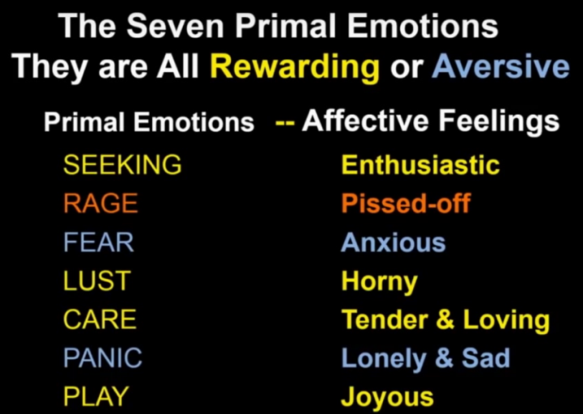
Figure 2 – The seven primal Emotions.
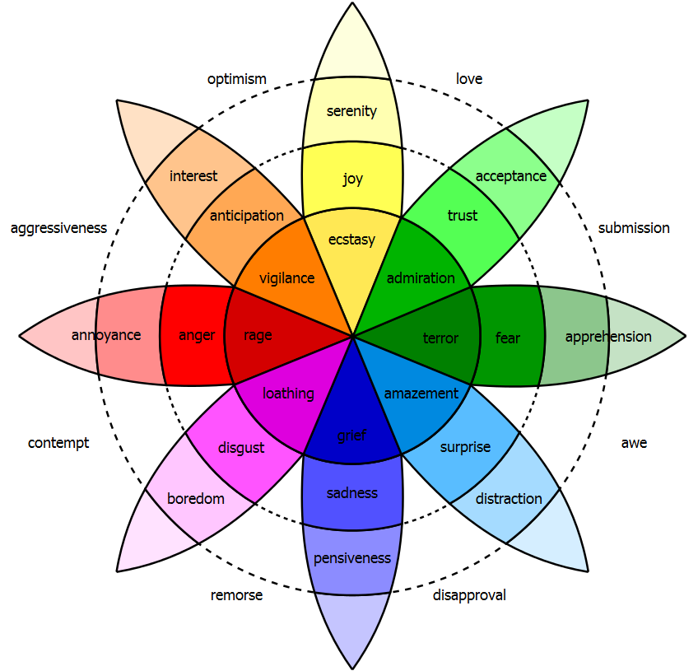
Figure 3 – Plutchik's wheel of emotions (1980).
The psychologists Paul Ekman and Wallace Verne have observed seven primary universal emotions: joy, sadness, rage, fear, surprise, disgust and panic. According to them and as shown in the wheel of emotions (Figure 3), further emotions can be interpreted as shades of these primal emotions.
The above mentioned psychologists have also concluded that the facial expressions of these primal emotions are constant across culture. They emerge from deep, ancient brain structures and not from the cerebral cortex. Darwin was the first to affirm that human beings and even animals have expressions that are essential to survival and understood by all. His theory was demonstrated many years later by Paul Ekman.

Context awareness
In the EmoSpaces project, context awareness can be defined as the technological capabilities for detecting information related to the End-users and their environment in real-time. This information is of interest to understand the context of use, improve the user experience, and thusly the overall value brought to the user.
For instance, real-time localization and recognition of the End-user will be the EmoSpaces subsystems related to context awareness. Moreover, information such as the End-user’s current and planned activities, mood, emotions, stress, behavior, planning, objectives, etc. are important in order to determine the context of use.
The way of detecting, analyzing, storing and managing these personal data is a key challenge of the project, especially in respect to privacy and ethical issues.

Emotion detection, affective computing and emotion-oriented services
This section aims at summarizing the landscape of solutions related to emotion detection and affective computing at R&D and product levels.
According to Picard (MIT Press 1997), Affective Computing is computing that relates to, arises from, or deliberately influences emotion or other affective phenomena.
The diversity of researches, applications and innovation ideas related to the emotion topic and affective computing (gaming, psychology, learning services, kid toys, costumer’s tests and wellbeing, etc.) reflects the high-level of expectations and innovation potentials. As shown in the Hype Cycle for Emerging technologies of 2016, Affective Computing currently states at the middle of the Innovation Trigger slope with an expected mainstream adoption from 5 to 10 years. In comparison, Connected Home has almost reached the peak of inflated expectations.
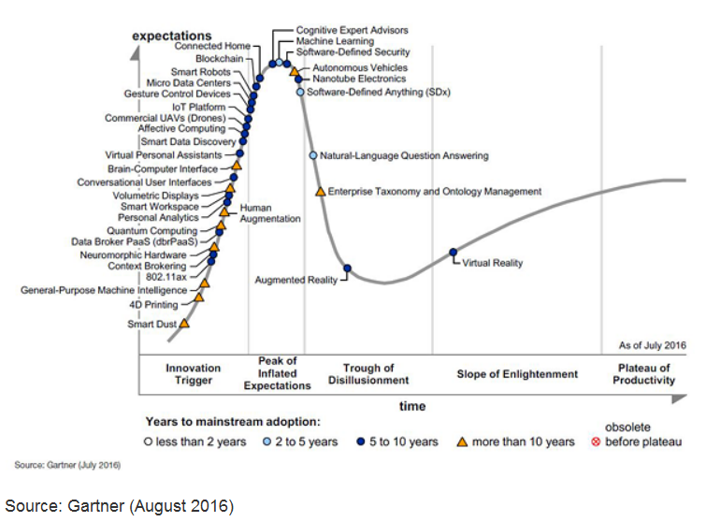
Figure 4 – Hype Cycle for Emerging Technologies, 2016

R&D projects on Affective computing
This paragraph aims at providing a relevant but not exhaustive enumeration of current R&D projects related to Affective computing to show the wide range of potential future applications related to emotion awareness.
The use case examples include interactive gaming and toys, security applications, devices to help autistics discern emotion, provide better learning experiences, better shopping experience and virtual psychology applications.
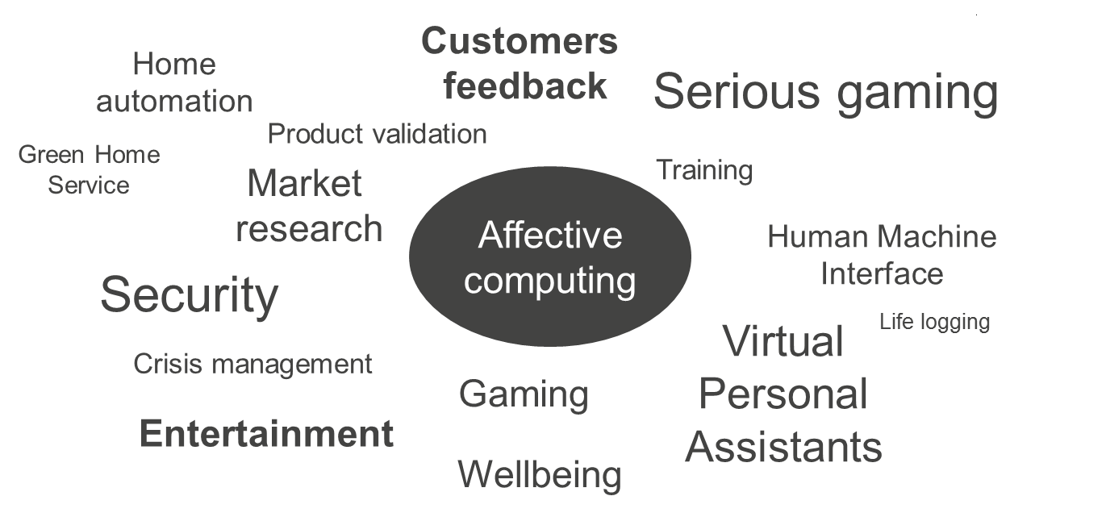
Figure 5 – Main applications of Affective computing
Domain | Project name | Description
Gaming | Affquake (MIT Medical Lab) | This project aims to treat signals that relate to a player’s affect in a way that alters game play.  http://affect.media.mit.edu/projects.php?id=180
Learning Assistance | Affective Learning Companion | The companion aims to help learners to develop the ability to persevere during frustrating learning episodes.  http://affect.media.mit.edu/projects.php?id=1068
Human Interaction | Galvactivator | The galvactivator is a glove-like wearable device that senses the wearer's skin conductivity and maps its values to a bright LED display. http://affect.media.mit.edu/projects.php?id=254
Human Interaction | Affector | Affector is a distorted video window connecting neighboring offices of two friends (and colleagues). A camera located under the video screen captures video as well as 'filters' information such as light levels, colour, and movement. This filtered information distorts the captured images of the friends that are then projected in the window of the neighboring office. The friends determine amongst themselves what information is used as a filter and various kinds of distortion in order to convey a sense of each other's mood.  https://www.interaction-design.org/literature/book/the-encyclopedia-of-human-computer-interaction-2nd-ed/affective-computing
Cyber-psychology | Wasabi | Affective computing with primary and secondary emotions in a virtual human  http://www.becker-asano.de/AffectiveComputingWithPrimaryAndSecondaryEmotionsInAVirtualHuman.pdf
Smart toys | Eyes of things | Smart Doll with Emotion recognition. The project aims to embed a sensor device inside a doll’s head or torso. Through facial emotion recognition, the doll can assess the girl’s emotional display and react accordingly.  http://eyesofthings.eu/?page_id=1461
Stress management | Melomind | Based on electroencephalographic technology, Melomind headphones teaches the End-user how to relax efficiently and improve his daily life.  http://www.melomind.com/en/
Measure TV rates | Measuring the Engagement Level of TV viewers (Javier Hernandez et al) | This project is a study of the feasibility of using visual information to automatically measure the engagement level of TV viewers.  http://affect.media.mit.edu/pdfs/13.Hernandez.et_al.pdf
Develop individuals with Autisms | The Development of Emotion Recognition in Individuals with Autism (Keiran M. Rump, Joyce L. Giovannelli, Nancy J. Minshew, and Mark S. Strauss) | This project aims at the Development of Emotion Recognition in Individuals with Autism in order to support them in their daily living.  Child Dev. 2009 Sep-Oct; 80(5): 1434–1447.  https://www.ncbi.nlm.nih.gov/pmc/articles/PMC3085906/

Existing affective computing solutions
Numerous smartphone applications are available for emotion recognition mainly based on facial recognition, text or speech analysis. Most of these applications now use deep learning technologies.
Emotion
recognition
Face expressions
Speech
Text
The table below lists the main smartphone applications based on facial recognition currently available in the market:
Applications for facial emotion recognition
Company name | Description
Picxel has developed a solution named face2market that analyzes facial emotions. The current main market is using emotion recognition as a support for product validation.
http://www.picxel.fr/index.php/fr/face2market/qsn
Emotient is a startup acquired by Apple on January 2016. The application detects emotions from several faces in the same image. Anger, Contempt, Disgust, Fear, Joy, Sadness and Surprise are detected in real time based on face detection and analysis.
A RESTful Emotient Web API is available and can be used by other systems.
Affectiva is a solution based on deep learning for massive scale engagement detection detecting surprise, smile, concentration, dislike, valence, attention and expressiveness in videos.
SDKs and APIs are available for mobile developers and provide visual analytics to track expressions over time.
Emovu by eyeris is an application based on deep learning for emotion recognition that reads facial micro-expressions.
They provide desktop and mobile SDKs as well as cloud applications for developers. Detected emotions are Joy, surprise, attention, expressiveness, emotion lift, valence and mood.
http://emovu.com/e/
nViso is an artificial intelligence solution that measures instantaneous emotional reactions of consumers and in retail environments (deep learning 3D facial imaging technology).
The targeted customers are market researchers, creative agencies and product developers.
http://www.nviso.ch/
 | Kairos is a startup commercializing solutions for Emotion analysis analyzing facial expressions and engagement of people in video, face recognition (find, match and remember people in photos and images) and human features for further analytics (glasses and expressions, gender and age, eye tracking, facial features, etc.)

Further solutions such as Face Reader by Noldus, SightCorp, SkyBiometry, Imotions and CrowdEmotion also provide facial emotion recognition.
Sentiment analysis software that analyzes texts to derive sentiment also exists. The table below lists the main software available. The main technologies behind these products are natural language processing and deep linguistic analysis.
Softwares for analyzing emotion from text
Company name |  | Description
IBM Watson | The Tone analyzer by IBM Watson detects emotional tones, social propensities and writing styles from any length of plain text. The application is available on GitHub.
Receptiviti gives machine learning technologies emotional intelligence by revealing user’s psychology, personality, decision-making style and emotions in real-time.
Among the many markets Receptivity targets are employee analytics (e.g how early can you detect at-risk employees?) and social analytics (e.g. what’s your Twitter personality?)
http://www.receptiviti.ai/
The Alchemy application is a sentiment analysis API that scans large chunks of text to provide a sense of the writer’s attitude or opinion.
http://www.alchemyapi.com/products/alchemylanguage/sentiment-analysis
Bitext is a deep linguistic analysis tool that uses word relations, sentences, structure and dependencies to extract bias and provide a sentiment analysis.
https://www.bitext.com/text-analysis-api-2/

Further text-to-emotion software supplement the table above such as Mood patrol, Synesketch, Tone API, Repustate, sentaero, aylien, textrazor, text-processing, sensq.
Speech to emotion software
Good vibration is a smartphone application recognizing emotion by voice.
It measures emotion and disorders from the voice, and enables feedback that improves quality of life.
SDK are available for developers.
Vokaturi detects emotions from voice and can distinguish whether the speaker is happy, sad, afraid or angry.
The open-source version of the software distinguishes between these five emotions with 61,4 percent accuracy when it hears the speaker for the first time (as compared with human majority ratings). The software is distributed under the General Public License (GPL).

The EmoServices and the EmoSpaces platform
In the context of the EmoSpaces project, the EmoServices are the applications provided by the EmoSpaces solution to the End-users. Services consume data from the EmoSpaces platform and deliver a service to the End-users such as wellbeing coaching advices (Service A: A1,A2,A3), context aware sound optimization (Service B), adaptation for class room (Service C) and customer suggestion (Service D).
From the Instituto Tecnológico de Informática (ITI), a Big Data platform for the capture, storage, analysis and exploitation of information is made available to the members of the EmoSpaces project. Together with the platform, or rather integrated in it, ITI provides a set of techniques and algorithms that allows and facilitates the work with the data. The functions of these tools include, for example, merging data or detecting emotions. In this way, the analyses carried out using ITI's Big Data platform make it possible to monitor and understand the behaviour and affective state of users, clients and consumers, contained in each of the use cases implemented by the partners.
The main objective of ITI's Big Data Analytics platform is to provide the end user with a BDAaaaS (Big Data Analytics as a Service) solution in the cloud. The main objective of this platform is the collection and integration of data from intelligent sensors, as well as the efficient management of large amounts of information, making use of Big Data techniques. From this platform the necessary data are provided to the use cases to be able to apply and develop the corresponding emotion detection techniques.
In this deliverable, each service will be illustrated by detailed examples that show its potential benefit to the End-users and then broken down into use cases describing at high level the main application contexts, which are then illustrated by more precise use case scenarios.
This deliverable distinguishes the description of use cases of the targeted future EmoSpaces product and the demonstration scenarios which will be delivered during the project as proofs of concept.

EmoService A1 – Wellbeing coaching
Today there is an increasing demand on developing platforms that supply elderly lifestyle monitoring and coaching. These platforms are expected to take full advantages of Internet of things (IoT) technologies for capturing users’ contexts and provide significant improvements to the way current systems and applications provide monitoring and coaching services.
Lifestyle coaching programs are good approaches to enhance quality of life and mental health of elderly, even though the enhancement of mental health and life quality are not specifically targeted in a life-style coaching program. In the case of people suffering from obesity, hypertension or diabetes, lifestyle intervention through coaching can reduce the risk of developing diabetes for those at high risk. For instance, a diabetes lifestyle intervention through coaching is effective in reducing the risk of diabetes and several studies are confirming that. Coaching concerns mostly achieving and maintaining a weight loss goal in combination with dietary restrictions. For instance, a low-fat intake is in general recommended; if reducing fat does not produce weight loss to goal, calorie restriction will be also recommended. The problem of applying these restrictions is their possible negative impact on the psychological conditions of people if they are not notified or warned about that and in some cases people stop the coaching programs.
From a coaching perspective, the Emospaces coaching system must assist subjects to achieve goal-directed and self-regulation that consists of a series of processes in which the agent suggests a set of goals, a plan of actions, contexts of executions and monitors how the plan is followed and uses metrics to evaluate the progress and performance. These metrics and evaluation provides self-reflection to individuals involved in the coaching and show them how close or far they are from the standard (gaining insight), and the program adapts according to his or her actions to further enhance performance and better help the subject reach his or her goals. The coaching agent role is to facilitate the individual movement through the self-regulatory cycle towards goal attainment. However, automating the coaching process requires the ability of the system to understand the behaviour of people and their socio-cognitive context.

End-Users and stakeholders description
The typical main End-users targeted for this application are economically active, elderly persons that have been diagnosed with Type 2 diabetes (cf. description of Jean-Jacques in D1.1, a typical End-user for Service A).
Type 2 diabetes (Diabetes mellitus type 2) is a long term metabolic disorder that is characterized by high blood sugar, insulin resistance, and relative lack of insulin. This form of diabetes was previously referred to as “non-insulin-dependent diabetes mellitus” or “adult-onset diabetes”. Common symptoms include increased thirst, frequent urination, and unexplained weight loss. Symptoms may also include increased hunger, feeling tired, and sores that do not heal. Often symptoms come on slowly. Long-term complications from high blood sugar include heart disease, strokes, diabetic retinopathy which can result in blindness, kidney failure, and poor blood flow in the limbs which may lead to amputations.
All relevant persons who will be allowed by the main End-user to receive information from the EmoSpaces solution such as caregivers, family members and doctors are also considered as potential End-users of EmoSpaces.
The main stakeholders of Service A are the End-users (elderly persons diagnosed with Type 2 diabetes), their family, caregivers and doctors. Further stakeholders are health care professionals, patient associations, industrials and national authorities.

User institutions
Below is a list of the main French speaking research and patient associations related to diabetes which could be contacted by the EmoSpaces partners to find potential End-users and validate EmoSpaces concept and solution.
 | Fédération Française des Diabétiques | https://www.federationdesdiabetiques.org/
 | Société francophone du diabète | http://www.sfdiabete.org
 | Fédération Francophone pour la Recherche sur le diabète (FFRD) | http://www.ffrdiabete.org
 | Association Belge du Diabète | http://www.diabete-abd.be/
 | European Foundation for the Study of Diabetes | http://www.europeandiabetesfoundation.org/

Context of use
The End-users shall be able to use the EmoSpaces solution at home and outdoor even if the detection capabilities of EmoSpaces are less effective in the latter case

Landscape of existing applications

E-health business overview
E-health is a large and constantly evolving business sector composed of heterogeneous activity segments with a wide range of activities from information and wellbeing services to telemedicine services. E-health covers the whole spectrum of activities involved in functional process of healthcare provision such as information, prevention, treatment and patient support.
Prevention
Treatment
Support
Inform
* Functional segments
related to service A
are highlighted by
an orange circle
Figure 7 Global eHealth functional segments
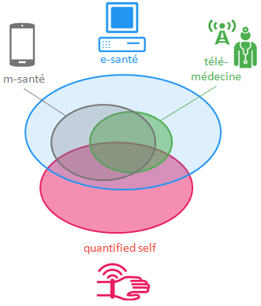
Service A positioning
Figure 8 – Overview of e-health activity types
Below follows a description of the main e-health activity types among all e-health activities.
EmoSpaces Service A is part of e-health, m-health and quantified-self technologies. However, Service A is not linked to any telemedicine activities covering care treatment.
mHealth (mobile health) is a general term for the use of mobile phones and other wireless technology in medical care (e.g. ECG) and coaching services (sport, wellbeing, diet, etc.) Those are generally characterized by the following functionality:
- Communication between people and care services
- Remote access to information (such as the electronic health record)
- Monitoring and surveillance of patients.
Examples of main actors in France are Withings, B Braun, Medical, Fresenius Care Fusion, Avitum, EMA, Gambro and UmanLife [1].
Quantified self is a movement to incorporate technology into data acquisition on aspects of a person’s daily life in terms of inputs (e.g. food consumed, quality of surrounding air), states (e.g. mood, arousal, blood oxygen levels), and performance (mental and physical). Such self-monitoring and self-sensing, which combines wearable sensors (EEG, ECG, video, etc.) and wearable computing, are also known as life-logging.
The main products and services are:
- Body scales: Ihealth, Withings, Terraillon, Fitbit;
- Physical activity trackers;
- Activity, Heart rate and Breath monitors;
- Blood pressure monitors.
Telemedecine allows health care professionals to evaluate, diagnose and treat patients remotely using telecommunications technology. Telemedicine allows patients in remote locations to access medical expertise quickly, efficiently and without travel.

Wellbeing coaching services
Numerous services and programs dedicated to coaching are already available on the internet and/or through smartphone applications. Each service has its own definition of wellbeing. But all definitions have a common trait which is finding the right balance between different life domains, such as physical health, social activities and relationships with family and friends, eat healthy, develop brain activities and a healthy environment.
Below are several examples of graphical representations for wellbeing according to different associations, schools or coaching services.
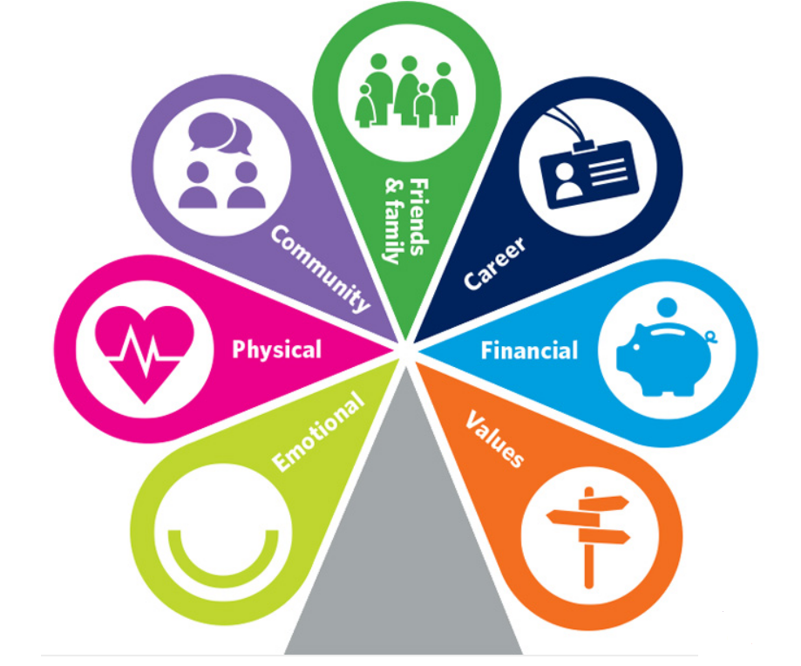
Figure 9 – Wellbeing domains according to CABA (online coaching services for wellbeing) providing 24 hours supports covering emotional support, health & career support, financial assistance, debt advice, career development, legal advices and wellbeing advices?

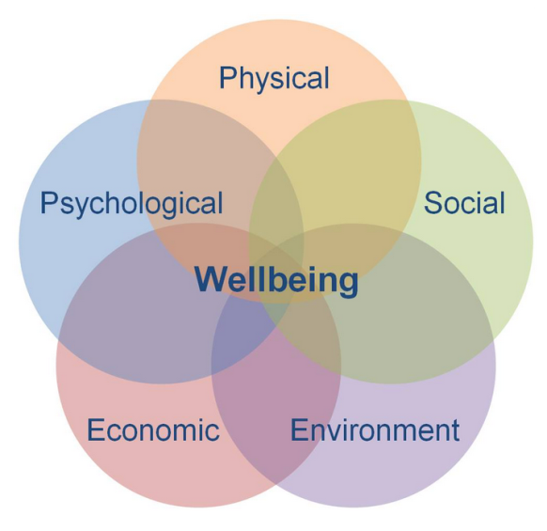
Figure 10 – Wellbeing domains according to Health and Wellbeing UK (Wellbeing audits and strategy).

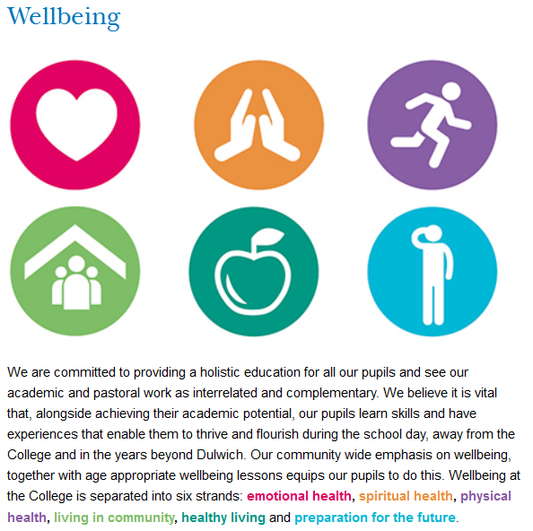
Figure 11 – Wellbeing domains according to Dulwhich College

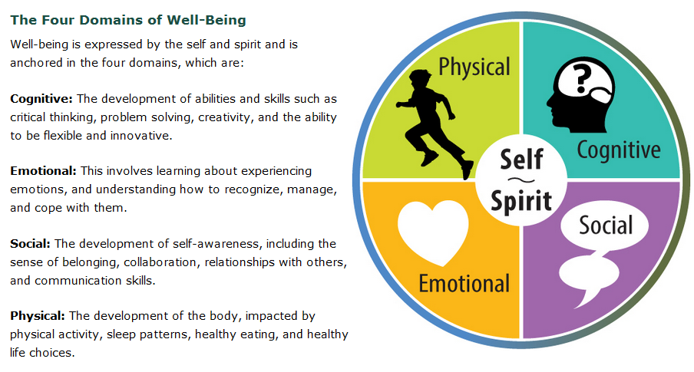
Figure 12 – Wellbeing domains according to Ministry of Education (Ontario)
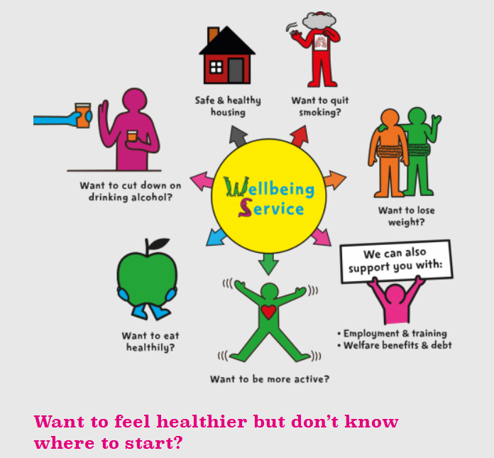
Figure 13 – Wellbeing domains according to refresh (free help and support to improve your health).
In addition, several Wellbeing coaching smartphone applications are currently available to help the user improve his behaviors and feel healthier (drink monitoring, pills monitoring, healthy habits) and more productive. Some examples are listed and briefly described in the table below.
Wellbeing coaching smartphone applications
Smartphone application | Description
Fabulous: Motivate Me! | Free Android Application  Fabulous is a science-based application, incubated in Duke’s Behavioral Economics Lab that will help the user to build healthy rituals into his (her) life, just like an elite athlete.
Coach Me | Free Android Application  Coach Me is a productivity coaching application that includes three types of features:  - Habit tracker (free feature)  - Habit Coaching  - Leadership Coaching
Smylife | Free Android French Application  This application helps the user to get thinks positive and smile.  The user writes everyday positive and negative experiences, and sorts these experiences. The user evaluates his personal level of wellbeing and tracks the evolutions.  http://smylifeapp.com/
Hydro | The hydro application reminds the user to drink water and helps him stay hydrated every day.
Med Helper | Med Helper is a Pill reminder application.

Wellbeing coaching diabetes applications
Below is a selection of applications selected as the best diabetes applications in 2016 by the American website Healthline specialized in the diabetes subject.
The advantage of these applications is their “easy-to-use” approach, as they can be simply downloaded and used as any other smartphone application. However, they rely on information provided by the End-user himself which requires day-to-day motivation. These applications do not benefit from any automated context awareness.
Wellbeing coaching smartphone applications for diabetes
Smartphone application | Description
 | This smartphone application includes a journal, a meal planner, recipes and a food guide. It also scans barcodes on packaged foods to immediately get nutrition information.
 | This smartphone application helps tracking all measurements, medicines, food intake and exercise. The application also allows estimating HbA1C and helping plan next doctor’s appointment.
 | This smartphone application tracks blood sugar and connects with other people with diabetes.
 | This application monitors glucose, AND wearable fitness trackers and shows inputs from multiple diabetes management technology.
 | This application tracks what the user eats, provides immediate feedback on how the user is doing and information on how diet affects overall health.

Expected benefits to the End-users and innovation expectations
We expect that the general quality of life of the end user improves after using the system for some time. We expect that the innovative technical capabilities of the platform, such as context awareness and behavioural analysis, will allow the service to help the user to keep engaged in coaching programs. This should improve the user’s health as well as the general psychological condition of the user, as keeping engaged in the coaching should help diminish user’s frustration. Improving the user’s quality of life should ultimately incur in larger life expectancy and lower health costs.
From the user’s perceptive, this system should innovate in two ways essentially. The service should allow constant monitoring and coaching at a reasonably low cost in relation to other, non-automated, alternatives. Also, behaviour recognition should allow the user to perceive the system not simply as a reactive tool, but as an intelligent system that can keep track of important events across longer time periods.

Innovation roadmap of EmoService A
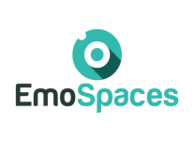
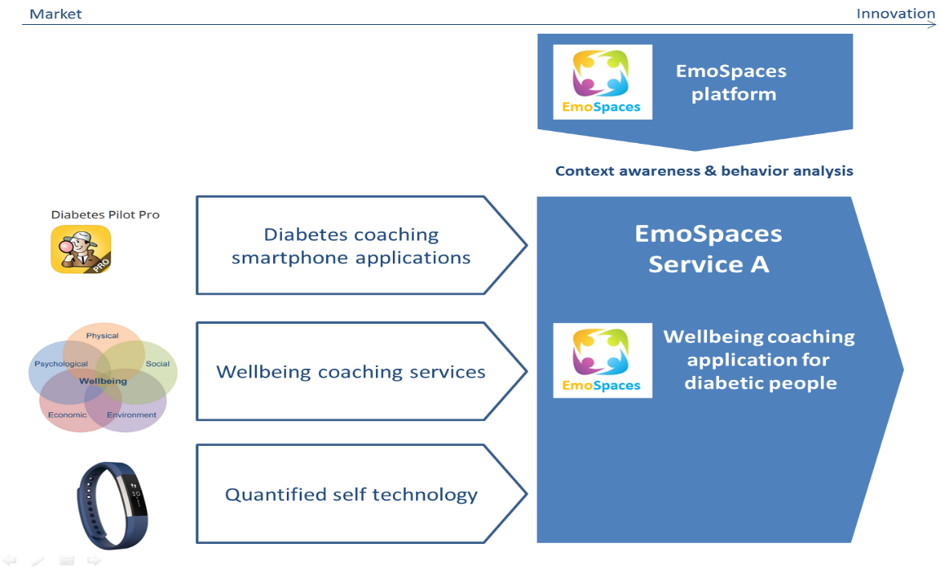

Innovation positioning of EmoService A versus existing technology
 | Features provided by existing technologies | Targeted Innovation  of Service A
Diabetes coaching smartphone applications | Dedicated to people with diabetes. However, all information shall be manually indicated | The targeted innovation is the capability of EmoSpaces to detect this information of context (activities, behaviour, mood) automatically
Wellbeing coaching services | The services cover a large range of Wellbeing domains (diet, habits, sleep, sport, social activities, work…) | The targeted innovation is the capability of EmoSpaces to automatically analyse behaviours and provide coaching services related to long-term daily monitoring.
Quantified-self technology | This technology provides the ability to monitor health | The targeted innovation if the capability to integrate this type of data with further information provided by further sensors (cameras, Kinect, …) and further data analysis to provide an overall context awareness of the user.

EmoSpaces use cases and scenarios
We focus in this work on the monitoring and coaching of elderly people to enhance their quality of life, including mental and physical health. For demonstrative purposes of this use case let us consider the case of Jean-Jacques, an elderly person that has been diagnosed since a few weeks with Type 2 diabetes at an early stage with no dependence on insulin medication. To prevent any future complication and enhance Jean-Jacques lifestyle, the doctor suggests him to follow a coaching program to control weight and to change his life style, including improving his diet and helping him in doing more exercises. However, Jean-Jaques’ current life style is not corresponding to the perquisites needed to succeed in a conventional coaching program. Therefore, the doctor suggests testing the experimental Coaching System developed in the Emospaces project. This coaching system acts like an agent that can be embodied in different devices (smartphone, smart-TV or personal robot), and that is able to recognize the behaviour and context of Jean-Jacques and supply dynamically coaching services according. Note that Jean-Jacques does not have a coaching compliant behaviour because he spends a lot of time in his car driving between his home and his job, shopping and at customers’ places, although these are relatively close by public transportation or by walking. Moreover, Jean-Jacques is not regular in practicing sports or having social relations. He also does not respect regular meal times, as he usually skips breakfast or lunch, rarely cooks by himself, and prefers to have meals in fast foods. Moreover, as Jean-Jacques has a managing position at his company, he is usually under stress. He also smokes and drinks.

Use case - Lifestyle coaching to control weight (A1.1)
The Emospaces coaching system detects the working and living context of Jean-Jacques, recognizes his behaviour and suggests him to choose food item with less carbohydrate in order to keep his weight on control and lose the extra kilograms in smooth manner when he is about to take a decision regarding his next meal(s). In addition, the Emospaces coaching system delivers context aware smart notices when Jean-Jacques cancels or misses a scheduled physical activity or decides to have meal in a fast food restaurant. A more detailed example of how the coaching service would affect the user is the following:
 | Use case illustration
Context | Jean-Jacques (JJ) is an economically active, elderly person that has been recently diagnosed with Type-II diabetes. His doctor suggested that, in order to control the condition, he needs to follow a balanced diet and practice sports. JJ has been following his diet restrictions and walking 40 minutes in his treadmill every day (medical advice).
 |  | JJ without coaching assistance | JJ using coaching assistance (EmoSpaces)
Narrative | 1 | JJ gets ready to walk in his treadmill at home. He feels a bit bored with the treadmill. He has been walking on it for weeks.
 | 2 |  | - The system detects the situation. It is also aware that JJ has been doing this for weeks.  - The system uses its domain knowledge about people’s behaviour and understands that JJ might get bored with the treadmill exercise soon.  - Accessing information about different types of aerobic exercises, the system selects a new type of exercise based on JJ’s profile and requirements.  - The system picks a new set of exercises (say, dancing) and suggests it to JJ.
 | 3 | - He would like to try a different kind of exercise that did not involve the threadmill.  - After 20 mins walking, he starts to get too bored and stops exercising. | JJ tries the new exercises and gives feedback.
 | 4 | - This pattern repeats until JJ starts to miss his daily walks.  - His weight starts to increase again, leading to degraded psychological state, stress and difficulties to keep a healthy lifestyle. | - The pattern repeats until JJ learns new types of exercises. The system stops suggesting new exercises for a while, in order to avoid being too intrusive. It keeps monitoring to check if JJ does not stop exercising all together (abnormal situation monitoring, next use-case).  - His weight starts to normalize, leading to improved psychological state, satisfaction and further encouragement to maintain a healthy lifestyle.

The following tables give an overview of the target scenarios that we plan to develop within the context of use case A1.1. In Scenario A1.1.1, the coaching system should coach the user in doing physical activities, preferably indoors. Similarly, in Scenario A1.1.2, the system should coach the user in eating healthier, also in an indoor context.
Use case scenario A1.1.1 - Monitor engagement in doing physical activities
Steps | Description
#1 | The End-user is at home doing daily physical activities such as home sport or house-keeping.
#2 | The EmoSpaces system detects the physical activities made at home (indoor environment).
#3 | The End-user leaves the house and wears a connected object such as a smart bracelet and/or a smartphone. He does several outdoor physical activities such as, biking, walking or running.
#4 | The EmoSpaces system detects the physical activities made outdoor.
#5 | The EmoSpaces system analyses the physical activities made indoor and outdoor.
#6 | Finally, the EmoSpaces system displays advices to the End-user to keep him engaged according to his physical activities (advices based on historical end-users activities, end-users goals, coaching expertise).

Use case scenario A1.1.2 - Monitor engagement in respecting regular diet
Steps | Description
#1 | The End-user is at home doing several daily activities related to diet such as cooking, eating or drinking.
#2 | The EmoSpaces system detects and records the cooking and eating activities made during the day at home (indoor environment)
#5 | At the end of the day, the EmoSpaces coaching agent display advices to the End-user to keep him engaged according to his diet of the day (advices based on historical end-users activities, end-users goals, coaching expertise).

Use case - Coaching by detection of abnormal behaviours (A1.2)
The Emospaces coaching agent should be able to monitor Jean-Jacques on the long term by preventing a possible decline of his conditions. An important part of that objective is to detect and act on deviations of normal behaviours. Behaviours develop after repetition of certain actions during a long time frame, so the system is expected to detect behaviours only after some period of time. Therefore, reaction to (abnormal) behaviour has to take that into account. A depiction of how the system could help the user by detecting abnormal behaviour is the following:
 | Use case illustration
Context | Jean-Jacques (JJ) is an economically active, elderly person that has been recently diagnosed with Type-II diabetes. His doctor suggested that, in order to control the condition, he has to have a balanced diet and practice sports. Jean-Jacques plans to work from home in the mornings and go visit clients and the headquarters in the afternoon.
 |  | JJ without coaching assistance | JJ using coaching assistance (EmoSpaces)
Narrative | 1 | JJ starts his work day by trying to plan his activities during the day following the doctor’s instructions. He plans to stop working at 11:00 and fix his lunch, then leave to meet a client at 13:00.
 | 2 |  | JJ programs his calendar with his whole schedule, reserving time for preparing lunches. Today, his calendar says he should stop working at 11:00 and fix his lunch, then leave to meet a client at 13:00. The system has access to devices around his home. It also synchronizes with his calendar.
 | 3 | He looks at his watch by 10:58. Abnormally, he decides to spend a little more time working. He can simplify his menu for the day. | He looks at his watch by 10:58. He decides to spend a little more time working.
 | 4 | He looks again at his watch. It is 11:45. He realizes that he has no time for fixing lunch. He decides to go to a vegetarian restaurant instead. | It is 11:10 and JJ is still working in his computer, while he should already be in the kitchen. Having access to the computer, the system detects the abnormal situation. The system detects also that JJ is in a generally bad mood, which can indicate that he might be resistant against suggestions.  It is 11:30 and JJ is still working, but he is tired. The system also realizes that JJ will not be able to cook by himself today. Based on recent behaviour by JJ, the system also calculates that there is plenty of time for JJ to go to the Vegetarian restaurant that he is used to go to frequently.  The system then reminds JJ that he should cook his own food to stay healthy and that he is not doing that as frequently as he should. It also concedes that it might not be possible today to achieve that goal, but if the leaves now, he can go to his favourite Vegetarian restaurant, which is also a good option.
 | 5 | Jean-Jacques gets into his car and notices he is slightly late (12:15). | Jean-Jacques is convinced. He gets into his car at 11:50, leaving on time.
 | 6 | - Jean-Jacques decides to go to the fast-food restaurant close to his home. Besides, he really like French fries and (Diet) coke.  He orders the food at the drive-through. He eats it very fast and heads to his client, stressed out and frustrated. | He eats a balanced meal at the Vegetarian restaurant. He is slightly frustrated for not being able to cook again, but satisfied with himself for not having gone to the fast-food again.
 | 7 | Two weeks later, in his medical check-up, he is informed that his cholesterol is dangerously high for his condition. The doctor then prescribes him specific medicine for that. | Two weeks later, in his medical check-up, he is informed that his cholesterol is under control. The doctor does not prescribe him cholesterol controlling medicine.
The following tables give an overview of the target scenarios that we plan to develop within the context of use case A1.2. In Scenario A1.2.1, the coaching system should coach the user when it detects that the user is staying too much time at home. Similarly, in Scenario A2.2, the system should detect low levels of social engagement.
Use case scenario A1.2.1 - Coaching by detection of prolonged periods of time at home
Steps | Description
#1 | The End-user leaves home with a certain frequency.
#2 | The End-user stops leaving home, becoming also much less active at home as well.
#3 | System detects a change in behaviour after some time. The system also detects that the end-user’s mood is deteriorating.
#4 | The system reacts, alerting the user for the danger of a secluded life, and suggests alternatives.
#5 | If no change is perceived, the system reacts by alerting family and care-givers.

Use case scenario A1.2.2 - Coaching by detection of non-regular engagement in social life
Steps | Description
#1 | End-user commonly interacts with other persons through smart phone, social networks, and personal meetings
#2 | The End-user’s behaviour changes, becoming less social.
#3 | Based on usage data from communication devices, as well as data about diverse social behaviour in home, the system detect lowers social engagement.
#4 | The system alerts the End-user, and tries to encourage him or her to keep in touch with friends and family.
#5 | If no change is perceived, the system reacts by alerting family and care-givers.

Use case - Coaching in critical situations (A1.3)
The Emospaces coaching systems can detect some critical situations that may cause harmful effects for Jean-Jacques safety, such as falls. More than just abnormal situation, critical situations have to be acted on quickly, usually involving interaction with outside users. For example, in case of a detected fall, the EmoSpaces coaching systems can help first responders, family members and Jacque himself to react correctly. An example of a situation where the system could be useful is the following:
 | Use case illustration
Context | Jean-Jacques (JJ) is an economically active, elderly person that has been recently diagnosed with Type-II diabetes. He also lives alone, having contact with his son everyday by phone, usually on the evenings. |  | It is the same Jean-Jacques (JJ). However, now he decides to use the coaching system in his devices.
Narrative | 1 | Jean-Jacques wakes up feeling dizzy and weak. He decides to have a shower to improve his mood.
 | 2 |  | The system has access to devices around his home. It also controls a companion robot that is able to move around the house and interact with Jean-Jacques. The system notices that Jean-Jacques has entered the bathroom.
 | 3 | As he is walking in the bathroom, he slips on the smooth floor and falls to the ground, hurting his ankle. | As he is walking in the bathroom, he slips on the smooth floor and falls to the ground, hurting his ankle.
 | 4 | As he tries to get back on his feet, he realizes that he has no strength to pull his weight out of the ground, as he is hurt and weak. | As he tries to get back on his feet, he realizes that he has no strength to pull his weight out of the ground, as he is hurt and weak.
 | 5 | He searches for his phone to try to call his son, but realizes the mobile is in the bedroom. | He searches for his phone to try to call his son, but realizes the mobile is in the bedroom.
 | 6 | Jean-Jacques stays stranded on the floor. | Jean-Jacques stays stranded on the floor.
 | 7 | After 2 hours, he feels a bit better and is able to carry himself to the bedroom and to the phone.  He calls his son asking for help. | After 25 minutes, the system infers that it has been too much time since Jean-Jacques last crossed the bathroom door.  The system decides to send the robot to the bathroom to investigate.  As the robot arrives in the bathroom, it tries to make contact with Jean-Jacques. He is then able to contact his son through the robot interface.
 | 8 | Jean-Jacques is scared that the situation might repeat itself. He and his family decide that he cannot live alone anymore. As he moves to his son home, he starts feeling that he is losing independence, impacting heavily his psychological condition. | Jean-Jacques is a bit scared, but relieved for having the coaching system in place. While his son insists that Jean-Jacques should come live with him, Jean-Jacques decides to keep his independence and live alone, with the help of the intelligent agent system, which improves his psychological condition.
The following tables give an overview of the target scenario that we plan to develop within the context of use case A1.3. In Scenario A1.3.1, the coaching system should detect and react to the end-user falling to the floor.
Use case scenario A1.3.1 - Fall detection
Steps | Description
#1 | The End-user falls to the ground.
#2 | The End-user fails to get up for an extensive amount of time.
#3 | The EmoSpaces system detects that the end-user has been on the floor for a considerable amount of time.
#4 | The EmoSpaces coaching tries to contact the user, while contacting family and caregiver.

Use case: Social Integration (A2)

Description
Children with Autism Spectrum Disorder (ASD) are very comfortable following patterns and routine tasks. When they face situations that are not usual for them, they can have episodes of stress, fear, fear, panic, trauma. Some of these situations can even be the daily life of the child. Examples of situations that can cause stress are: get a haircut, brushing teeth, going to the doctor, taking a trip, etc ...
Nowadays, ASD affects 1 in every 62 people. People with ASD represent a group that needs more attention from the Society and Public Administrations. These people are very comfortable following patterns and routine tasks. Therefore, when faced with situations that are not usual for them, they may have episodes of stress, fear, fear, panic, trauma. However, many of these situations are necessary in its daily life. As examples of these situations we can find going to the dentist, get a haircut, waiting for the bus, taking a trip, etc.
The use case we propose is the development of scenarios in Virtual Reality to cover different situations of the life of an autistic person in order to facilitate the achievement of a specific goal, avoiding the fear that may cause. The technological solution will detect the level of stress of the user and modify simulation parameters, such as light and sound, to reduce the level of nervousness. With these simulations, users will be able to gradually get used to what they will find in the different situations that they must face in their day to day.
The impact of this solution is to reduce or reduce, and if possible cancel, the fear of the autistic person when facing a situation that may cause fear, in a simple and fun way for them. It is also a good complement to the current way of working with them, which is based on pictograms on which they are explained by drawings what can be found.
The use case is already being tested with the help of the association ASTRADE, Association for the care of people with autism and generalized disorders of the development of the Region of Murcia. This association has already shown considerable interest in the application and is actively collaborating in the use case. In addition, the dissemination of the first tests by ASTRADE have aroused great expectation among users and family members, which serves as an indication of the interest and potential market that it has. The development of a desktop VR application with all the functionalities and potential of current equipment is foreseen, focused on the use of associations and institutions, and a lighter mobile version that can be used by the families themselves.
On behalf of Answare, this use case represents a real business opportunity, in addition to the social benefit that EmoSpaces can bring to a group that grows more every day, such as people diagnosed with ASD.
An example of use:
 | Use case illustration
Context | Xavier is an autistic kid and he likes his daily routine. But he gets stressed when he must do unusual activities like going to the dentist.  He goes to an association for autistic kids with specialists. They help him to face uncommon situations using pictograms to make him understand how the visit is going to be. |  | Xavier is an autistic kid and he likes his daily routine. But he gets stressed when he must do unusual activities like going to the dentist.  He goes to an association for autistic kids with specialists. They help him to face uncommon situations using VR for an immersive experience to make him experiment the virtual visit before the real one.
Narrative | 1 | Xavier needs to go to the dentist, but he gets stressed every time he goes.
 | 2 | Xavier goes to an association for autistic kids and he has specialist that help him to manage unusual situations.
 | 3 | The specialists provide him pictograms to explain all the steps of the visit to the dentist. | The specialists configure the VR software adjusting waiting time, lights and sound depending of the sessions taken before.
 | 4 | Xavier sees the pictograms and the specialists explain him the meaning of them and what represents. The specialists tell him that he must be seated until he receives a green card. In that moment he can get up and go to the doctor’s room. | Xavier uses the VR software and he sees a virtual representation of a real clinic, with other patients and a dentist. The software detects his stress level and adjust lights and sound to make the experience more relaxing.  When he receives a light green he can get up and go from the waiting room to the dentist office. The doctor tells him to sit down in the dentist chair and the simulation ends.
 | 5 | When Xavier must go to the real dentist office, his parents have some pictograms to tell him when he can get up, etc.  It’s the first time he sees all the equipment and he doesn’t understand why there’s more patients waiting. | Xavier goes to the dentist office with his parents and they have some pictograms to tell him when he can get up, etc. He recognizes all the equipment and sees other patients waiting, like in the simulation.
 | 6 | He starts to get stressed and he wants to go out of there. His parents try to relax him showing him some pictures and comics that he likes. | Xavier has learnt all the steps and he is familiar with all around him.

Use case scenario A4.4 – Scene adaptation to the user stress level
Steps | Description
#1 | User is running VR simulation
#2 | User starts to get stressed.
#3 | A band in the wrist detects this stress
#4 | The scene adapts illumination and sound to decrease user stress level.

Data sources
This section describes the external databases that are required by the use case. These data sources represent data that is not provided through the sensor networks.
Interactions with the system
Source | Internal, generated by the application
Relationship with other data sources | Data base of the platform
Type | Continuous flow
Description | The system will evolve through applied gamification techniques.
Redistribution conditions | It can not be redistributed

Meetings with associations of autistic children
Source | External, provided by external associations
Relationship with other data sources | Data base of the platform
Type | Continuous flow
Description | Data obtained from the meeting with associations of autistic children, related to the users and their different sensations and behaviors.
Redistribution conditions | It can not be redistributed

Data base
Source | Internal, generated by the partners in the development of the use case
Relationship with other data sources | Data base generated in the project
Type | Historical
Description | Data obtained from the database of partners whose use case has a usefulness in the implementation of aid functionalities for children with autism.
Redistribution conditions | It can not be redistributed

Contextual information
The contextual information is the data that is needed in the case of use by proportional additional information about the user and the environment with which it interacts.

User profile

This context information provides data related to the modeling of the user (age, interests, behavior, etc.). This information will be used to contextualize the child within its environment, and allow the platform to adapt to the specific needs of the user.

Physical space modelling
This contextual information refers to data related to the physical environment, which will be used to establish a physical environment around the child that allows adaptation to the environment surrounding the user.

Virtual space modelling
Contextual information represented by data resulting from the interaction with the platform. This information is used for the adaptation of the visualization of contents in the platform. The objective is to model a control panel that is getting richer and that in turn optimizes the metrics shown.

Requirements
This section contains the specific requirements of this use case, these are requirements that are not contemplated as general requirements of the EmoSpaces platform.
The requirements will be developed throughout the project. Three steps have been defined to iteratively refine the requirements. Due to the fact that this use case was identified as a business opportunity throughout the first year, the requirements have not been defined in more detail. The necessary steps to define the requirements are:
- Definition of possible scenarios with the child monitor.
- Definition of the solution for each scenario (together with the Astrade specialists).
- Definition of ICT solution.

Devices
This section describes the necessary devices for the implementation of the use case.
For the use case described in this section, in addition to the use of devices such as mobiles or tablets, cameras will be used to detect emotions to analyze the user's mood, as well as their responses to certain stimuli.
In addition, wearables will provide information on the user's response to certain situations and will allow obtaining details about the context in which they move, including their habits and customs.

IoT sensors
In this section, the relevant IoT sensors are described by the use case.
In terms of contextual sensors, with them you will obtain information relative to the user's environment, such as an accelerometer and GPS for movement; heart rate monitor to determine the pulse; barometer to measure the pressure of the environment and thermometer.

Expected results
The expected results in this use case can be summarized in the following points:
- Decrease or reduce and if possible, cancel the fear of the child when facing a situation that may cause fear.
- Preparation of the autistic child for situations that come out of their usual routine in a simple and fun way for them.
- Improvement in the quality of life of both children and parents, since children will suffer less from changes in their routine.
Due to the situation of the users identified by this use case, the measurement of the expected results will be carried out with interviews to users and, depending on availability, with sessions with social workers or psychologists.
The use case will be tested with the help of the association ASTRADE, association of parents of autistic children, in the Region of Murcia (http://www.astrade.es/). This association has already shown enough interest in the EmoSpace project and in particular for this use case; confirming their collaboration and willingness to participate in the use case.

6.1.6 The challenges they face
ASD people are uncomfortable with non-everyday situations. They like repetition and routines. For this reason, unusual situations produce them high stress levels.
VR provides an immersive and realistic simulations. They have a better training experience closer than reality and less stressful process.

End-users and stakeholders description

We define people at risk of social exclusion to people with a disability that prevents them from carrying out certain unusual activities. This people have two main problems to confront every time they want to do non-routine activities: the waiting time in every activity that they try to do and the anticipation of unusual events.
Our software is aimed to this groups: for example, Autism Spectrum Disorder (ASD) individuals, people with Down Syndrome, cerebral palsy or Alzheimer. They are affected by the same problems. About 1 percent of the world population has ASD, 1 in 68 births in USA and 1 in 100 in Europe (in 2012), in USA 1 in every 700 babies born has Down Syndrome, about 4 per 1000 has cerebral palsy and 44 million people are affected by Alzheimer.
We are working closely with ASTRADE, a non-profit organization that works with ASD people. ASTRADE is the association for the care of people with Autism and Developmental Disorders of the Region of Murcia. It was born in the spring of 1996 and the most important goal of the association is to promote the well-being and quality of life of these people and their families during the different stages of their life. They work nowadays with more than 600 families.
It is integrated into FEAPS Region of Murcia, which is the federation of organizations in favor of people with disabilities and cerebral palsy.

Landscape of existing applications
- Floreo: mobile VR to develop a supplementary method of teaching social and communication skills for ASD kids.
  - https://floreotech.com/

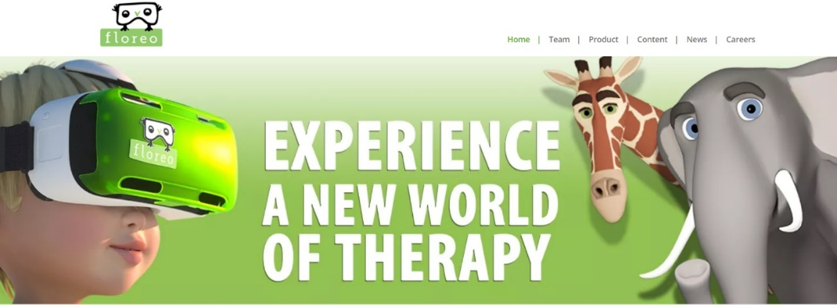

- A Pilot Study of the Use of a Virtual Reality Headset in Autism Populations: Teach social norms in different environments like classroom, crossing roads, sitting in buses or which urinal to use in a public location.
  - https://www.ncbi.nlm.nih.gov/pubmed/27272115
  - http://network.autism.org.uk/good-practice/evidence-base/potential-virtual-reality-technologies-autistic-people
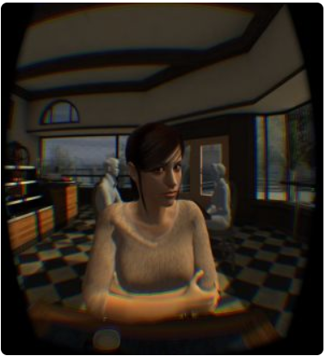

Expected benefits to the End-users and innovation expectations
◦ The challenges they face
ASD people are uncomfortable with non-everyday situations. They like repetition and routines. For this reason, unusual situations produce them high stress levels. They currently use pictograms to learn all the steps they will experiment in these situations, but VR provides an immersive and realistic simulations. They have a better training experience closer than reality and less stressful process.
◦ How your proposed product will help solve these challenges
Our VR simulation prepares them to face these uncommon situations. Software reproduces instructions with pictograms and signs that they understand to explain each step and what they must do.
• Ways in which your product will be better
Our software simulates a realistic visit to the dentist, from the waiting room to the doctor’s office. Sensors detects the users’ stress level and adapt illumination and sound to relax them.
The simulation starts in the waiting room and users must wait seated. In the room users see more virtual simulated people waiting their turn.
Users stay seated until they receive a green signal. This signal allows them to get up from the chair and a doctor tell them to come inside the office.

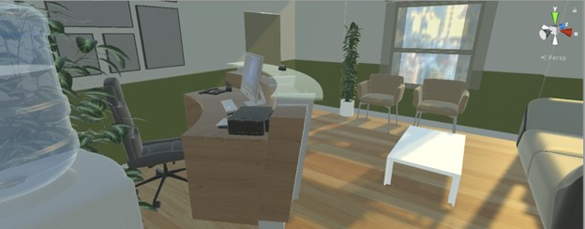
When users arrive to the office they see all the equipment and receive information about the procedure.
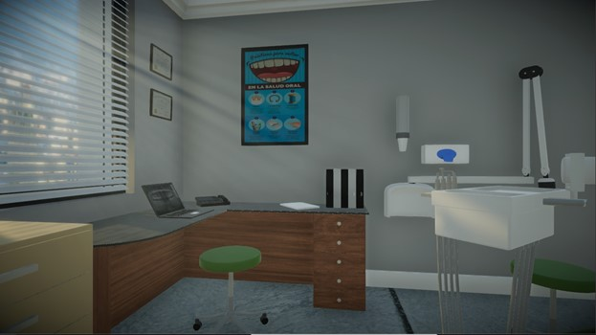

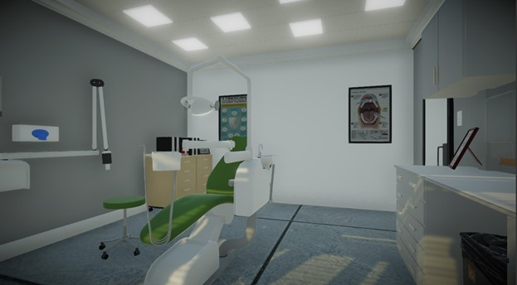

All the training is supervised by specialists. They can configure different parameters like the waiting time in the first room and illumination and sound.

Monitoring and providing services to depressive disorder people (A3)

Description
According to national institute of mental health [1], the depression is a mostly common and serious mood disorder. The depression disorder causes server symptoms that affect the human feelings, thinking and doing daily activities. Such as sleeping, studying , eating and other activities. According to the literature of psychology it is recommended that if the depression symptoms remain for as long as two weeks, it must be diagonized. The literature [2] describes many causes of depression. The symptoms of depression can be categorized and captured from as (a) Physical appearance, (b) Thoughts, (c) Behaviors and (d) Feelings.
- Physical appearance: To capture depression symptoms from the physical appearance of the person, we can use the data of his posture, his face expression, pain in muscles, , his weight loss, his tiredness , his poor appetite, his sleeping pattern or difficulty in sleeping data or insomnia.
- Thoughts in mind: The data from thoughts ( “Nothing good ever happens to me”, “Life is not worth living”, “my future looks bleak”, “I am worthless”, “its my fault”, and “I am failure” ) of person can be used to detect or monitor the depression disorder of the human. The social media data is the most important source to detect person thoughts.
- Behavior: The human behavior is also important source of the data, to monitor the depression symptoms. This data can include withdraws from the family, friends, and colleagues. Does not get things done, stops doing enjoyable activities , difficulty in concentrating on given tasks, increase alcohol consumptions, change in appetite, impression of restlessness, angry outbursts, self-harm and suicide attempts [3,4].
- Feelings: The feelings includes overwhelmed, unhappy, irritable, frustrated, lacking confidence, and hesitant. The person who is in depression, mostly experiences negative and unrealistic feelings of guiltiness. His feelings of guiltiness mostly occur no apparent reason.
Initially the person will be diagnosed by the psychologist or specialist and then the EmoSpaces system will monitor the depressive disorder symptoms levels and provide the services to the user who use EmoSpaces application. The EmoSpaces application will help to the user to treat, and reduce the depression symptoms and achieving a normal happier life.

End-users and stakeholders description
We do not going to fix this use case to any special person with special age group. This solution can be used people having interest in technological products which help them in their wellbeing’s. The parents whose childrens are not concentrating on their studies and facing the depression disorder symptoms. The adults who goes through unpredictable routines of life during their early stages of work. The elderly people that have been diagnosed with depression symptoms by the psychologist and psychologist suggest for the EmoSpaces application which monitor the depression symptoms of elderly and will provide the care services to them.

Landscape of existing applications
Currently to detect and monitor the depression symptoms, most of the applications including mobile apps uses the manual methods to detect and monitor the depression disorder symptoms and provides coaching services in order to reduce or get rid of from the depression. Some of the popular mobile apps described as follows.
Table 1 – Existing applications for handling depression disorder
App | Features
Code Blue | Code Blue is designed to provide teenagers struggling from depression or bullying with support when they need it. Users can choose several contacts to be part of their support group. With just a few taps, the app will alert the support group that the user needs immediate help. Members of the support group can then text or call the user. The app can also share the user’s location with the support group, and members can indicate that they are on their way to see the user in person.
Anxiety Reliever | - track anxiety symptoms.  - provides relaxation exercises.  - Calming audio sessions will help you to overcome anxiety, relax and fall asleep faster. Each session will guide you through stress and anxiety to feeling better and calmer.  - In the Tips section, you will find calming and guiding tips that help to feel less anxious and stressed.  kind of anxiety : Generalized Anxiety Disorder, Obsessive-Compulsive Disorder, Phobia, Social Anxiety, Panic Disorder, or Agoraphobia.
MoodTools | - Depression Information - Read basic information, detailed self-help guides, and find help with internet resources.  - Depression Test - Take the PHQ-9 depression questionnaire and track your symptom severity over time.  - Videos - Discover helpful YouTube videos that can improve your mood and behavior, from guided meditations to enlightening TED talks.  - Thought Diary - Improve your mood by analyzing your thoughts and identifying negative / distorted thinking patterns based on principles from Cognitive Therapy.  Activities - Regain your energy by performing energizing activities and tracking which activities improve your mood the most, based on principles from Behavioral Activation Therapy.
Breathe2Relax | Breathe2Relax is an app developed for stress management. It walks users through breathing exercises that help to reduce stress, stabilize mood, control anger, and manage anxiety. The app’s developers note that it can be used on its own to help reduce stress or in combination with other therapies.
Talkspace | Talkspace seeks to make therapy more available by connecting users with one of over 200 licensed therapists via messaging. With a subscription to Talkspace, users get matched to a therapist that they can chat with at any time. The creators of Talkspace note that their app is not meant to be a substitute for in-person therapy, and their therapists are trained to identify when users need more extensive help than the app can provide.
IBM Watson Speech to Text and Tone Analysis | Combining Watson Speech to Text, with Watson Tone Analysis in an app. The app converts speech to text, samples segments in real time, and plots the measured emotion on a graph. charting the breakdown of the emotions in a line graph, there is endless scope for reacting to changes, or extremes of emotion.  For example:  • Calls could automatically be directed to someone better suited to dealing with an angry person, or sad person.  • Quality and professionalism of call handlers could be charted over time at an individual level, at a building level, and at a corporate level.  • Retention of customers could be evaluated against the emotional levels inside of the conversation.  • Patterns of emotions could be matched against handling of certain policies  • Customer choices are often made based on emotion. It excites me to think that the future quality of a service could change based on something as simple as caring about the tone of a conversation.

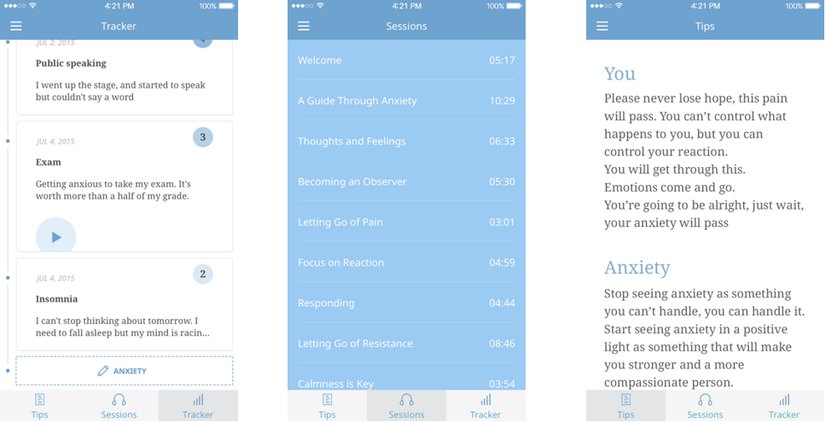
Figure 14 – Mobile App Anxiety Reliever
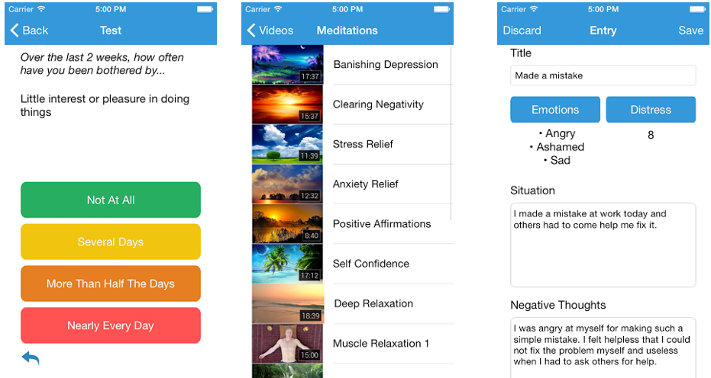
Figure 15 – Mobile App Mood Tool helps to monitor and reduce depression
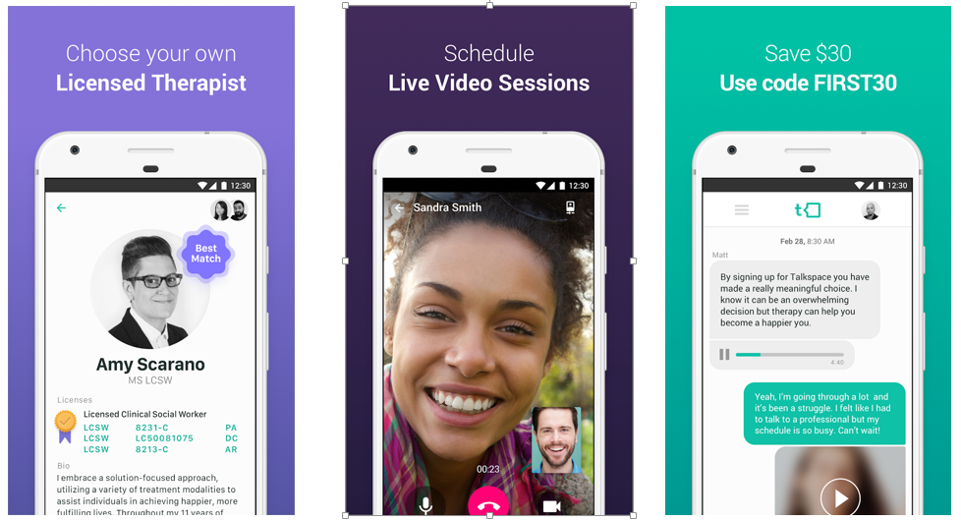
Figure 16 – Mobile App TalkSpace facilitate in choosing own therapist

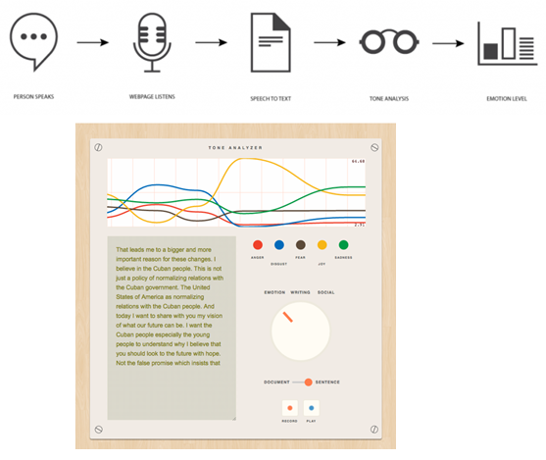
Figure 17- IBM Waston tone analysis

Expected benefits to the End-users and innovation expectations
We anticipate that the person having depressive disorder and the family, friends and the entire society life and interaction style will be improved, the childrens can better concentrate their studies and the parrents will remain satisfy with their childrens. The elderly can live independently and happy life and the adults life can also be improved.
From the user perspective, the EmoSpaces application can monitor the user depression symptoms automatically from the data of things and services to which the user interact on daily basis such as electricity and gas consumption in the home, opening the number of times the door of refrigerator, their buying pattern, their facial expression, postures and e.t.c. The system recognizes the user behavior through his talking with friends and family, how they interact with them. Based on the syptoms and doctors recommendations EmoSpaces system will provide the services such as comedy movie recommendation, book recommendation, exercise recommendation, music recommendation, therapeutic video recommendation, and well-balanced diet recommendation.

Use Case Scenario: Smart space of depressive disorder
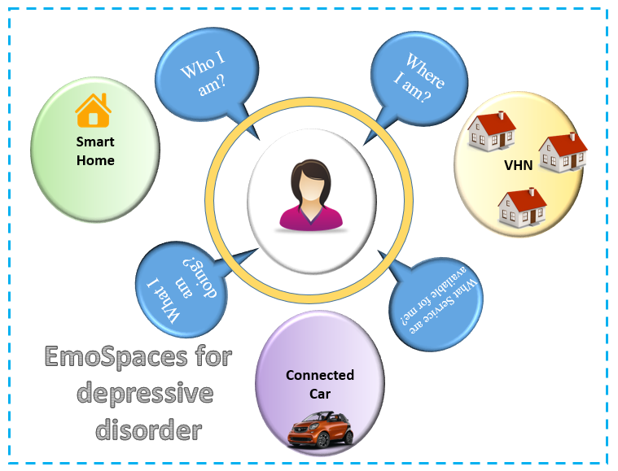
Figure 18 - Smart Space for Depressive disorder
- It is often happen that user perform so many tasks and activities in his routine life on daily basis.
- The vicinity of these tasks and activities could be home or his connected car while travelling to or from office.
- Due to routine life, busy schedule and heavy workload, the user become so tired and depressed
- Which affect his living of life and style of interaction in this fast era of competency
- Therefore the user needs to monitor his depressive disorder
- Through the automation of objects, to which he interact with them.
This automation could be obtained by predicting and recognizing user’s intensity of tiredness,
workload activities either he is in home or driving from home to office or office to home based on his activities and emotions
We could monitor user depressive disorder,
- So he could get relaxed and feels comfort in a very less time.
- The user’s activities, emotions and depressive disorder recognized through
- Smart phone sensors
- Cameras, and interactions on social media platforms.
- Wrist mounted devices
- Interactions on social media platforms.
- Actigraph
- Gyroscopes
- Refrigerator
- Accoustic sensors
- Based on the user emotions, activities we can monitor the user depressive
- disorder and provide him leisure services
- The room entities automatically customized
- For example automatically customization of
- Room lighting
- Room temperature
- Music
- Video
- So the master could quickly get relaxed from his work tiredness.
- Clouded Collaborations
- The room temperature and lighting could also be customized based on the weather data from the cloud services
- For example on sunny day do not on so many lights in order to save energy
- And also customize the environment inside the room based on the weather data from the cloud
- Virtual Home
- All the entities in home is connected with the user space
- He can monitor and customize all the entities in the home
- For example the user can check the battery and fuel level of his car parked in home garage from his room
- He could check the grocery available in the fridge from his office and also adjust the thermostat of the fridge
- Whenever a user in the home perform any activity (physical exercise, social interaction through Facebook, Google plus, watching movies), then his activates are recorded and things in the home customized for the user.
- Services in Smart space for Customization
- Activity monitoring
- Automatic Home Monitoring
- Social media interaction & Collaboration
- Cloud Collaborations for new Features
- Home Appliances monitoring
- News, Music and Movies
- Food Recommender
- Meeting schedules
- Environment Monitoring
- Connected car monitoring
- Economy & Technology News
- User Authentication
- Virtual Home virtual Monitoring
The Following figures depict the scenario for monitoring the depressive disoder and providing the service to the user in smart home
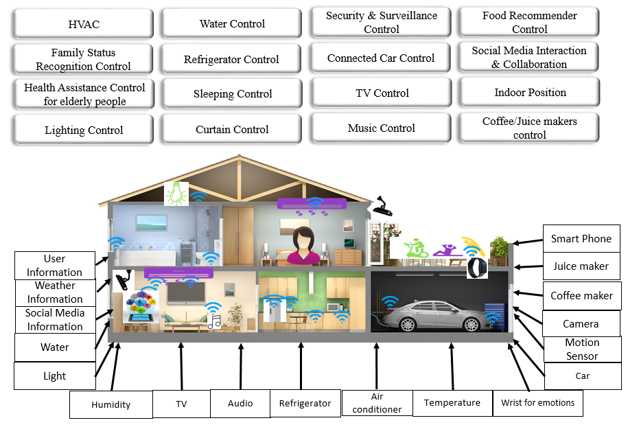
Figure 19 - Monitoring Depressive disorder of a user and provide services in Smart home

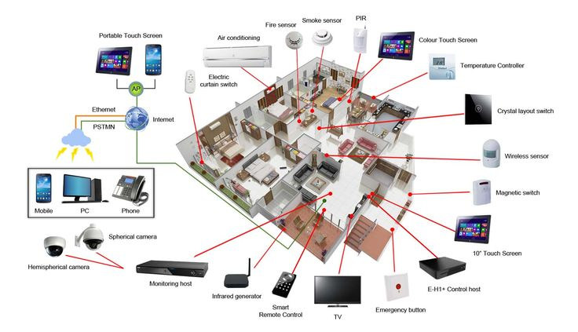
Figure 20 - Devices and sensors used in smart home to monitor depressive disorder
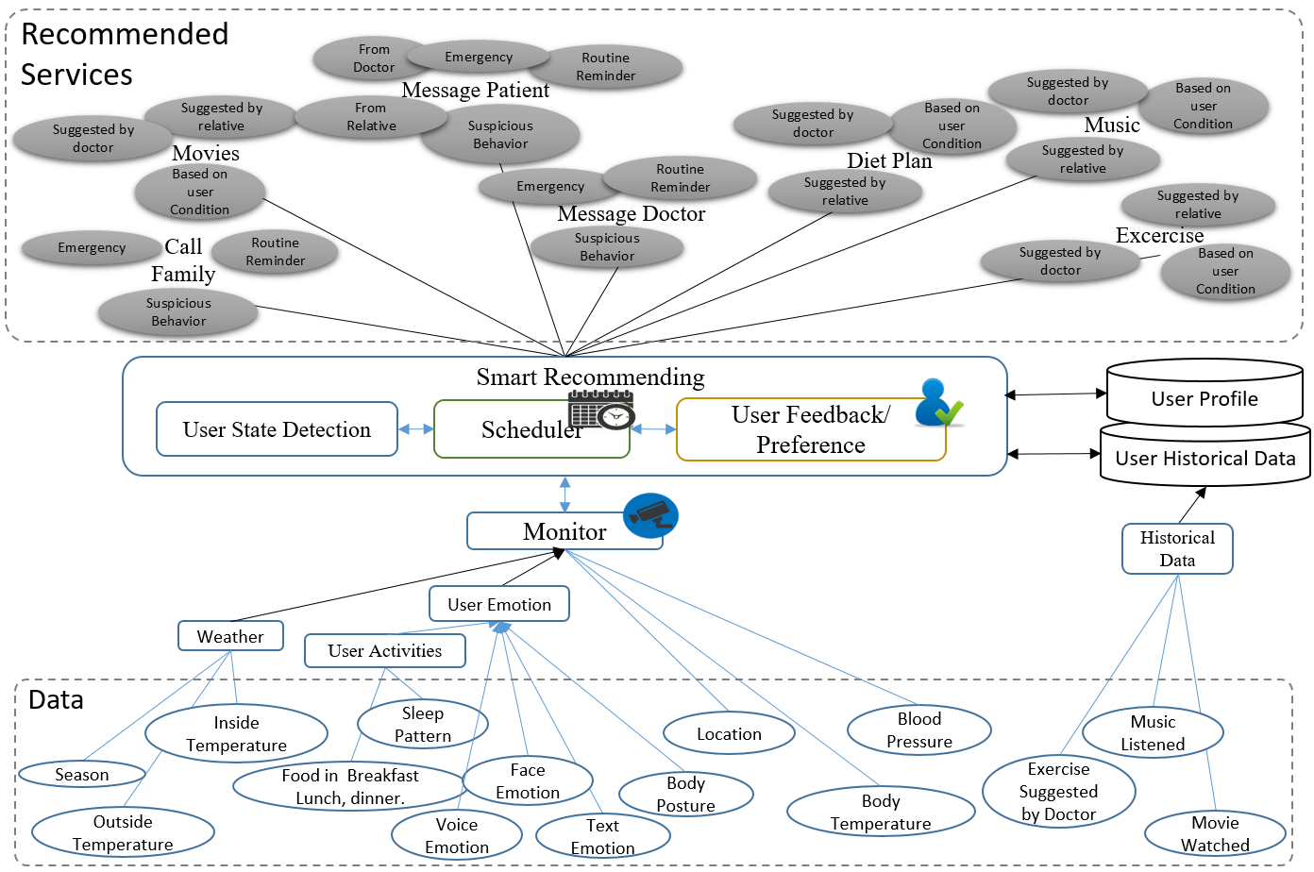
Figure 21 - Smart Recommender for Personalized Smart Space

Required VOs List in to monitor user depressive disorder order in smart home based on user’s activities & emotions
Table 2 - VOs description used in smart home to monitor depressive disorder
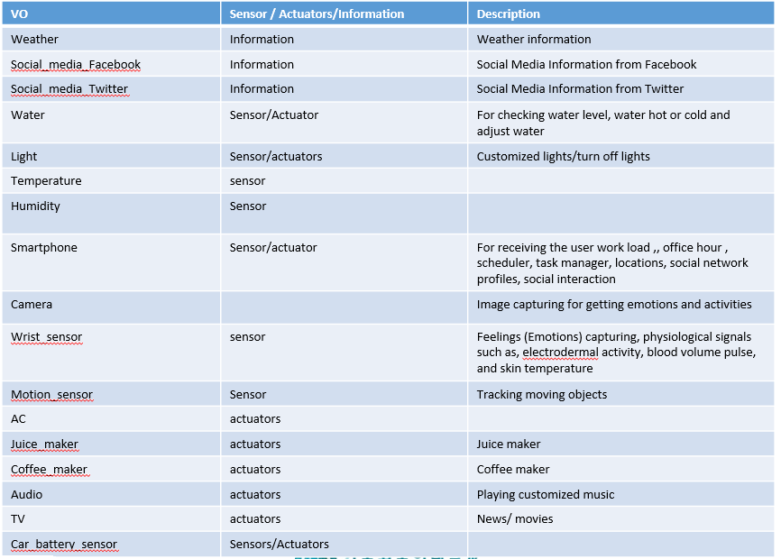
Table 3 - CVOs description used in smart home to monitor depressive disorder
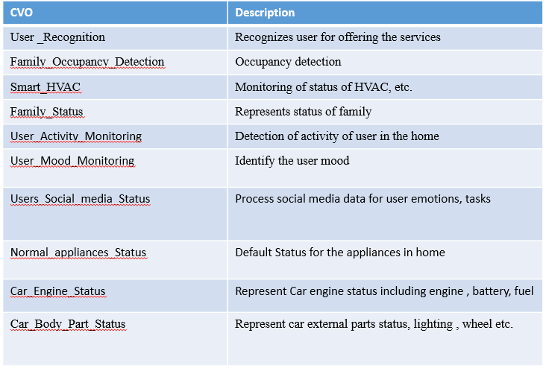
Conceptuel semantic ontology model for Smart Space to monitor user’s depressive disorder based on user’s activities & emotions: Smart home is shown in following figures.

First figure shows the main model and other figures shows each service individuel.
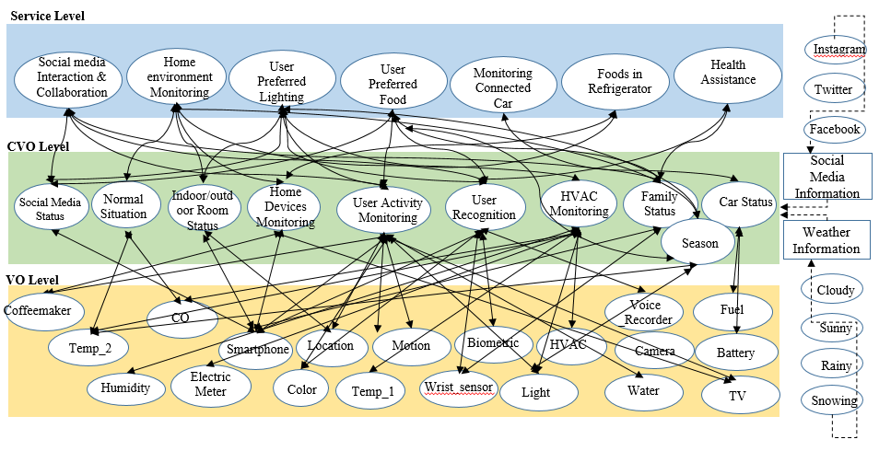
Figure 22 -Conceptual semantic ontology model for Smart Space to monitor user’s depressive disorder based on user’s activities & emotions

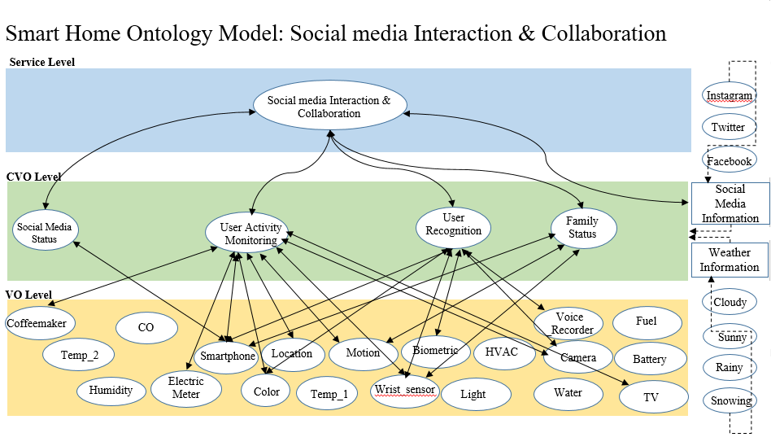
Figure 23 - Conceptual semantic ontology model Social media interaction & collaborations

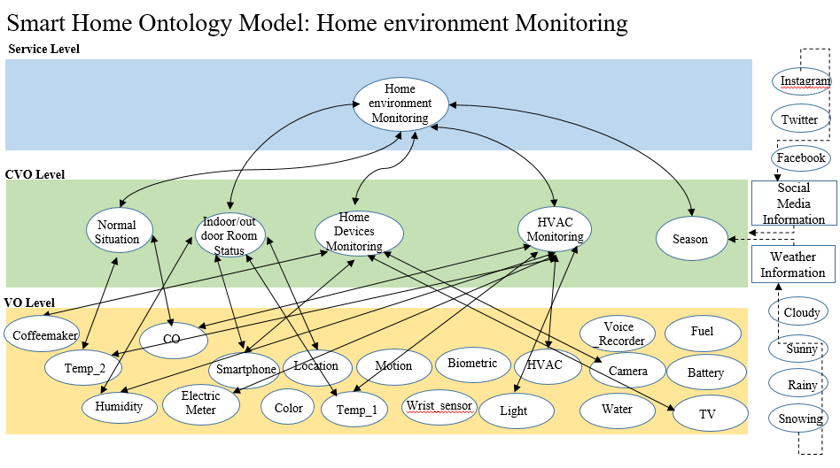
Figure 24 - Conceptual semantic ontology home environment monitoring

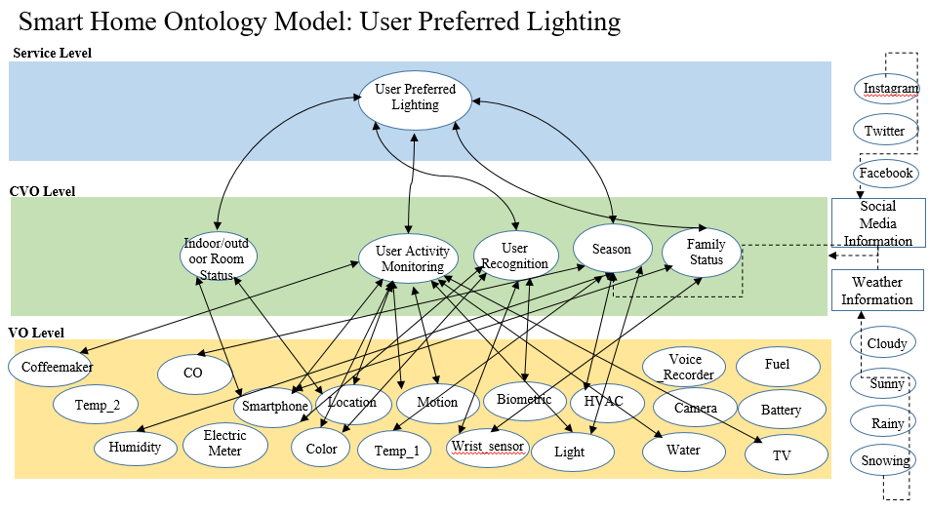
Figure 25 - Conceptual semantic ontology user preferred lighting

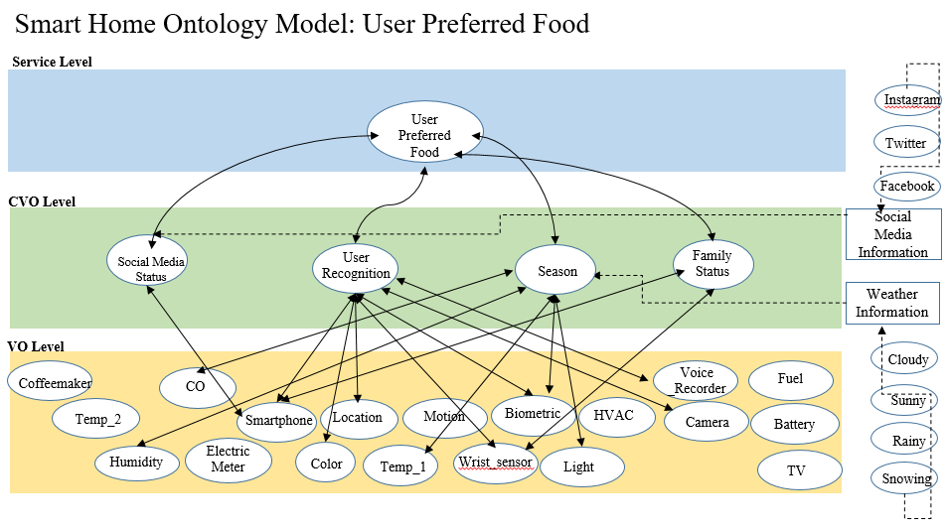
Figure 26 - Conceptual semantic ontology user preferred food

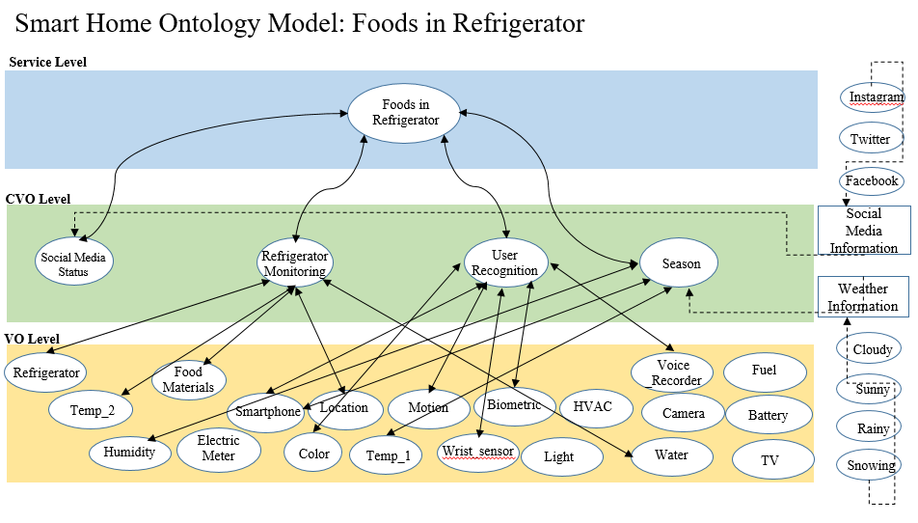
Figure 27 - Conceptual semantic ontology Foods available in Refrigerator

Patient Questionnaire to Detect Depressive disorder
Following questionnaire are used in clinic to find out depression symptoms in patients
Table 4 - Depression Symptoms questionnaire: Reference: https://goo.gl/tFPFJB
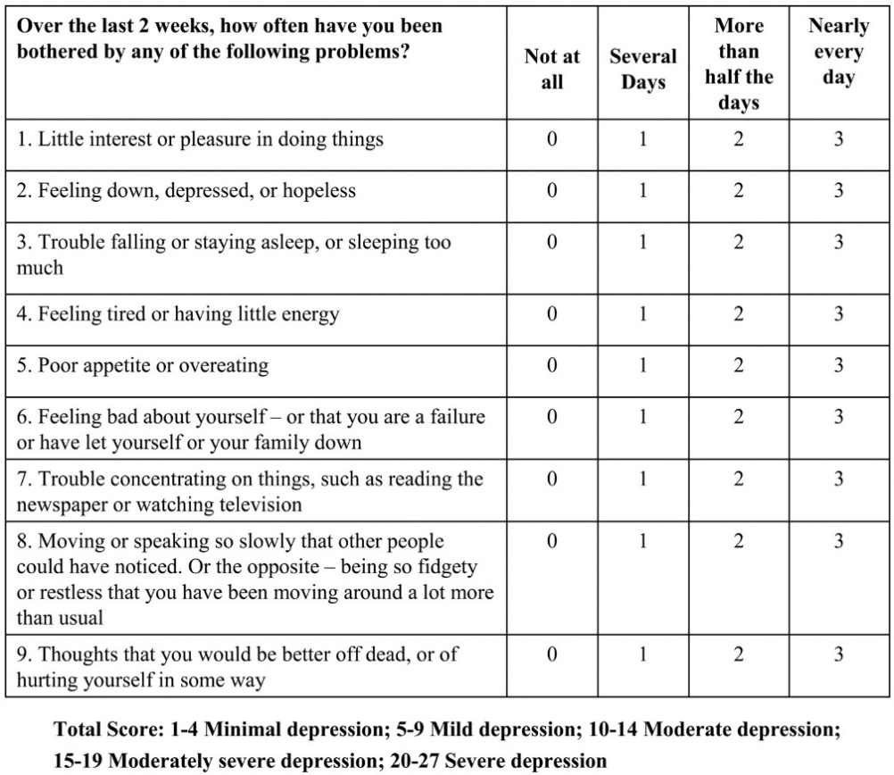
We will monitor these symptoms in our EmoSpaces system with following CVOs and VOs and provide them services accordingly.
Table 5 - Table 2: CVOs required to monitor Depression Symptoms
S# | Depression Symptoms | CVO | VO/Data Sources/Sensors
01 | Little Interest of pleasure in doing things | Monitor_User_Daily_Food_Consumption | VO_Refrigerator, VO_Acoustic _sensor, VO_motion_sensor, VO_Kitchen_gas_consumption, VO_kitchen_electric_consumption  Ref: https://goo.gl/dC1Qsq  https://goo.gl/BrfTGg
 |  | Monitor_USER_Daily_walking_steps | VO_Camera, VO_accelerometers, VO_gyroscopes  Ref: https://goo.gl/MTgbwZ
 |  | Monitor_User_daily_sleeping_Pattern | VO_Actigraph, VO_Non-wearable (Emfit QS, S+ by Resmed, Beddit 3.0 Smart Sleep Monitor, Sleepace Reston) Wearable (Fitbit charge 2, Jawbone Up3)  Ref: https://goo.gl/2vceZ8 , https://goo.gl/7x3SiS
 |  | Monitor_user_daily_Interaction_time_with_Family | VO_Smartphone, SNS
 |  | Monitor_user_daily_Interaction_time_with_friends | VO_Smartphone, SNS
02 | Feeling down, depressed or hopeless | Monitor_user_body_temperature | VO_LM35, VO_ Blood Glucose, VO_wrist
 |  | Monitor_User_Voice | Mic, smartphone,
 |  | Monitor_user_Facial_Expressions | VO_camera
03 | Feeling tired or having a little energy | Monitor_user_body_temperature | VO_LM35, VO_Blood VO_Glucose, VO_wrist
 |  | Monitor_User_Voice | VO_Mic, VO_smartphone,
 |  | Monitor_user_Facial_Expressions | VO_camera
04 | Poor appetite or overeating | Monitor_User_Daily_Food_Consumption | VO_Refrigerator, VO_Acoustic _sensor, VO_motion_sensor, VO_Kitchen_gas_consumption, VO_kitchen_electric_consumption  Ref: https://goo.gl/dC1Qsq  https://goo.gl/BrfTGg
05 | Feeling bad about yourself--or that you are a failure or have let yourself or your family down | Monitor_user_Facial_Expressions | VO_Camera1 , VO_ camera2 …
 |  | Monitor_user_posture | VO_Camera1, VO_ camera2 …
 |  | Monitor_user_voice_tone | VO_mic
06 | Moving or speaking so slowly that other people could have noticed? Or the opposite — being so fidgety or restless that you have been moving around a lot more than usual | Monitor_user_walking_speed | VO_Smartphone, VO_Accelerometer, VO_motion_sensor, VO_camera
 |  | Monitor_user_posture | VO_Camera1, VO_camera2

Complete List of CVOs & VOs & data sources for Monitoring depressive disorder

S# | CVO | VO/Data Sources/Sensors
01 | Monitor_User_Daily_Food_Consumption | VO_Refrigerator, VO_Acoustic_sensor, VO_motion_sensor, VO_Kitchen_gas_consumption, VO_kitchen_electric_consumption
02 | Monitor_USER_Daily_walking_steps | Camera, accelerometers, gyroscopes
03 | Monitor_User_daily_sleeping_Pattern | VO_Actigraph, VO_Non-wearable (Emfit QS, S+ by Resmed, VO_Beddit 3.0 Smart Sleep Monitor, Sleepace Reston) Wearable (Fitbit charge 2, Jawbone Up3)
04 | Monitor_user_daily_Interaction_time_within_Family | VO_Smartphone, SNS
05 | Monitor_user_daily_Interaction_time_with_people_out_of_Family | VO_Smartphone, SNS
06 | Monitor_user_body_temperature | VO_LM35, VO_Blood Glucose, VO_wrist
07 | Monitor_User_Voice | VO_Mic, VO_smartphone,
08 | Monitor_user_Facial_Expressions | VO_Camera1 …. VO_Camera2
09 | Monitor_user_posture | VO_Camera1 …. VO_Camera2
10 | Monitor_user_voice_tone | VO_Mic , VO_acoustic sensor
11 | Monitor_user_walking_speed | VO_Smartphone, VO_Accelerometer, VO_motion_sensor, VO_camera

Ontology Model to Monitor Depressive Disorder
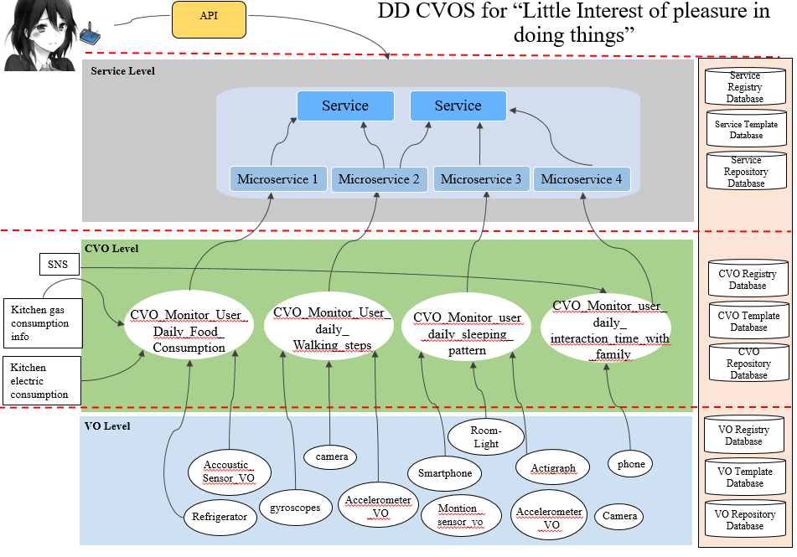
Figure 28 - Ontlogy model
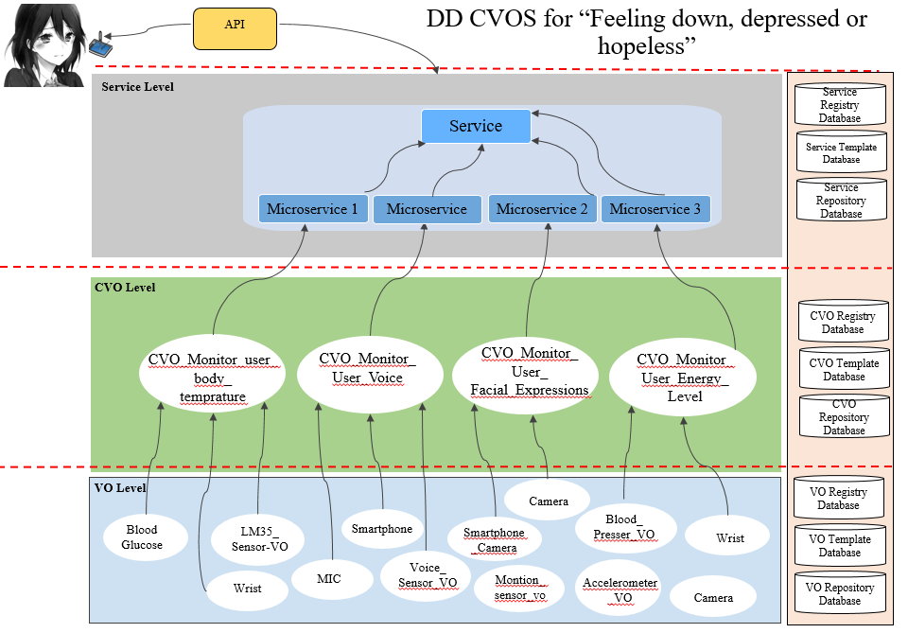
Figure 29 - Ontology model

Services for Depressive Disorder
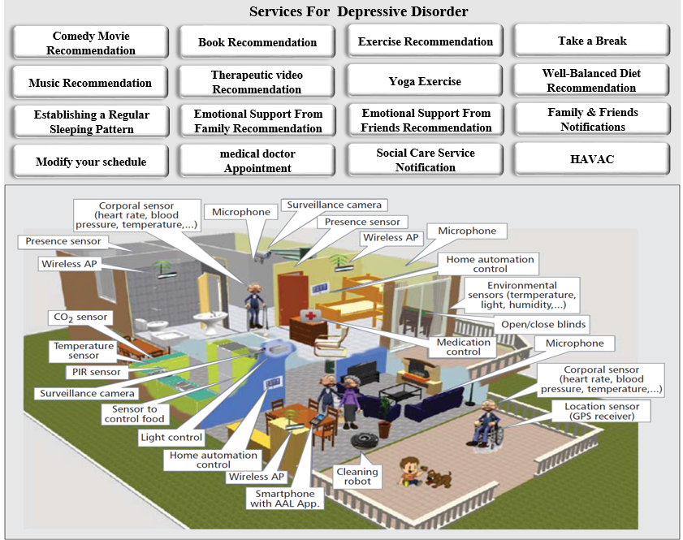
Figure 30 - depict the scenario of services of depressive disorder

References:
- https://www.nimh.nih.gov/health/topics/depression/index.shtml?utm_source=BrainLine.orgutm_medium=Twitter
- www.huffingtonpost.com/arshya-vahabzadeh/can-machine-learning-decode-depression_b_9283828.html
- http://www.valleybehavioral.com/depression/signs-symptoms-causes
https://www.beyondblue.org.au/the-facts/depression/signs-and-symptoms

EmoService B – Sound optimisation for wellbeing
The second domain application for the EmoSpaces project is focused on sound. Our goal in EmoService B is to enhance the perception of sounds by the End-user when he/she is at home listening to music on the HiFi or listening to the radio, or watching television, or on the phone, or with a tablet or using any device that generates sounds.
We address 3 types of sound optimizations:
- Optimization of the sound rendering of the sound source (the device that generates sound), such as radio, television, mobile phone, tablet and HiFi loudspeakers.
- Optimization depending on the content: speech/ music, energetic/calm, rich/light…
- Optimization depending on the preferences and the audition capacity of the listener
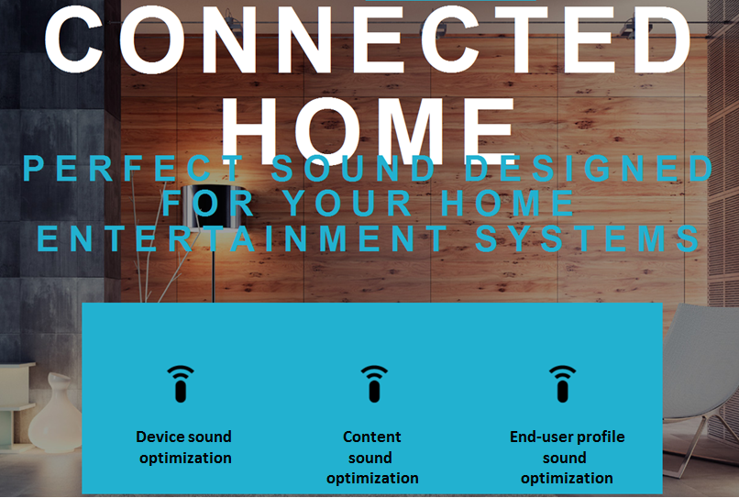
Figure 31 – Arkamys Sound rendering features
We will pay special attention to find out how emotions of the listener can be used as inputs to steer these sound optimizations. For example, which rule to implement in the player in order to pick up relevant sound tracks in a playlist depending on the listener emotions?
In this project, we consider sound perception in the context of the connected home, and we take into account specific constraints in relation to this context, such as the number of listeners in a room, or the movement of listeners from one room to another.
However, the technologies we intend to develop here can find applications in other contexts. Listening to the radio or mp3 in a car is a good example. The three types of optimizations we propose to develop (optimization depending on the device, the content, and the user) are totally pertinent in this specific context, but the acoustic constraints are very different in a car cabin, such as size of the listening area, type and location of the loudspeakers, and reverberation. The application for the automotive market is out of scope of the present project.

End-users and stakeholders description
We do not target any specific population. On the contrary, the sound rendering optimizations address everyone in a house.
From the B2B point of view, the first stakeholders are the device manufacturers who are likely to implement the technologies in their gears, such as TV, radio, tablets, smartphones, HiFi amplifiers.
The semiconductor manufacturers represent another group of stakeholders. The components that run the audio algorithms come with a number of constraints, mainly due to memory and processing power limitations. These constraints of implementation must be taken into account in order to be able to bring real products on the market.
From the evaluation point of view, the first stakeholders are our sound experts who will tune the different algorithms and assess the audio rendering with the tools and methodology they use every day for our different products. This will provide the “judgement” of the expert. This assessment will be challenged (and hopefully confirmed) by a team made up of non-audio experts taken among the partners of the project.

User groups
The optimizations of sound perception to be developed in the project are not limited to any specific user group: they work for all.
This means that the benefits of the technologies must be evaluated by a user group representative of the whole population, as far as possible.
However, optimization depending on the audition capacity of the listener is of great interest especially for seniors who face hearing loss with age, naturally.
The EmoSpaces project will benefit from the results of a previous project (the Feder project named “SYTIS”), which was dedicated to hearing impaired people when they are using their smartphone for a call. The corpus of users was made up of people with normal hearing (half of the corpus) and people with hearing loss (second half), from mild to severe hearing impairment, wearing or not wearing hearing aids. The benefit of the optimization was measured in terms of gain of intelligibility. The results have been analysed according to the degree of hearing impairment. The benefit has been demonstrated for 90% of the subjects, weather with normal hearing or with hearing loss: it works for all.
In the present project, we will not address any specific population.

Context of use
We are focused on listening conditions at home. We will consider specificities of listening over headset or loudspeakers.

Landscape of existing applications

Multi-room audio systems
With the appearance of numerous portable speakers and the multiplication of online music services, the multi-room audio systems have recently become a very seductive solution. In this context, the multi-room service is the ideal solution to broadcast the music around the home (Figure 15).
Multi-room audio: is the ability to listen to music in several rooms. Depending on the system you choose, you will be able to play different music in different rooms at the same time, or the same music in all rooms, or just a couple simultaneously.
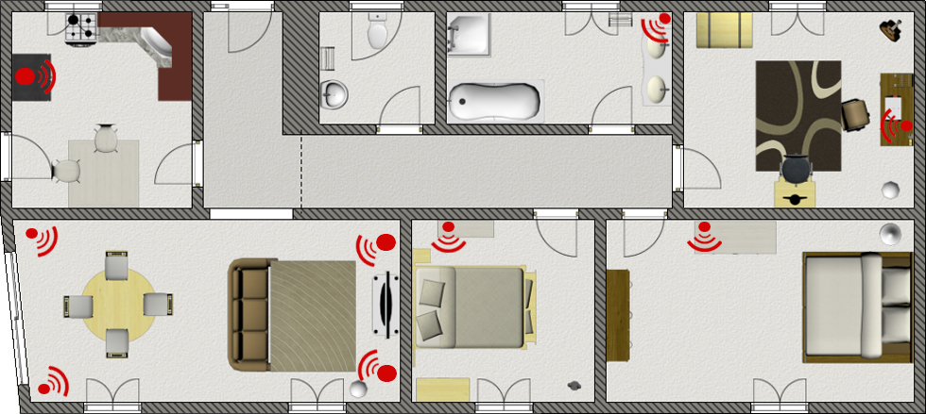
Figure 32 – Multi-room audio: ability to listen to music in several rooms

Existing multi-room audio systems consist of three modules (Figure 13):
- Music sources (computer, tablet computer, smart phone, computer data storage, NAS, Internet-based music streaming service, …)
- Centralized audio control centre (smart device)
- Audio devices (loudspeakers: hi-fi system, television, speaker portable…)
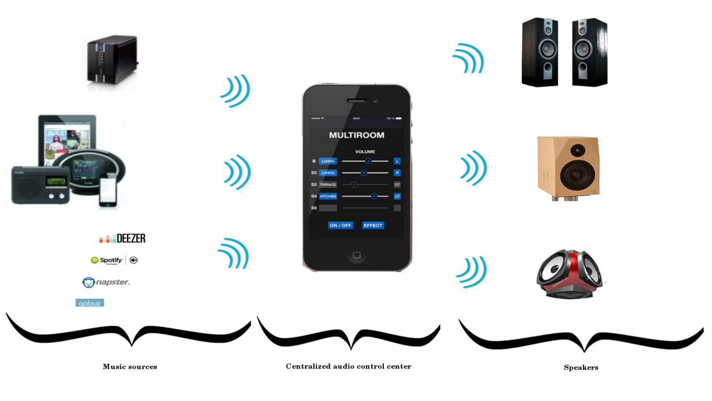
Figure 33 – Multi-room audio system and its three modules: music sources, control centre, speakers.
The centralized audio control centre is connected to other modules via different wireless protocols such as Bluetooth, NFC, Wi-Fi, 3G, and is responsible for providing the interface between the music sources and the loudspeakers.
There are currently many multi-room audio systems on the market. Each solution offers their own device (speaker portable) and their own application in order to manage the different services. For example, Sonos is one of the biggest and most well-known players in the multi-room audio market (Figure 14). The Sonos system uses a Wi-Fi mesh network rather than Bluetooth, making its own platform.

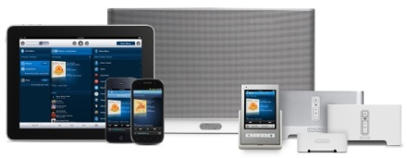
Figure 34 – Sonos’ multi-room audio system.
Some examples of different multi-room audio services are listed below (Figure 19). These applications are very similar and use the same wireless protocols. The differences are their own speakers (e.g. ergonomic, size, portable, sound quality) and their application IHM (friendly and easy to use, for example HEOS DENON’s application – Figure 15).
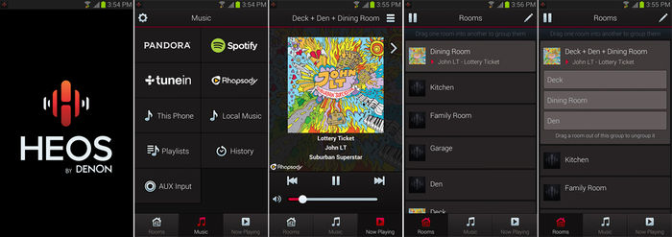
Figure 35 – HEOS Audio Control application by DENON.

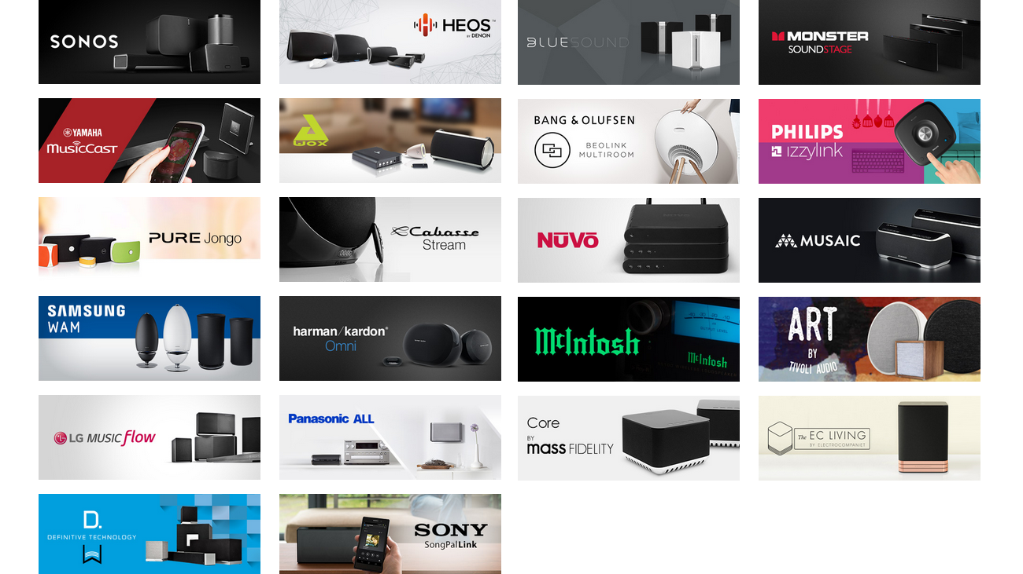
Figure 36 – Some concurrent solutions on multi-room audio market.
The advantages of these multi room audio systems are:
- Ease of installation with small portable speakers;
- Ease of use;
- Scalable system: we can start to equip one or two rooms, then to extend on other room.
The limits are as follows:
- System highly dependent on quality signal (Wi-Fi , Bluetooth…);
- “Closed system”. Each element must be from the same brand;
- No Artificial Intelligence: each action (e.g. change music, volume control, start device) must be achieved by an human.

Intelligent music player
Since a few years, thanks to new technologies (cloud, support device, audio coding format), users have access to large databases of music. So users need better and easier applications to manage these large databases. In this context, most applications suggest creating several playlists. Users can create playlist, or more recently, these applications can create playlists based of the musical genre or the musical mood (more details in the next paragraph 5.3.3). The current trend shows that music market participants would like to add more and more artificial intelligence to their music player. Two examples of intelligent music players are described below:
- Prizm, the music brain
- Cone aether, the learning speaker

PRIZM: the music brain
The music brain PRIZM is a new intelligent device. The innovative technology based on machine learning algorithm detects:
- listening habits: Prizm learns listening habits from you: each time you interact with it. Prizm remembers your preferences, to play music you will love. For example, you listen to rock at 8pm during the week and listen to jazz at 8pm during the week-end. PRIZM learns your habits and plays rock on evenings during the week and jazz during the week-end.
- multi-user recognition: Prizm captures Wi-Fi and Bluetooth signals from smartphones to identify users in the room. Thanks to its algorithm, Prizm finds the most suitable songs to play. Fitness trackers (e.g. smart watch) are the next evolution.
- context awareness: In order to adapt the music, Prizm understands what is happening in the room using several parameters: time, day (week or week-end), sound level (e.g. a quiet evening or an evening with several friends)
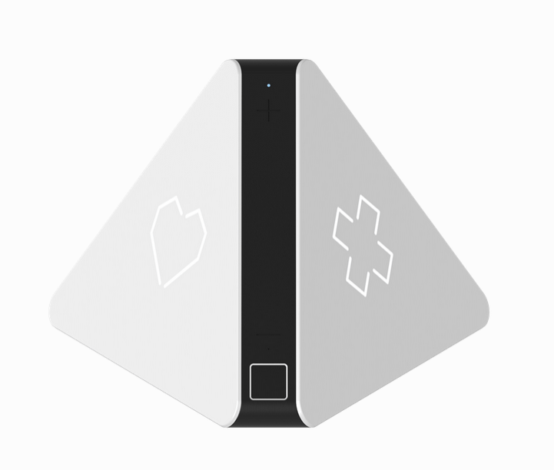
Figure 37 : Prizm – music brain

Cone aether - the learning speaker
A concurrent of PRIZM is the learning speaker Cone aether. This device is a small portable speaker which integrates a speech recognition module and a listening habits detector. This "intelligent" speaker records autonomously your favourite songs, the time and the place where you liked them, and suggests music content to you later on.
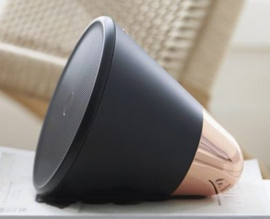
Figure 38 – Cone aether, the learning speaker.

Online music websites and offline application using mood analysis
Some examples of music player adapted to the mood follow below in the following order:
- JVC – Smart Music Control
- Mood player
- Musicovery
- Stereomood

JVC – Smart Music Control
JVC Smart Music Control (JSMC) is a free standalone music player application that can automatically create a music playlist in a unique way – such as by the “mood” that you are now in. And you can perform operations by either simple gesture control or by voice command.
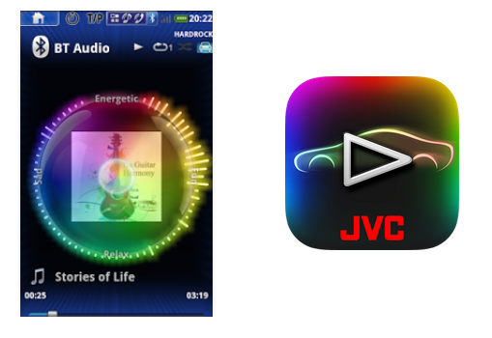
Figure 39 – JVC Smart Music Control application.

Mood player
This application uses face detection and mood recognition to determine the user’s mood and based on this, it returns a personalized play list. Or the user can set it manually, along with the energy level of the music you want to listen to. After the user set those, they need to click on "get playlist" to get a Youtube playlist which will hopefully match their mood.
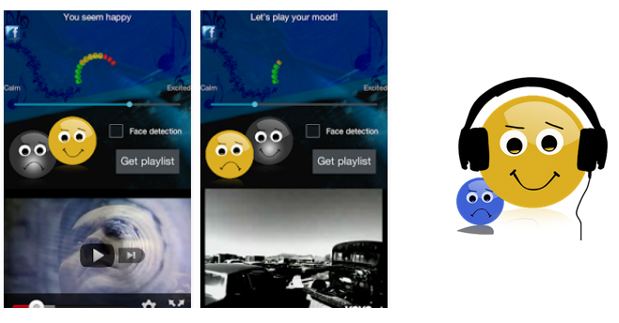
Figure 40 – Mood player application.

Musicovery
Musicovery is an online interactive radio player which plays songs according to the user’s mood and genre. It offers a personalized way to play songs. One can easily select one’s favorite artist and listen to one’s favorite songs. The tool displays search results in a visually attractive interface.
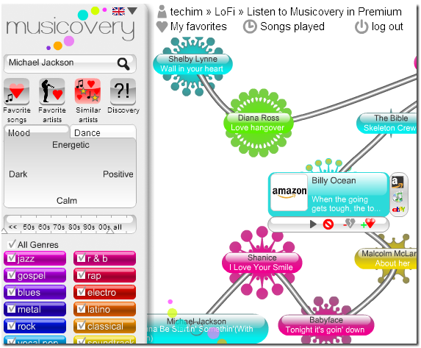
Figure 41 – Musicovery application.

Stereomood
In this tablet application, users have ready-made playlists. They can choose their mood from some tags, listen, discover new music, share and tag their emotions in music.
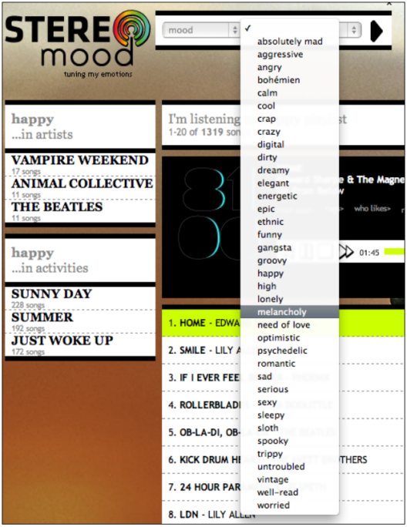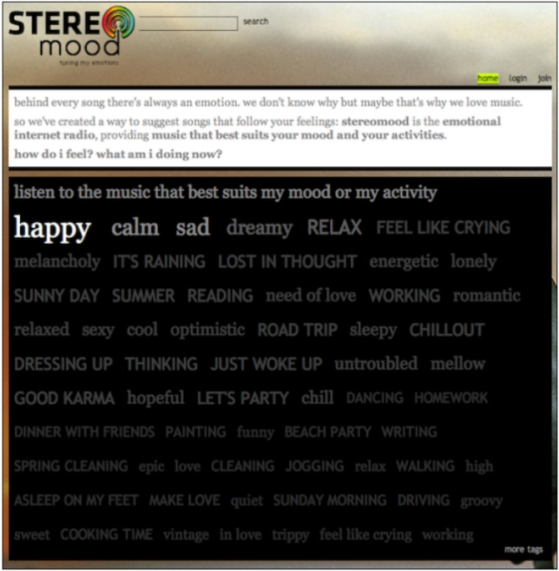
Figure 42 – Stereomood application.

Expected benefits to the End-user and innovation expectations

Innovation roadmap of Service B
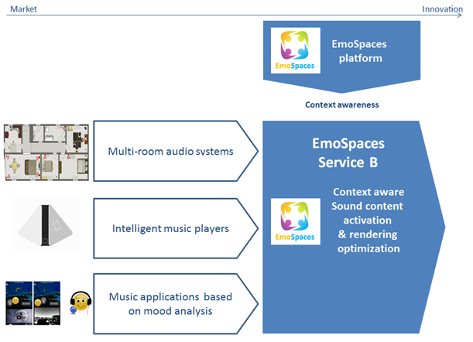

Innovation positioning of Service B versus existing technology
 | Features provided by  existing technologies | Targeted Innovation  of Service B
Multi room audio systems | Multi-room audio systems include music sources, centralized audio control center (smart device) and audio devices (loudspeakers: hi-fi system, television, speaker portable…) | The targeted innovation of Service B is to improve the multi room audio capabilities by automatically activate/deactivate the devices based on the user’s localization and activities.
Intelligent music players | Current intelligent music players such as Prizm learn listening habits, remember preferences, play music the user will love. These systems also include multi-user recognition and context awareness. | The targeted innovation is to improve the features provided by current intelligent music players by optimizing sound rendering based on localized user, device and content. The innovation also relies on the capability to localize, recognize and detect user activity without using the user smartphone or GPS tracker.
Music applications based on mood analysis | This technology provides the ability to select music based on the user’s mood. | The targeted innovation is to improve the existing features by selecting content and sound rendering based on user mood but also based on user activity.

The main benefit of optimizing the sound rendering of a device goes to the device manufacturer as it allows getting the best sound from a specific hardware set-up and it avoids buying more expensive hardware for the same audio quality.
When tuning options are provided through pre-settings or tuning functions, the user is able to customize the sound of the device according to his/her preferences, which is almost always considered as an advantage.
Optimization depending on the audition capacity of the listener is another step as it will enhance intelligibility during calls on the phone. In some cases, it will even allow people to communicate when it would be impossible for them to communicate otherwise.
Enhancement of the perception of the dialogs on a TV when watching a movie or listening to the news is another example of benefit we will provide. It avoids pumping up the volume when we do not understand clearly people talking. It saves our ears and limits disturbing the neighbours.
Optimization depending on the content is another way to offer customization of how we consume our multimedia contents. With several thousands of sound tracks at our disposal, it is out of the question to let the user optimize the tuning of each sound track manually. In the EmoSpaces project, we offer an automatic method, independent from the musical genre and based on the analysis of the audio signal. Moreover, we will study how our emotions can steer the way we enjoy our multimedia contents.

EmoSpaces Use cases and scenarios
Sound optimization for wellbeing will be realized by Arkamys within the EmoSpaces project through three main innovative technological features presented below:
Feature 1: Sound optimization based on the device
Audio rendering of the device such as TV, tablet and or smartphone (Android) will be optimized (tonal balance, dynamic, distorsion, automatic volume control). The optimization will be tuned by sound experts. The End-user has no control of this feature.
We will focus on two different devices currently used at home;
- Smartphone or tablet, listening over the speaker(s) of the device or with a headset
- Television
As the audio rendering is extremely dependant on the hardware quality and any audio signal processing embedded in the device. We will consider only one model of each type for the purpose of the demonstration.
Our sound optimization first compensates for potential acoustic defects of the device with frequency equalisation and dynamic range control.
Then, we propose sound enhancement features such as:
- Bass rendering enhancement (bass management without changing anything of the hardware setup)
- Ambiance to provide immersive and spatial effects (room effects, reverberation)
- Automatic Volume Control to normalize the perceived sound level when we are changing from one program to the other (television)
However, the location of the listener in the room can be used as an input to optimize the sound rendering at this very position when watching the television.
Automatic adaptation depending on noise variations in the room (open windows for example) is out of the scope of this project.
Feature 2: Sound rendering depending on the content
Clusters of music tracks with strong similarities will be created through signal analysis, independently from musical genre. One pre-setting per cluster will be tuned (ambiance = stereo widening + reverberation + bass enhancement). The optimization of each pre-setting will be tuned by sound experts. The End-user for this feature can activate or deactivate it.
We assume that the user has access to several thousands of sound tracks and we assume that the system also has access to these sound tracks to analyse their content. Then, the system is able to automatically create clusters of sound tracks that allude to the same mood (same “energy”, same “dynamic”, same “spectral density”, etc…), all this completely independently from the musical genre.
This is a way to generate coherent playlists and push coherent contents in the same mood, which can benefit from a specific audio processing to enhance the sound rendering specifically for this mood.
Furthermore, in the context of a connected home, we can propose different types of contents depending on the activity of the user.
Feature 3: Sound rendering depending on the End-user
Finally, we will consider emotion of the listener as a relevant input to drive the contents pushed by the system. The question of the rule(s) to apply will be addressed in a limited number of scenarios. Sound rendering depending on the user: sound rendering will be optimized according to user’s audition capacity (Optimisation = frequency + dynamic adjustment).
The first step consists in getting information from the user about his/her preferences and audition capacity. This will generate an individual audition profile, which will be transferred to the system.
The second step is the activation of sound optimisation of the listening device with the parameters of the profile. In the context of the connected home, this profile is automatically activated by the system which recognizes who is listening. When several people are listening together, a generic pre-setting can be activated.

Use case - Context aware sound optimization on home devices (B1)
Use case scenario B1.1 - Audio content and sound optimization following the user from one room to another
Step | Description
#1 | The End-user is listening to music in a room (e.g. the living room).
#2 | The End-user is localized by the EmoSpaces system.
#3 | The EmoSpaces system activates the closest device and optimizes sound rendering based on the device.
#4 | The End-user leaves the room and goes to another room (e.g. the kitchen)
#5 | The EmoSpaces system detects the movement and locates the user in the new room (e.g. the kitchen).
#6 | The EmoSpaces system automatically switches on the new (closest) listening device in the kitchen and streams content to this device with a device-specific sound optimization preset.
#7 | The EmoSpaces system switches off the device in the living room.
#8 | The EmoSpaces system controls smart transitions (fade in / fade out) between devices.
Use case scenario B1.2 – Push adapted audio content and optimize audio rendering based on End-user activity
Step | Description
#1 | The End-user is at home doing several indoor activities such as the following scenario example: he starts cooking then sits down at the table to have lunch or dinner.
#2 | The EmoSpaces system detects the End-users activities.
#3 | The EmoSpaces system automatically streams appropriate content to the listening device based on the detected activities.  Comment: a relation [activity <-> content] table has been previously initialized
#4 | When the End-user changes from one activity to another (smooth transition), the EmoSpaces system selects the closest device, push the most adapted audio content and optimize audio rendering.

Use case scenario B1.3 – Audio rendering adapted to device, content and End-users
Step | Description
#1 | Two people enter the living room and sit down on a sofa in front of the TV.
#2 | The EmoSpaces system:  - detects the two people and their activity;  - switches the TV on (closest device in front of the sofa);  - activates TV sound optimization pre-setting;  - displays merge of the two users playlists when choosing the movie to be watched;  - activates content optimization when the movie has been launched.
#2 | The program changes with the tablet (music news).
#3 | The EmoSpaces system controls volume changes (Automatic Volume Control) and activates new pre-settings to optimize speech intelligibility.
#4 | One person leaves the room, the other stays on the sofa.
#5 | The EmoSpaces system detects that one of the end-users is alone and activates his/her individual audio profile.
#6 | The EmoSpaces system detects the emotion of the end-user and validates or not the content and selection (feedback loop).

Use case - Context aware sound optimization on wearable devices (B2)
In this use case, the listening device is an android tablet or smartphone.
The measurement of the audition capacity of the user is processed once for each potential user in order to generate his/her user profile.
The profile is measured while listening over high-quality headphones. The profile is independent from the listening device.
The objective is to provide the End-user with a better listening experience on handled device, which can be used at home and outdoor and validate the user profile generation process.
Use case scenario B2.1 – Watching movie on a wearable device
Step | Description
#1 | The EmoSpaces system recognizes the End-user.
#2 | The EmoSpaces system launches the audition profile app: generation of pure tone at different levels, listening over headphone. The user is asked if he/she hears or not the sound.
#3 | The EmoSpaces system generates the audition profile of the user.
#4 | When watching the moving, the EmoSpaces system:  - activates device optimization preset depending on listening (speaker or headset);  - activates the user profile optimization.
#5 | The EmoSpaces system detects the End-user emotion and:  - proposes appropriate content from the user-playlist;  - [emotion content] table has been previously initialized;  - activates sound optimization depending on this content.

EmoService C – E-Learning

Description
The Emospaces project will carry out a smart modelling of the space that surrounds a user to be able to offer a service that adapts to each user. To achieve this, the implementation of the Aml concept is needed. The study of the environment is divided into two areas, wherein the project aims to make an influence: the virtual and the physical space. The virtual space requires a longer development time, since it is easier to monitor application usage due to the creators’ interest in improving the application and its business opportunities. For the case of the physical space, the technologies previously described in the document will be applied to a greater or a lesser extent, according to the needs of each use case.

End-users and stakeholders description
Enterprises play a fundamental role in the growth of the e-Learning paradigm, since the number of them that are opting for this type of learning is growing. Over 41% of the Fortune 500 corporations are employing some form of e-Learning on their workers. On the other hand, a survey conducted by Ambien Insight concluded that e-Learning has increased revenue in 42% of the companies [1]. Thus, all companies that offer training to their employees would be big clients for EmoSpaces, since the project is offering not only a flexible and interactive education, but one that is customized and based on the workers’ emotions, which can also mean a performance improvement.
In Spain, the culture of “Continuous Training” as an integral part of enterprise politics and strategy is implemented in 80% of the companies. For this reason, there are many companies that stand out for the training they offer to their workers. These are the ones that can be clients for EmoSpaces, since being able to offer personalized content is and added and differentiating value. These companies invest large amounts of money to improve the mentioned training, which could mean that they are interested in introducing a new training modality as the one offered by the present project.
Below, the main potential clients for EmoSpaces, taking into account the training programs they are currently offering:

Telefónica | Telefonica Group invest a large fraction of their capital in developing and implementing e-learning in their platform.
Unión FENOSA | Education is conducted by the Union Fenosa “Corporate University”.
Telefónica Móviles | They employ e-learning techniques and they are characterized by an education oriented to providing fast answers for very concrete needs.
Banco Santander | Santander Bank opt for online education via the Form@via virtual channel.
IBM | In IBM, education is based on on-site training or online training, depending on the courses content.
Caixa Galicia | Through the ITE (Enterprise Technological Institute), Caixa Galicia manages a large fraction of training programs intended for their workers.
Siemens | Through the e-people portal, Siemens offers custom training for each worker.
Asociación Nacional de Centros de e-Learning y Distancia (ANCED) | ANCED can be a large client for EmoSpaces, since is the main national organization to integrate the most important private centers for e-learning and online education. They aim at representing, managing and defending their associates’ interests, as well as fostering and developing online training and e-learning, both for business and individuals.

On the other hand, education centers would be another key client for Emospaces, since the number of centers that offer courses, masters and university degrees have grown in the last years. Choosing this modality of education can solve many of the problems that the education is suffering lately. Thus, EmoSpaces represents a big chance for education centers to develop new markets and increase their profitability, since more and more students demand a customized and flexible education. Furthermore, in Spain this type of education is trending: there are already around 1300 high schools and universities that use the Moodle tool (virtual learning environment tool) [7]. Below, some of the education centers that opted for this modality and that would be potential EmoSpaces clients are shown:
Universidad de Málaga | Universidad Politécnica de Madrid
Universidad de Las Palmas de Gran Canaria | Universidad Politécnica de Cataluña
Universidad de Cádiz | Universidad Rey Juan Carlos
Universidad de Extremadura | Universidad Carlos III

EmoSpaces can also provide pedagogic tools for students with learning difficulties or some kind of disorder. For this reason, the platform can also be commercialized as a complementary therapy. For instance, children with autism could be a potential group, since it has been demonstrated that these children show interest and have special abilities to interact with computers or other electronic devices. Thus, emotions-based learning will be specially adequate for this type of patient. To reach these users, EmoSpaces can be commercialized through research centers and associations, or directly through the end users: the patients.
The main Spanish associations for autism have been identified, with the goal of introducing EmoSpaces to them, as a complementary therapy for their patients:
Confederación Autismo España | http://www.autismo.org.es/
Confederación Española de Autismo (FESPAU) | http://www.fespau.es/somos-fespau.html
Asociación Española de Profesionales del Autismo (AETAPI) | http://aetapi.org/
ALEPH-TEA | http://www.aleph-tea.org/
Asociación de padres de personas con autismo (APNA) | http://www.apna.es/

Customer characteristics

This use case aims at finding a tool that is able to analyze the users’ emotions in smart spaces, and to adapt those spaces to improve the user experience. To this effect, EmoSpaces will combine physical and social sensors, in which users frequently show their emotions.
Generally, the main characteristics that the e-learning use case must have are:
- Dynamic adaptation to the student level. Students demand a studying program, designed to satisfy their specific needs.
- Attractive content. This new education modality has to be applied in a creative way, to create a thrilling and motivating experience for the student.
- Granularity. Students demand segmented content, to ease the assimilation of new knowledge.
- Interactivity. Users need to interact frequently to maintain their focus and improve the learning process.
With these elements, the resulting product will be an LMS that is able to help with the learning by showing information to the teacher that the student has assigned, or by direct system actions based on usage parameters, attitude, etc, about the student’s physical environment. These two options are able to alter the student’s state, trying to draw their attention, availability and implication in each task performed in the LMS.

The challenges they face

The main challenges that the project will face are:
- Improve motivation and student’s implication
- Be able to provide the teacher with more accurate feedback about their students, enabling them to act accordingly.
- Detect problems in the teaching methodologies based on the students’ behavior.

How your proposed product will help solve these challenges

Implementing EmoSpaces with this license will allow the user to benefit from the following services:
- User modelling: creation of a profile of the students that participate in the offered courses, so that the experience can adapt to the users, instead of all the way around.
- Modelling of both physical and virtual space, by establishing a context environment using technologies that the users of the platform normally utilize.
- Interaction system and evolution of the platform subject to users’ emotional responses. Adaptability and creation of recommendations, tailored to the user needs, with the goal of motivating them and offer a more fluid and attractive experience.
- First-hand feedback from the students, obtained through different sources that are useful for enriching the content of the courses and the way of imparting the lectures.
- Creation of a dashboard, available for teachers of the platform manager, to allow the modification of the platform systems with the goal of reinforcing and influencing in the user’s attitude.
To that effect, the platform will gather data from:
- Behavioral patterns, preferences and surveys.
- Relationships with teachers or other students.
- Time spend in the platform, and the contents that the student is consulting.
- Geolocalization of the user.
- The courses that are being taken and their performance.
- A social network in which it is possible to communicate with users or with the teacher.
- Emotional state of the individual, captured by the camera integrated in the user’s device.
- User’s heart rate and weather conditions of the environment.

Landscape of existing applications

Competing products and their advantages and disadvantages.

FaceReader
FaceReader is an automatic software for facial expressions in which new events can be added, such as the beginning of an ad or a distraction, to evaluate their impact on the user. This software is able to detect the following emotions: neutrality, boredom, interest and confusion [9].
Facial expressions analysis can be obtained from an image or video, in which a number of frames can be selected to increase the analysis speed. Besides, it is possible to add marks to the interesting events to compare the obtained results, for example, to compare the impact of an ad campaign between men and women. On the other hand, FaceReader can export the gathered data to other programs.
FaceReader works in the following environments:
- Psychology: it studies how people respond to a specific stimulus.
- Education: it analyzes the students’ facial expressions to improve the development of educational tools.
- Human-Machine interaction: the facial expressions can generate information that can be used to evaluate the user experience.
- Marketing: it can analyze how people respond to commercial ads.
- Consumer’s behavior it is able to evaluate how the participants react to a certain stimulus.
The service cost is based on a credit system. The cost of said credits is calculated by the minute. The following table shows the cost of each credit:
License Type | Credits | Price
Single project | > 100 credits | 2.50 €/min
 | > 250 credits | 2.40 €/min
Frequent user | > 500 credits | 2.20 €/min
 | > 1000 credits | 1.80 €/min
Agency/Reseller | > 5000 credits | 1.40 €/min
 | > 10000 credits | 1.00 €/min

Emotion API

Emotion API is an application developed by Microsoft that is able to detect the users’ emotions, both from an image and from a video. The detected emotions are rage, contempt, loath, fear, happiness, neutrality and surprise [10].
LEVEL | CHARACTERISTICS | PRICE
Emotion API: Free | 30.000 free image transactions per month  300 video loads (limited to 1 per minute)  3.000 status request per month (limited to 1 per minute) | Free
Emotion API: Basic | 10 image transactions per second  (the face must be previously specified) | 0,085€ for 1.000 transactions
Emotion API: Standard | 10 image transactions per second  3.000 video loads (limited to 2 per minute)  30.000 status request per month (limited to 10 per minute) | 0,211€ for 1.000 transactions

iMotions

iMotions is a company dedicated to the development of high-tech software, specialized in Eye Tracking and biometrical solutions. The biometric investigation platform helps its clients to conduct investigations about human behavior in the areas of Marketing, Psychology, Neuroscience, Education and Health. The iMotions software has several sensors, wich can be integrated with the facial expressions recognizer, EEG, EMG, ECG and Eye Tracking.
Regarding expressions recogntions, it is able to detect seven emotions (joy, anger, surprise, fear, contempt, sadness and loath) and the head orientation. For that, it uses 33 facial reference points [3].

Comparative

The following table shows a comparative analysis of EmoSpaces vs. the different tools considered in the competence analysis.
COMPETENCE | Expressions recognition through facial analysis | Expressions recognition through voice analysis | Expressions recognition through social networks | Behavioral patterns creation | Improves and develops educational tools | Consumer behavior analysis | Works in a tourist environment
FaceReader
iMotions
EmoSpace

Expected benefits to the End-users and innovation expectations
The main benefits that the project will face are:
• Motivation is Improved and student’s implication, and control about their courses
• Teachers are benefits with more accurate feedback about their students, enabling them to act accordingly.
• Teachers detect problems about methodologies based on the students’ behaviour and problems about emotions with students

EmoSpaces use cases and scenarios

Use case – E-learning (C1)
Use case scenario C1.1 – Virtual space
The definition of the virtual space of the educational platform stems from the user’s browsing habits. Data related to their patterns and preferences are obtained through the interactions of the user with the network (opinions in social networks, text analysis, emotions…). The LMS application, generated during the EmoSpaces project, will itself be able to monitor the user’s experience while using the platform.
The information gathered from the different sources will be used, in this case, to adapt the virtual space by modifying the visualization, or even the content, of the courses. These changes, be it automatic or manual (dashboard), will influence the user’s experience while using the application, with the goal of focalizing said experience in maximizing the performance during the learning process.

Use case scenario C1.2 - Physical space
The physical space is defined as the environment from which a user gets online, and that surrounds them while navigating the application. The inclusion of the Aml technology will enable the modelling of the scenario, to obtain the information required for making decisions related to the creation of an adequate studying environment. Due to the current development status of the Aml, directly influencing the physical environment is not yet possible, although recommendations can be given. It will be up to the student whether to apply them or not
One of the main advantages of the Aml, that can be exploited by the EmoSpaces project is the localization in indoor environments. The monitoring of device usage, together with the technology based on persons profiling, allows to locate users more precisely indoors, which is an area that currently is not being heavily explored.

EmoService D – E-Retail

Description
The EmoSpaces project will model the intelligent space around users to offer services adapted to each type of Retail company; in other words, it will be a sufficiently broad and adaptive environment for Retail companies to have a content manager and an analysis of what is happening in their stores in real time.The software can be installed locally or in the cloud; or mixed, we can have one physical and one virtual space. The virtual environment has a major development, because it must have online and bidirectional access with the updating of all data in real time, plus a good internet connection so that access to information does not fail. The physical environment part is related to the necessary hardware (cameras and information processing machines, as well as installation and wiring).

End-users and stakeholders description
In EMOSPACES, the user is placed as the centre of the design, with the rest of the elements acting around him. The main entities in this model are the following:
- User: Refers to the people who will use this service. Within the scope of Retail, the users will be the customers within the different sales sectors. There are verticals within the same line, food, consumer, automotive, fashion, shopping centers, etc.
- Actor: Are those elements, whether people or mechanisms, that are capable of executing services. The user in this case can be the same if the data analyst belongs to the decision-making people within the contracting company of the service.
- Service: Any activity that the system is able to offer to the users/customers to satisfy the contracted needs. The main services identified in the system are:
  - Monitoring: With the aim of extracting information about the real environment and customers of the stores or sales areas. Monitoring serves as a point-of-sale analysis.
    - User monitoring: Information on the status of the users is obtained thanks to the video camera that detects the user's emotions and the empathic bracelet that collects the biometric data.
    - Monitoring of the environment, data are obtained from:
      - Basic emotions
      - Secondary and tertiary emotions
      - Emotional metrics
      - Gender
      - Age

Landscape of existing applications
Nowadays, several companies offer face recognition products and services, some of them including emotion recognition. The following table shows the main features of the main face recognition services on the market (source: https://www.kairos.com/blog/face-recognition-kairos-vs-microsoft-vs-google-vs-amazon-vs-opencv )
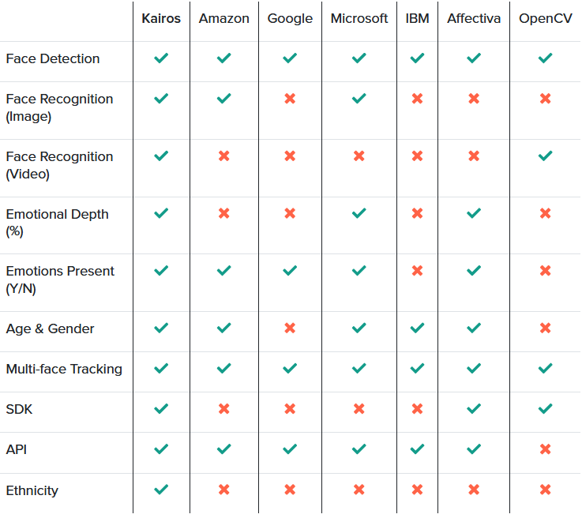
Figure 43 – EmoService D: Face recognition applications
Regarding emotion recognition, these are their main functionalities:
- Kairos includes video analysis for emotion detection (joy, surprise, sadness, fear, anger, and disgust) via their proprietary face analysis and machine learning algorithms.
- Google offers emotion classifiers (likelihood of joy, sorrow, anger, and surprise), however, without video analysis.
- Microsoft analyses videos to classify emotions (anger, contempt, disgust, fear, happiness, neutral, sadness, surprise). They also provide an emotion API.
- Affectiva analyses videos to detect emotions and facial expressions, from an extensive library of labelede emotion training data.
It should be noted that a number of players have been taken out of the market in recent years, with many having been shut down as part of the purchase terms. It speaks to the explosion in demand for face analysis, and its importance to business strategy. For instance : Emotient (Apple), Face.com (Facebook), Faciometrics (Facebook), FaceFirst (Apple), Orbeus (Amazon), Polar Rose (Apple), Looksery (Snapchat), Itseez (Intel), Msqrd (Facebook), Viewdle (Google), PittPatt (Google), Alchemy (IBM), RealFace (Facebook), AIMatter (Google), Regaind (Apple), IMRSV (Kairos).

Expected benefits to the End-users and innovation expectations
The EmoSpaces project will model the intelligent space around the user in order to offer a service adapted to each type of Retail company; in other words, it will be a sufficiently broad and adaptive environment for Retail companies to have a content manager and an analysis of what is happening in their stores in real time.
The platform will collect information about the emotions of the users, the basic emotions, as well as the secondary and tertiary emotions, which will provide us with information about the behaviour of the users of the real environment.
In order to understand more easily what happens in the stores and how customers react to the products displayed in them, a control panel will be provided. This panel will display, unified, all the data under monitoring.
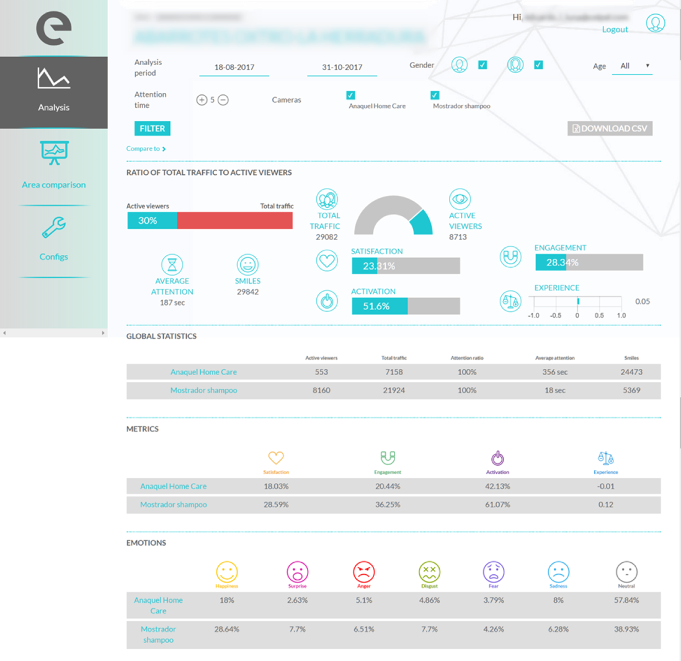
Figure 44 EmoService D: Dashboard
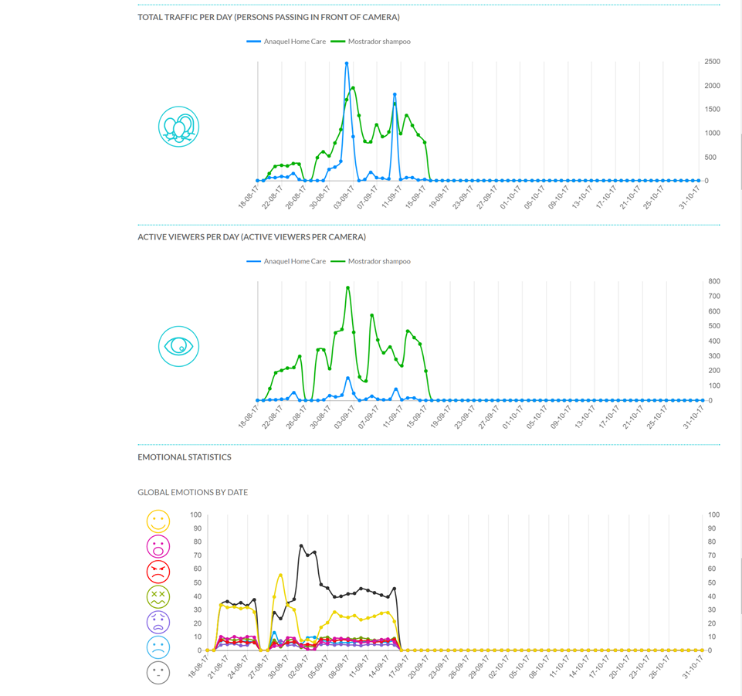
Figure 45 EmoService D: Emotions evolution on time

EmoSpaces use cases and scenarios

Use case – E-Retail (D1)
Nowadays it is not enough to give a good value for money, now brands have to provide added value, because experience is what really makes consumers have a memory and that we buy again, thereby increasing the conversion ratio and thus sales and profits that they ultimately want and long for. Hence the whole fan phenomenon, now not enough of a buyer, now it is necessary to recommend, refer and repeat the purchase, that is the real fan. And how can we better measure these behaviors?
The emotions help us to be able to predict the behaviour of the consumers, they help us to be able to improve the decision making. When we really know how a consumer has behaved when faced with a product, stimulus or packaging we will really know if this customer will buy again, we can measure the call to action and thus improve the reliability of sales prediction.
Use case scenario D1.1 – Physical stores
Physical stores must innovate in the monitoring of the consumer at the point of sale, proposing products that meet the wishes of their customers. A tablet in the grocery checkout can scan the products that the person has chosen to buy and suggest the accessories to suit the emotions that the consumer's face registers at the time. This system allows, in a product survey, to know if the tester's answers correspond to reality or not.
Steps | Description
#1 | The End-user goes to grocery checkout to pay.
#2 | A tablet in the grocery checkout scan the products that the End-user has chosen to buy.
#3 | The EmoSpaces system suggests some other products to suit the emotions that the consumer’s face registers with each suggestion.
#4 | The End-user can buy something that he or she did not take into account in his or her initial planning.

Use case scenario D1.2 – Ecommerce
Ecommerce stores have the opportunity to analyze online the emotions of the consumer of online sales who plays at trying on sets of clothes on a virtual mannequin and the computer's webcam analyzes their emotions to suggest sets based on their emotional preferences. The ecommerce visitors can select the garments to form sets through a filter and the model is displayed with the chosen garment. The system requests camera permissions in exchange for discount promotions and suggests garments based on the emotions generated by the selected sets. On a technical level, ecommerce would be integrated with Emotion Research Lab software to measure consumer emotions in real time. All the information gathered is stored in a server with immediate online access for the brand, with the aim of monitoring the emotions produced by the different products.
Steps | Description
#1 | The End-user is surfing the web looking for clothes.
#2 | The End-user selects a set of clothes to try on the virtual mannequin.
#3 | The system suggests new sets based on the emotions of the end user's face.
#4 | The End-user may discover combinations of clothing that she/he had not originally thought of.

Use case scenario D1.3 – Showcases
Showcases are the "call to action" of physical stores. Two-way communication involves the consumer in an unforgettable experience. The technology now allows the showcase to scan the color of the person's clothing and project mannequins with products that complement the look of the consumer passing in front of the display case. The digital screens with integrated camera project models that feature sets based on the color of the clothing of the person paying attention to the screen. These sets change in real time according to the emotions obtained according to the proposed set, feeding back in the same direction if the emotion is positive or proposing a change if the emotion is negative. On a technical level, the screen would be integrated with the software to measure the emotions of the consumer in real time as well as recording the color of the clothes programmed to propose products available inside the store. All the information gathered is stored in a server with immediate online access for the brand, with the aim of monitoring the emotions produced by the different products.
Steps | Description
#1 | The user walks past a shop window.
#2 | The system recognizes the color of the user's clothing and proposes products that complement the user's appearance and that are displayed on a mannequin.
#3 | The suggestions change according to the emotions obtained from the user's face.
#4 | The user can get to know new shops from which to purchase accessories for her/him.

Possible interplay between EmoServices
In addition to the two distinct services described above, there is a possible interaction between those two services. Considering sound rendering as a mean to enhance coaching and well-being of people, one can imagine a situation where if the concerned person looks downcast, an air of music that this person appreciates can be automatically played by a music player. The sound level is then tuned so as to be perceptible by the person of interest without being too intrusive to the point of being disturbing. Coaching in this case is "active" since it involves automatic direct intervention for the wellbeing of the person, unlike the case where coaching can be considered as "passive" (the case where advices are proposed to a person who has to carry out these advices).

Synthesis table of use cases scenarios
The table below synthetises the use cases and use case scenarios which are described in the present document and which will be the basis for the further work steps of the EmoSpaces project.
Summary of the use cases and scenarios.
EmoService | Use case | Use case scenario
Service A  Wellbeing coaching | A1 - Lifestyle coaching to control weight | A1.1 | Monitor engagement in doing physical activities
 |  | A1.2 | Monitor engagement in respecting regular diet
 | A2 - Coaching by detection of abnormal behaviors | A2.1 | Coaching by detection of prolonged periods of time at home
 |  | A2.2 | Coaching by detection of non-regular engagement in social life
 | A3 - Coaching in critical situations | A3.1 | Fall detection
Service B  Sound optimization | B1 – Context aware sound optimization on home devices | B1.1 | Audio content and sound optimization following the user from one room to another
 |  | B1.2 | Push adapted audio content and optimize audio rendering based on End-user activity
 |  | B1.3 | Audio rendering adapted to device, content and End-users
 | B2 – Context aware sound optimization on wearable device | B2.1 | Watching movie on a wearable device (e.g tablet)

http://nordicapis.com/20-emotion-recognition-apis-that-will-leave-you-impressed-and-concerned/
https://en.wikipedia.org/wiki/Diabetes_mellitus_type_2
http://www.healthline.com/health/diabetes/top-iphone-android-apps
This illustration is given as an example and does not specifically describe the final implementations of Emospaces.
http://www.autism-society.org/what-is/facts-and-statistics/
http://www.autismeurope.org/about-autism/prevalence-rate-of-autism/
https://www.cdc.gov/ncbddd/birthdefects/downsyndrome/data.html
https://www.cdc.gov/ncbddd/cp/data.html
https://www.alzheimers.net/resources/alzheimers-statistics/
http://www.astrade.es/index.php/nosotros
http://www.plenainclusionmurcia.org/

