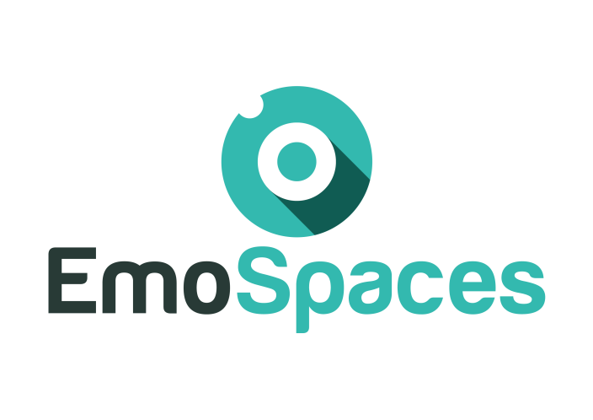

**Enhanced Affective Wellbeing based on Emotion Technologies for adapting IoT spaces**

**D7.3 Final report**

|  |  |  |
| --- | --- | --- |
| **Consortium:** | **ITEA3** | |
| **Deliverable ID:** | **D7.3** | |
| **Work package/Task:** | |
| **Responsible partner:** | **Thales** | |
| **Contributing partner(s):** | **All** | |
| **Dissemination level:** | **Public** | |

🙔 This page is intentionally left blank. 🙔

Index

Index

1. Introduction 7

2. Scope and deliverable objectives 7

2.1. Scope 7

2.2. Deliverable objectives 7

3. Summary of the project context and its objectives 7

3.1. Executive summary 7

3.1.1. Paragraph 8

3.2. Consortium presentation 8

3.3. Work Plan 9

4. Project Results/Achievements 11

4.1. Activities/object recognition 11

4.1.1. Activity recognition 11

4.1.2. Objects detection 12

4.1.3. Tracking and users re-identification: 13

4.1. Wellbeing coaching : HapiCare application (MAIDIS) 17

4.2. Social simulator for training 18

4.2.1 VR simulation 18

4.3. Gamification platform 20

4.4. Use case: sound optimization 21

4.5. Emotion recognition 22

4.6. E-learning platform 22

4.6.1. Functionalities 26

4.6.2. Operation guide 27

4.7. ITI-BDAaaS platform 27

4.8. Semantic engine 28

**Document history**

|  |  |  |  |
| --- | --- | --- | --- |
| **Revision** | **Date** | **Content description/Modification** | **Author(s)** |
| V0.1 | 24/11/17 | First draft | Chietera (Thales) |
| V0.2 | 24/11/17 | VR simulation | F.Molina  (Ans) |
| V0.3 | 17/05/18 | Add content | Chietera (Thales) |
| V0.4 | 11/06/18 | Add content | D.Gil  (Experis) |
| V1 | 05/06/18 | review | A.Orcesi  (CEA) |
| V1.1 | 16/03/19 | Add content on behavioral analysis | H.Bennada  (Thales) |
| V1.2 | 05/05/19 | review | A.Orcesi  (CEA) |
| V1.3 | 12/05/19 | Add content on use case B | B. Piedallu  (Arkamys) |
| V1.4 | 22/05/19 | Add content use case C | D.Gil  (Experis) |
| V2.0 | 22/05/19 | review | Chietera (Thales) |
| V2.1 | 22/05/19 | Add content to behavioral analysis | Chietera (Thales) |
| V2.2 | 23/05/19 | review | Chietera (Thales) |

**Glossary**

|  |  |
| --- | --- |
| EmoSpaces | Enhanced Affective Wellbeing based on Emotion Technologies for adapting IoT spaces |
| ITEA3 | Information Technology for European Advancement 3 |

# Introduction

# Scope and deliverable objectives

## Scope

This document is the final report of the EmoSpaces project. Results of the project are reported

## Deliverable objectives

# Summary of the project context and its objectives

## Executive summary

The Internet of Things (IoT) has evolved from being a far-fetched futuristic vision to something that can realistically be expected to become a mainstream concept in a few years’ time. EmoSpaces’ goal is the development of an IoT platform that determines context awareness with a focus on sentiment and emotion recognition and ambient adaptation. The main innovative aspect of EmoSpaces lies in considering emotion and sentiments as a context source for improving intelligent services in IoT.

The EmoSpaces aim is to improve the uptake and impact of technologies supporting the human daily-life by advocating a holistic approach to cover a wide activity spectrum as health entertainment, learning...

While most domestic technologies embody only notions of efficiency, the so-called labour saving devices, without considering the user sensitivity. The change in EmoSpaces is to design not only for efficiency, but for experience, affect and desire.

The EmoSpaces project uses a people-centric approach and aspires to achieve system-level goals by influencing personal goals in terms of stimulating people to keep engage people in a coaching, diet or learning program, to assist people affect by disease or simply to provide positive experiences through the environment adaptation.

The main objective of EmoSpaces project is to :

* detect state of individual **emotional states** through smart sensing:

Collecting information from sensors and using data analytics to perform in door localization, Activity, Emotion recognition, …

* Analyze on the long term sentiment context, activities, behaviors and emotion states to
  + Detect abnormal behaviors
  + Adapt the environment and develop affective services (EmoServices)
* Develop a dedicated IoT platform to propose services and help users in their daily life

### Paragraph

Text normal

## Consortium presentation

The current consortium is built upon two consortia from France and South of Korea. A Spanish consortium is going to integrate EmoSpaces project as well.

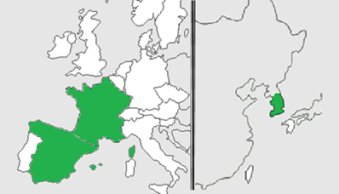

The Figure below lists the EmoSpaces partners from France, Korea and Spain.

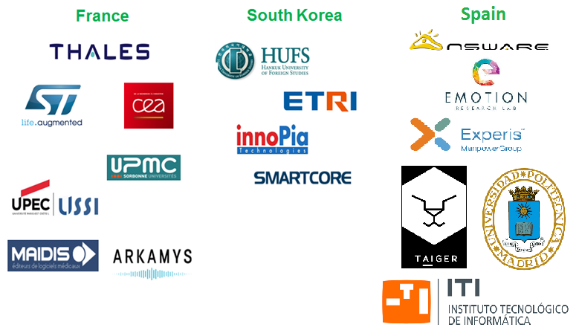

## Work Plan

The work in EmoSpaces is divided in seven different work packages:

WP1 - The main objectives of this work package are: define the user requirements and needs, define the technical requirements and architecture, address privacy and security aspects, and provide a functional specification for all identified components

WP2 - The main objective of the WP2 is to apply IoT technology in order to monitor and understand the behaviour and affective state of the user. The outcome of this WP will be a Multi-layered EmoSpaces platform for data fusion and distributed processing of smart sensors, as well as a comprehensive landscape of the IoT/SmartHome sensor technologies and alliances categorized according to their business and market relevance.

WP3 - The objective of this WP is to allow computers and sensors to participate in activities and results in which they had never been involved, enabling people (users) to interact with different devices via gestures, voice, movements, or simple context information.

WP4 - aims at dynamic adaptation of spaces to user needs, based on their context and profile. The project will apply intelligent automation techniques and persuasive eHealth so that adaptations can be learnt from previous interactions with users and between IoT devices

WP5 - develops techniques to test and demonstrate the results of WP1-WP4.

WP6 - The main objective of WP6 is the coordination of the overall dissemination, communication and exploitation activities carried out within the project, namely in the areas of Active and healthy ageing, Gaming, Home Environment / TV and Persuasive eHealth.

WP7 - This work package takes care of project management issues including administrative, technical, financial and legal coordination as well as the management of the knowledge and intellectual property gained in during the project.

The detailed relationship of inputs and outputs of the WPs is shown in Figure 1.

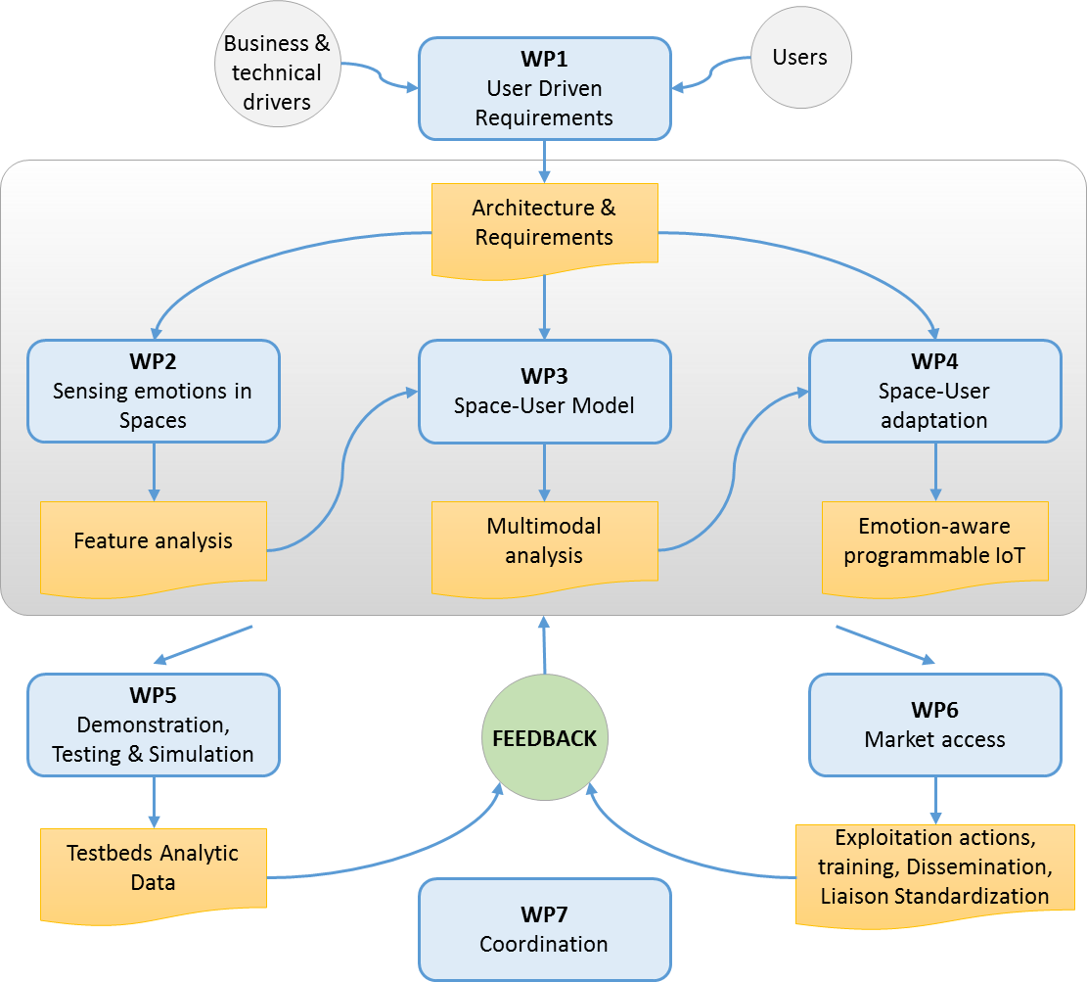

Figure 1. Detailed relationship of inputs and outputs of the WPs

The project is structured into 3 iterations, following an agile approach. The figure 1 presents a simplified process with focus on what kind of artefacts or description types that should be produced. Although the figure describes a sequential process, it should be interpreted as being iterative and with an increasing level of detail and precision as we get closer to the delivery date.

The work plan and work breakdown structure of the EmoSpaces project is described in details in the FPP (full project proposal) document.

# Project Results/Achievements

## Activities/object recognition

A software component based on machine learning techniques for user context recognition based on heterogeneous sensing analytics technology (user recognition and localization, activity and emotion capture) to assist the human real daily-life activities was developed.

In this context the building block automatically recognizing objects from video has been archived. The objects detection system for the living room and kitchen make the detection activity based on objects interaction easier. To support the daily life monitoring and human interaction a robust tracking algorithm for counting, for persons geolocation and for activity recognition are implemented

### Activity recognition

A Software targeting activity recognition has been developed. The module takes a (long) video as input and tries to recognize (and temporally locate) the different daily activities that are performed, among the following list : is cooking, is sitting the table, is eating, is clearing the table, is washing the dishes, is doing housework, is doing homework (e.g. reading books and writing on a paper).

The technology is using machine supervised learning on the DAHLIA video database, and makes use of an optimized Hough transform, which can be considered as a voting process. Each extracted video elementary feature votes with a dedicated weight for the different activities, temporally located at different times. Vote accumulation at each time makes an activity more probable than others. Weight optimization is off-line performed according to CEA DOHT (Deeply Optimized Hough Transform) algorithm.

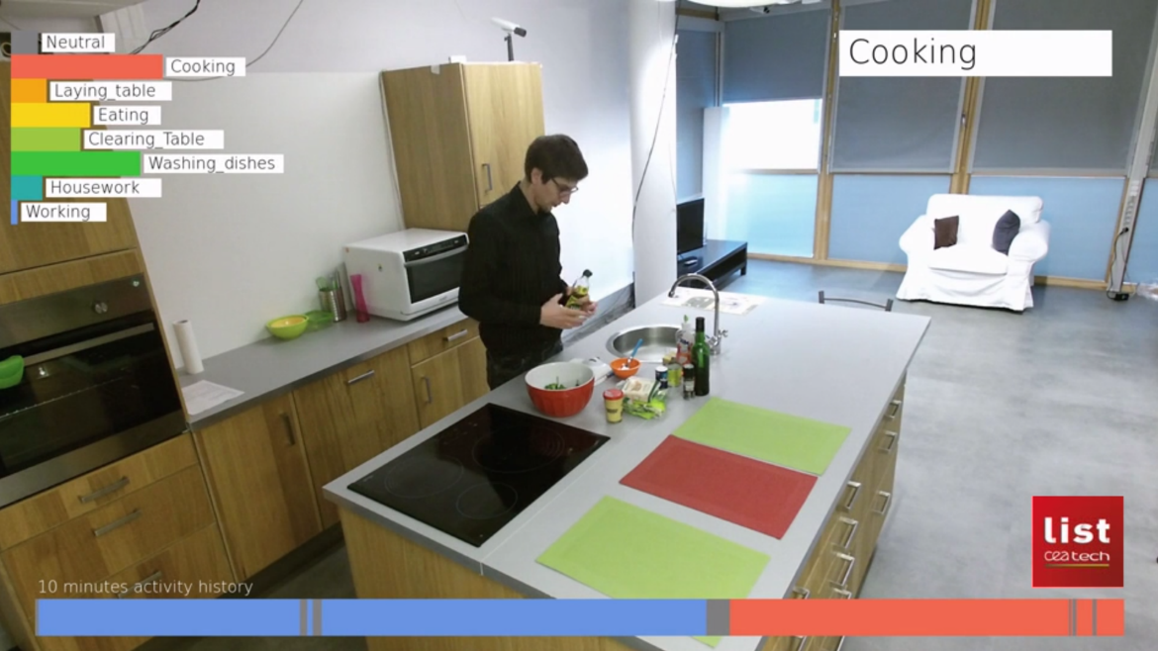

Real-time human activity recognition

### Objects detection

We have developed an objects detection system for the living room and kitchen, tuned for high accuracy detection of objects in order to detect dietary habit (healthy or not) for e-Health application and to make easier the detection activity based on objects interaction. The objects detection module is based on deep learning approach. We have implemented an object detection network of the state of the art: the Single Shot MultiBox Detector (SSD) and Faster Region-based Convolutional Neural Networks (Faster R-CNN). Then we have realized the training on the COCO database (81 classes - Common Objects in Context).The first results on the MobileMii platform are presented below:

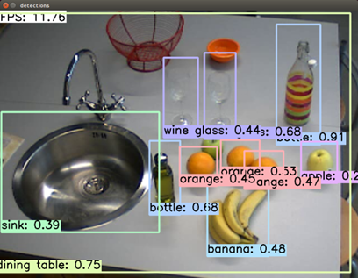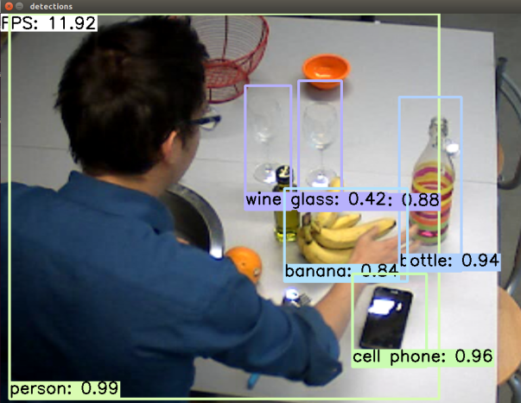

**Objects detections in order to ease the detection activity based on objects interaction**.

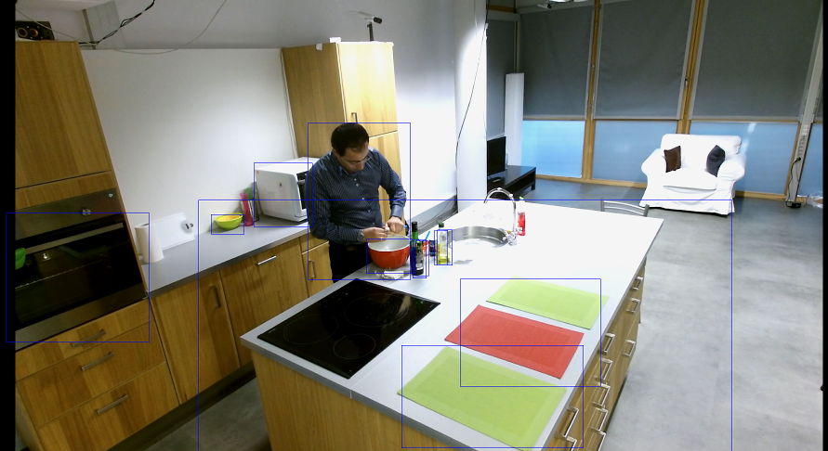

**Objects detections in order to ease the detection activity based on objects interaction. Faster R-CNN results.**

### Tracking and users re-identification:

We have developed a robust person tracking algorithm for counting, persons geolocation and activity recognition. For the Emospaces use case B devoted to stream music according to the user localisation, this will help to stream the right music to the right person. For home monitoring, it monitors the daily activity and human interactions.

The module is composed of 3 parts:

- a detection module based on background subtraction and people model pattern

- a tracking module based on particle filter (Monte Carlo approximation)

- a re-identify module based on deep learning approaches in 2 modalities :

* facial detection and recognition
* silhouette detection and recognition

The goal of this work is to increase the robustness of re-identifying people in the difficult context ( facial expression variations, illumination variations, pose variations, occlusion…) by coupling two modalities : facial recognition and soft biometry of the silhouette.

In the state of art, the problem of people recognition has been dealt with facial recognition technology, or with re-identification based on soft silhouettes biometry, but not both together. We propose to use the complementarity of these two approaches:

* It has been noted in the literature that facial recognition algorithms provide satisfactory performance when the conditions are favorable (front of your face, good face resolution). These performances deteriorate rapidly in other cases. It is also obvious that it is impossible to recognize a person seen from behind with the facial recognition module.
* The people re-identification with soft biometrics has generally lower performance, but has the advantage of being usable in situations where facial recognition is in default (profile or back).

In order to enjoy the benefits of the two modalities, we have implemented the complete chain (cf. Fig 1) with the following bricks:

* Face detection and 2D tracking
* Silhouette detection and 3D tracking , particulate filter
* Collaboration of face/silhouette tracks
* Silhouette matching based on deep-learning technologies: Triplet network with LeNet architecture and batch standardization
* Fusion of the face ranking and ranking silhouette.

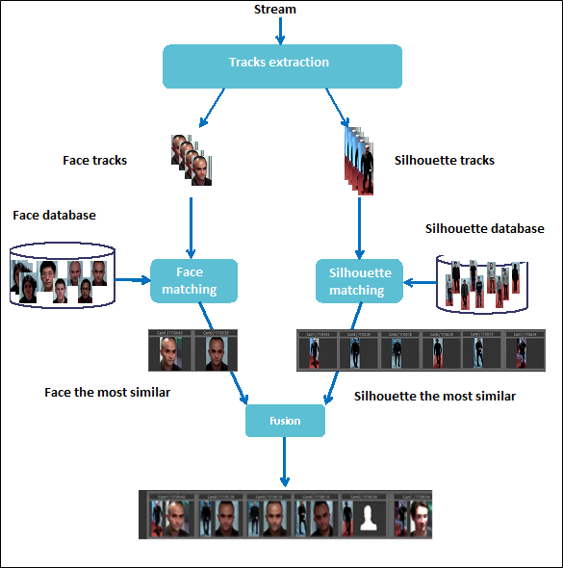

**Fig. 1  : Fusion of silhouettes ranking and face ranking**

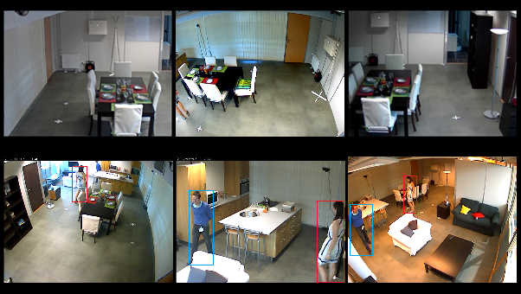

**Fig.2 :** **Video wall of the MobilMii platform and person tracking.**

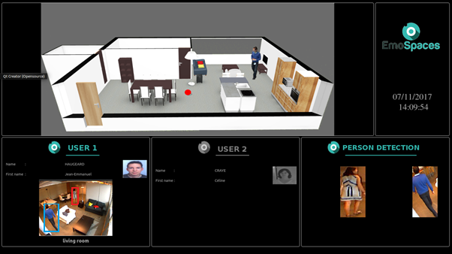

**Fig 3 : Real-time person detections**

In this example (Fig.2 and 3), the system detects 2 persons. One of these persons (user1) is an end-user of EmoSpaces applications. The other person is a guest. The system detects and counts 2 persons, geolocalize and try to recognize people (red point if a guest (not in the database) and silhouette if an end-user). And then the system sends user information to the other modules (activity, fall detection, music use case…). In this example, user2 (other end-user) is not present.

**4.1.4 Behavioral analysis using Clustering approach**

Thales developed a tool to analyses human daily behavior based on Clusters. Clustering is one of the most used techniques in machine learning when one needs to analyze data in the aim to detect usual (also considered as normal) and unusual (also considered as potentially abnormal) behaviors or events.

The principle of clustering techniques consists in subdividing a set of data into homogeneous clusters (or groups) according to a measure of similarity. The elements within the same cluster are very similar to each other and two elements belonging to two different clusters are very dissimilar.

The clustering technique we will use is called "relational analysis". One of its main advantages over other clustering techniques is its ability to process available data without arbitrary transformations. For example, it processes the missing data as it is (without arbitrary replacement) and does not randomly determine the number of clusters to be found in the data.

In Emospaces project this technique will help to identify the successive activities made by the person occupying the smart home.

These successive activities will be considered as trajectories taken by the occupant during each day of the week. Among the information that will be extracted through clustering we can have:

1. the successions of the regular activities done by the monitored person for each day of the week

2. the time spent during each activity, as well as the rare (or less common) activities

As a result of the relational analysis algorithm, we will obtain mainly two kind of clusters representing the activities made by the persons occupying the smart home. From one part, big clusters containing a big number of activities. These clusters highlight the usual and recurrent activities. From the other part, small clusters containing very few activities. These clusters highlight rare activities.

All these information will be stored and logged in the aim to be used later to detect unusual behavior of the persons occupying the connected house. These behaviors can be sent to a person assistance service who can decide whether it is necessary to intervene or not.

The principle of relational analysis algorithm consists in:

a- using predefined zones in the area of interest to describe the successive zones followed by the monitored person

b- computing a similarity measure based on these zones to construct groups of trajectories that are more similar to each other

c- extracting a representative trajectory, from each group. This trajectory will be used to compute the similarity of its group and a new unknown trajectory

In the frame of Emospaces project, it was not possible to collect real data: our test-bed environment only simulates an apartment thus it haven’t facilities allowing to spend inside a day or a complete week. For this reason, we have developed a tool to generate simulated data to overlap this barrier. Our tool was tested and validated only using synthetic data.

## Wellbeing coaching : HapiCare application (MAIDIS)

HapiCare is a Patient Services Portal offering an application for monitoring vital parameters collected by practitioners, connected objects and smart AI engines.

The aim is to extend the HapiCare abilities to monitor and coach the patient for a healthy daily life. The healthy daily life is defined with the help of the patient’s doctor using the portal.

Hapicare enables to collect heterogeneous information about patients with Chronic diseases and using a smart reasoning-engine, provide an e-coaching to them.

Although, the majority of collected information are medical, i.e. electrical health records, symptoms and vital sign records, but the non-medical information that EmoSpaces provides is vital to have a more comprehensive understanding of the patients’ situation and hence a better coaching.

The following list shows the ingredients of a lifestyle. The source of the corresponding information/ EmoSpaces building block is shown within brackets []:

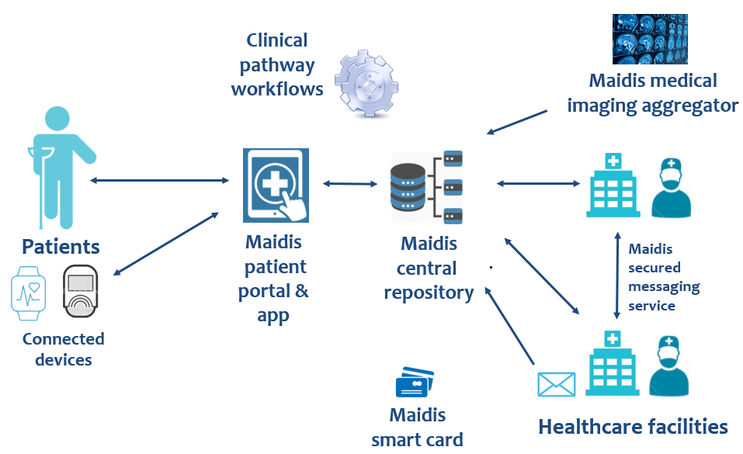

Figure 3: The healthcare system envisioned by Maidis

* Change in sleep pattern (Customized by: length, time of sleep) [Behavior analysis / Sleep monitoring sensors]
* Meal daily dietary pattern [Activity Recognition (having a meal)]
* Self-measurement of vital signs (Customized by: types, time) [Vital Signs Sensors]
* Work pattern Vs Exercise (Customized by: type, frequency, time, gap between them) [Activity Recognition/ Pedometer]
* Detection of Prolonged negative emotions [Emotion Recognition (negative moods)]

Hapicare based on the defined lifestyle, reminds the patient of the event and feedbacks the results. Moreover, reports ( with an automatic log book) the lifestyle of the patient for his next visit to doctor for his suggestions.

All the these information comes to the system, are analyzed through a production rule which provide one of the following reactions:

* Share positive advices (e.g. eating health or going out)
* Share the information and warn a family member
* Share the information with his doctor and book an appointment.

Target innovation explaining with respect to SotA:

The Emospaces services on wellbeing Coaching combines the capabilities of:

* a chronical disease coaching smartphone applications
* a wellbeing coaching application
* Quantified-self technology

## Social simulator for training

### 4.2.1 VR simulation

A VR software is developed, providing a realistic simulation to help autistic people to get use to unusual a stressful situation. This simulation can be configured to reduce stress in the user changing parameters like illumination or sounds. Users will have a first contact with all the elements that they will see in a dentist office or in a barbershop. They also will receive some instructions to know how they must act in a real situation.

We have implemented two scenarios:

* Dental clinic: the waiting room, the dentist office, a nurse, a doctor and four extra people.

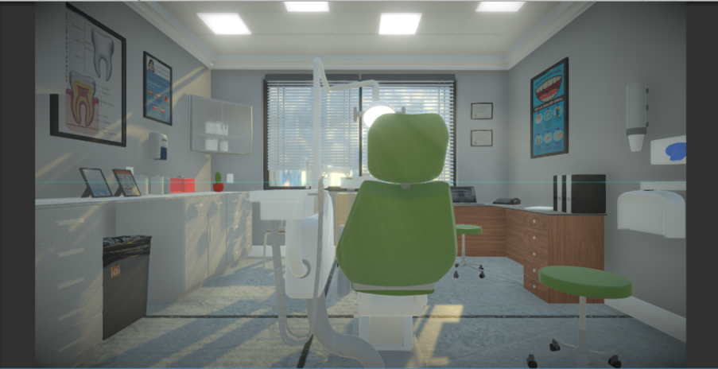

Simulation reproducing a dentist scenario

* Barber shop: the waiting room, the haircut room, a hairdresser, an employee and 3 extra people.

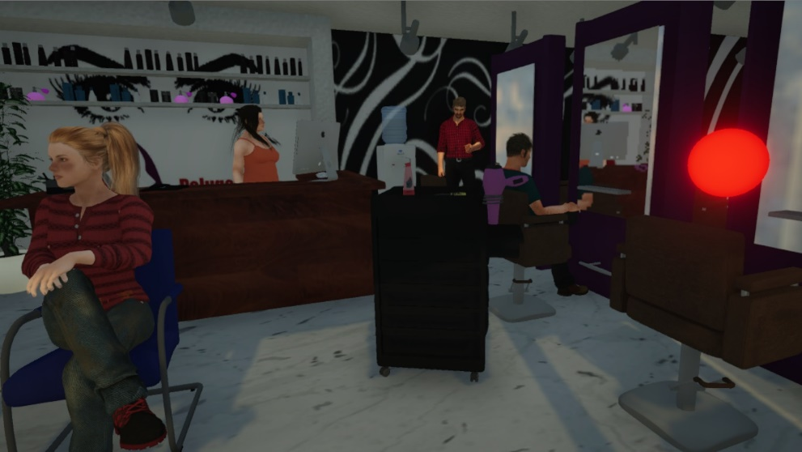

We also tested both scenes with autistic kids and specialist helpers with very good results.

## Gamification platform

The virtual space has been created in such a way that it is as realistic as possible and that the elements contained in the scene are faithful to those we could find in a real location. The solution is developed with the Unity graphics engine, in its version 2017. Within its functionalities allows us to use different degrees of lighting and modify it in real time to adapt to the mood of the user. In addition, we can simulate different times of the day acting on the color, intensity and warmth of the exterior light, being able to represent a more natural environment.

In the same way, Unity allows us to manage different audio profiles. We can reproduce or pause the different sound effects of the scenarios depending on the user's mood. It also gives us the possibility to add environmental music in real time or modify the volume of each sound individually to adapt the stage to each session.

With the corresponding algorithms, we can detect if the user shakes his head nervously, thanks to the gyroscope of the devices, and can make changes in the environment (lighting and sound) to reduce stress. To detect stressful situation we use the gyroscope because it is a very spread used sensor already in use in virtual reality glasses and in most mobile phones.

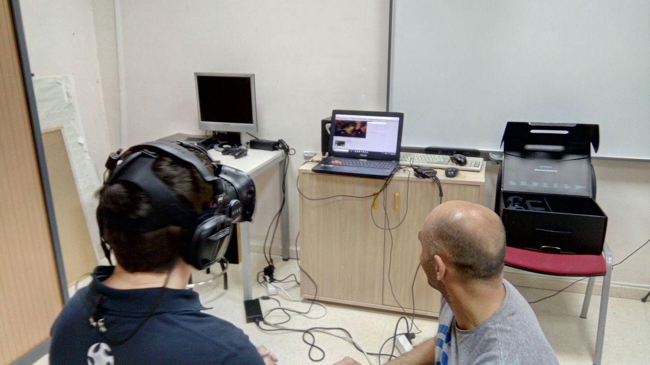

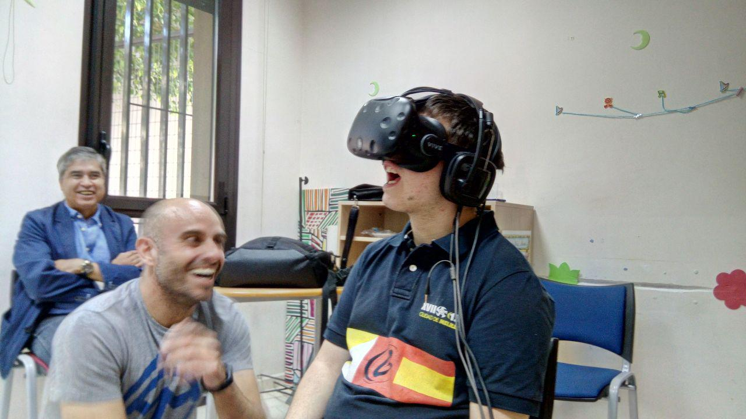

## Use case: sound optimization

Arkamys Company is providing the *Emospace Music Player*, which is dedicated to stream music “Emospace state dependant”.

This player is connected to Emospace system by the MQTT “machine to machine” protocol. It subscribes to 2 different messages:

* “roomentrance” which is triggered by the entrance of a known person in a room
* “personactivity” which is triggered by the detection of a specific activity performed by a known person

These messages transmit the following informations from the Emospace system to the Arkamys *Emospace Music Player*:

* timestamp
* person id
* room id
* respectively, an emotion id and an activity id.

Before to start using this player, each managed people creates 3 playlists: Calm, Chillout, and Energic. Depending of the current emotion and active people information, received through MQTT message, the Arkamys *Emospace Music Player* starts automatically the correct playlist of the correct user.

The “emotion” and “activity” ids are classified by these 3 final playlist types: Calm, Chillout, and Energic. For example, the “Calm” type contains "eating", "working", "sleeping" and "relaxing".

Any user can stop and start the music by a dedicated gesture. In that case, the Emospace system will send a “silence” or “music” state (through the emotion/activity id).

4 speakers are deployed in the apartment (kitchen, bedroom, dining room, lounge). The music is sent to the dedicated speaker, depending of the last room id received.

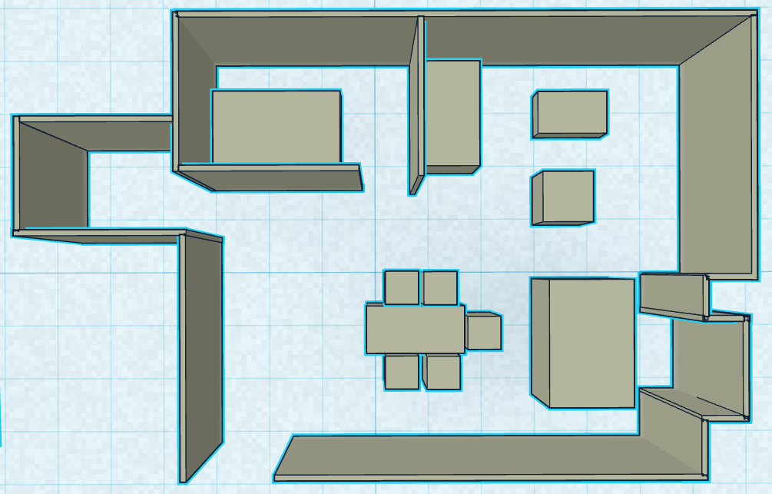

**Plan of the EmoSpaces apartment used as a testbed**

## Emotion recognition

Development of an emotion aware task automation tool for combining events from sensors / internet services based on semantic technologies. The platform includes web and mobile applications, and integration of a number of sensors / actuators as well as emotion recognition and regulation modules. Moreover, the platform is backed by Big Data and IoT platforms to enable scalability of the solution.

## E-learning platform

This development has been implemented while integrating emotion recognition technology. Also, it has been developed with recognition software from another project partner (ERL).

The operation of the platform and particularly the case of use of the e-learning is thought for users who take online courses through the platform.

Users show their emotions through their team's webcam while doing the courses, something foreign to them while they work. Subsequently, the platform is able to know the feelings that a user has had while carrying out the course.

It has been developed with web tools, mostly PHP. In addition, the result has been exported in a virtual machine so that it can be portable and can be found on any computer that can have a web camera from where emotions are recognized in the courses.

The integration of EMOSPACE into e-learning platforms will significantly improve the experience of distance learning or remote knowledge transmission.

EMOSPACE provides valuable emotional information from e-learners enabling:

1. Instructors to offer a more personalized support
2. Platform developers to provide an effective service that responds to profiles in accordance with expectations and desires.

Better e-training features and methodologies will help overcome the major barriers that this type of training is facing, such as unbundling and lack of engagement.

Within the EMOSPACE framework, Experis has been developing an emotional interactive e-learning platform.  This tool will provide recommendations to the teachers depending on the student profile in order to improve the learning abilities. In the development, two virtual spaces (teacher and student) have been considered, although the first efforts have focused on the development of the teacher's platform.

This innovative technology has been achieved in the platform with different methodologies and means of communication which take into consideration:

* Offline Emotional Tracking

During the Offline activities to be performed through the platform (test, lessons review, online activities, etc.), the e-learner's emotional responses are captured and analyzed, then displayed in a clear and meaningful manner to the instructor.

The following indicators will be displayed on the teacher's course monitoring platform:

1. By clicking on each student profile, instructors will be able to access to the “e-learner emotional evolution” graph, where the progress of the emotions tracked and provided by LRS are displayed. A mock-up of the chart that will be shown on the teachers monitoring panel can be seen in next figures.

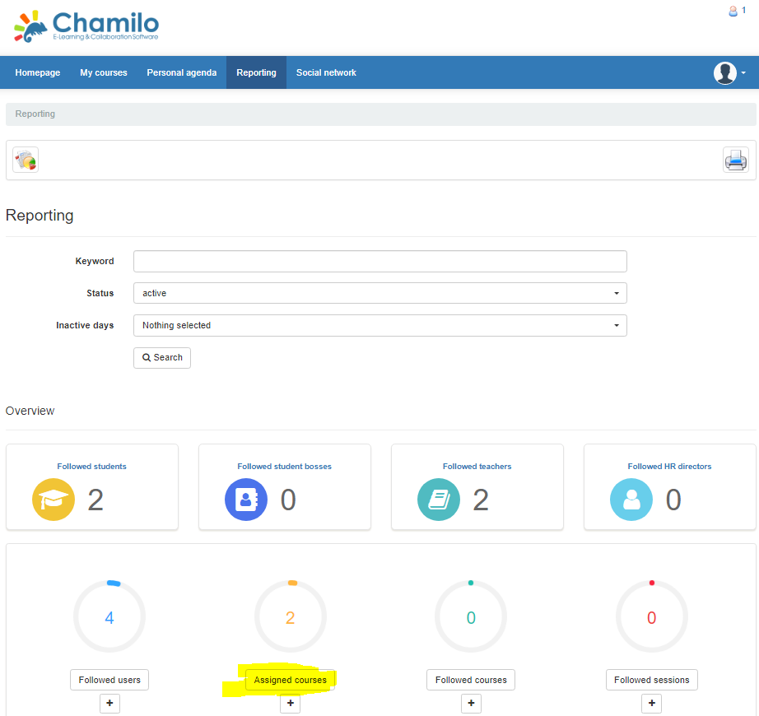

**Fig. 1: Professor reports dashboard**

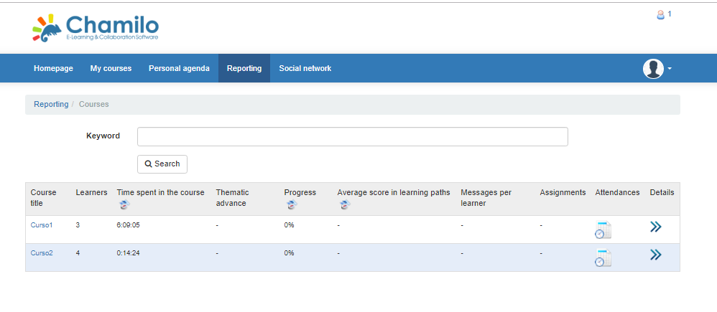

**Fig. 2: Alumns list**

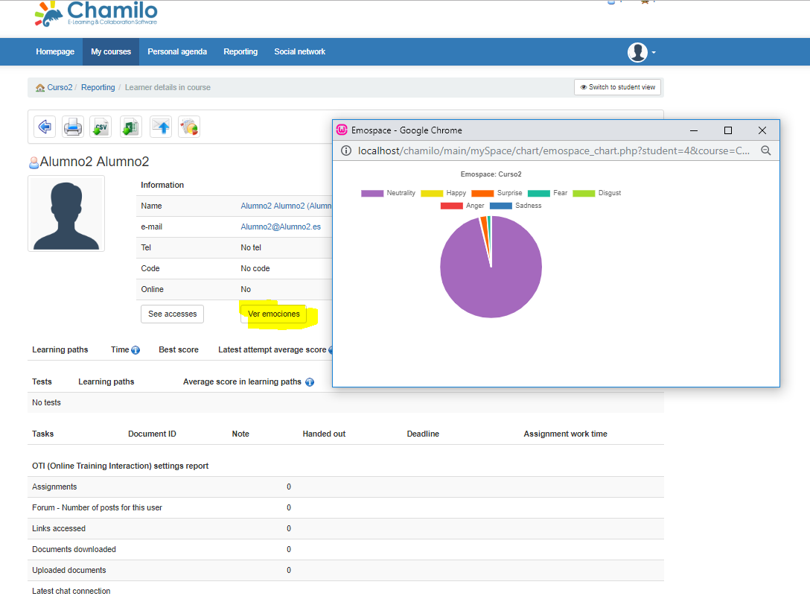

**Fig. 1: An alumn emotions in a course**

Additional indicators have been developed to be available in this panel:

1. Each student last session overall emotional status (work in progress).
2. A static and general overview of the major emotions that the course has caused to date (work in progress).

* Online Emotional Feedback (work in progress):

It has also been considered the possibility of providing a panel where the instructor can be informed about the live emotional status of the attendees.

This features together with the affective technology, would allow teachers to modify the teacher’s virtual space depending on the students’ status or preferences.

Finally, the possibility of configuring the tool for easy connection to the Big Data Platform is being explored, making it possible to exploit to the maximum the data extracted and providing teachers with meaningful and precise information.

### Functionalities

|  |  |
| --- | --- |
| Funcionalities |  |
| Monitoring | The System monitors the feelings of each user. When you complete each course, your emotions are collected so that you can later assess which courses are more interesting. |
| Visualization | Through the system you can see graphically the representation of the emotions collected for each user in each course in which they have participated |
| Personalized learning | The teacher can adapt the contents of the courses when they advance, then can assess whether the changes are welcomed by the students or have not had the expected reactions. |
| Analysis of global data | With the data of all users you can take action and draw global conclusions for the improvement of the e-learning platform. |

**Table. 1: Functionalities**

### Operation guide

* Start virtual Machine.
* The camera is activated in the virtual machine.
* Then, Chamilo can be accessed through two roles: user and teacher
* With the role of student, the steps to follow are:

1. User logs in chamilo.

2. Access in a specific course.

3. The app of Emotion is launched automatically.

a) Start running in the background if the camera is connected to the virtual machine

b) A csv file with user emotions data is created from scratch

4. The app starts to capture data in csv format

5. To stop the app, the user must return to the main page of the course and click on the button 'Stop Emospace' or wuth logout

6. When the Emotion app is stopped, the csv file data is dumped in a MySQL database to. The data is saved with the user id, the course code, the save date and a unique ID

7. To restart the Emotion app, you must refresh the main page of the course

* And finally, with the role of teacher, you can see the users emotions:

1. User logs in chamilo with professor

2. Go to Reports> Pending Courses> Course Details> Student Details

3. Click on the button 'See emotions' to. It opens a new window that paints a graph with the emotions registered by the student during the course.

## ITI-BDAaaS platform

Development of a Big Data Analytics platform to provide to the end-user a solution in the Cloud. The platform has been designed to easily create elastic services with automated life cycle management. The goal is to obtain elastic services adapting to varying running conditions of their environment (load changes, failures, upgrades, etc.) with minimal effort and expense on the part of the service provider.

Additionally, the ITI’s BDAaaS aims to allow the end-user to focus on the data analysis processing, without getting bogged down by the details of configuration, services, adaptability, deployment and doing transparent the IaaS selection. ITI’s BDAaaS provides an ecosystem of services to address different scenarios such as the Predictive Analytics and Exploratory Data Analysis (EDA) based on *Batch* or *Stream processing*.

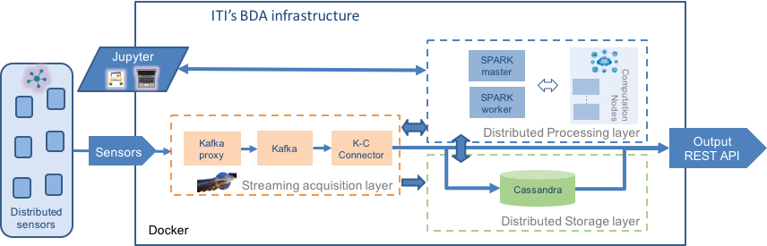

ITI's Big Data Analytics as a Service infrastructure

## Semantic engine

An intelligent automation platform based on semantic Event-Condition-Action (ECA) rules has been developed. Its main goal is to enable task automation in a smart environment, allowing users to create automation rules in a simple way. These rules can be used in Emospaces context to adapt the environment to the users depending on the context and their emotions.

The platform is based on a semantic rule engine called EYE[1], and rules are semantically modelled using EWE ontology[2]. This ontology is a vocabulary designed to model, in a descriptive approach, the most significant aspects of Task Automation Services (TAS), and provides a common model to define and describe them.

Users can use the platform for creating and configuring their own automation rules. These rules are intended to automate the adaption of the environment depending on their preferences and emotions. Some examples of these rules are presented below:

* “If stress level of a user is too high, then ask him to go for a walk.” When a very high stress level in a user has been detected, this rule proposes to go for a walk to achieve that his/her stress level falls and his wellness rises.
* “If temperature rises above 30⁰C, then turn on the air conditioning.” To stay at high level of temperatures may result in users’ stress, so this rule proposes to automatically control this temperature to prevent high levels of stress.
* “If average stress level of users is too high, then play relaxing music.” This rule proposes to play relaxing music in order to reduce the stress level of users.

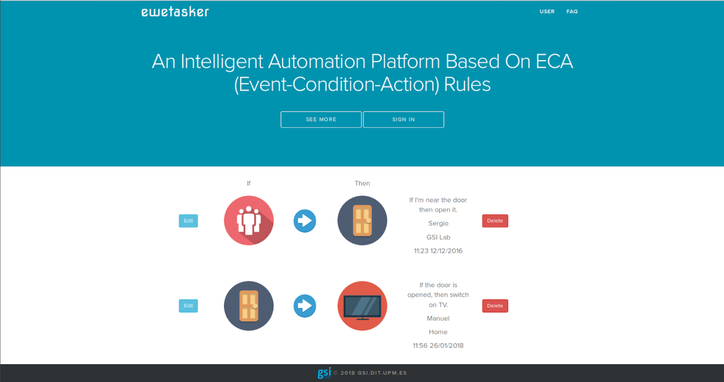

Semantic automation platform

Several devices and services have been integrated in the platform. In addition, the use of semantic technologies for describing each component of the platform facilitates the integration of new components. The following devices and services have been integrated:

* **Services**: Gmail, Telegram, Twitter.
* **Devices**: Google Chromecast, Empatica E4, Google Home, Estimote Beacons, smartlight, smartplug, smart TV, smartphone and temperature sensor.

The platform connects with these devices and services in order to perform the automation rules. It receives events coming from different sources or sensors (such as Empatica E4 or Estimote Beacons) and triggers the corresponding actions on the actuators (Smart TV, Google Home, etc.).

1. http://eulersharp.sourceforge.net/
2. http://www.gsi.dit.upm.es/ontologies/ewe