Press release
Eindhoven, 9 September 2020

New forms of engagement in entertainment and society Special ITEA Vice-chairman’s Award for MOS2S

Engagement and personalised experiences are becoming increasingly important nowadays. In society, city representatives no longer take decisions on their own and in the entertainment business, everybody can become a producer of content. Everybody wants to be, or can be at least, involved.

To bring this engagement to a higher level, 17 partners from 4 countries came together in the ITEA project MOS2S led by TNO in the Netherlands, and have created world-first ways to engage citizens and audiences of live events. Their new solutions are so successful that they have already been rolled out by major soccer clubs in the Dutch Eredivisie soccer league as well as by many European clubs. In addition, their technology was selected, out of 200 applications, to be demonstrated during the Eurovision Song contest of 2020. The common denominator in MOS2S is the media orchestration platform, which combines multimedia streams and live sensor data from different domains in real time.
For e-democracy, the MOS2S team developed amongst others VRT’s Babbelbox, which is a mobile booth which is set up at crowded locations and lets citizens give feedback on societal issues. With AI, the recordings are automatically classified to determine for example age and gender, allowing policy makers to zoom in on the differences in opinions between young and senior citizens in an unbiased way. The VRT journalist Rudi Vranckx used the Babbelbox in his TV show ‘Breaking Europe’ to gather the citizens’ opinion on European topics as migration, climate and unemployment. The Babbelbox has successfully been used in 7 countries so far, and is an entirely mobile solution that can be set up at any place: from town squares to mountain tops.

For live events, for the first time in the world, a football match in the Johan Cruijff ArenA was broadcasted in real time, with only 0.3 seconds delay from the pitch in Amsterdam to a viewing area in South Korea. Combining new Ultra-Wide Vision technology with a super-fast data connection enabled a crowd of South Koreans to experience the live event in an unmatched way; the entire stadium was displayed to them in panoramic high resolution, down to the tiniest drop of sweat and quivering blade of grass. This new technology makes it possible for people on the other side of the world to experience live events in real time as if they are at the event itself in person. Conducted by TNO, the Johan Cruijff ArenA, the Korean Electronics and Telecommunications Research Institute (ETRI) and SURFnet, the test broadcast was designed amongst other things to demonstrate whether European Championship matches can be experienced live worldwide as full stadium experiences.

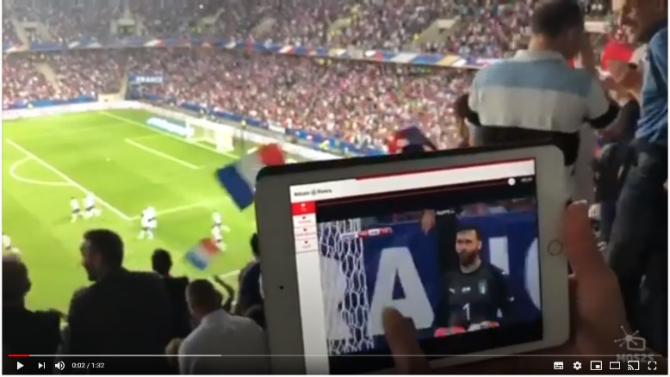
For these outstanding results, the MOS2S project was awarded today with the ITEA Award of Excellence. Discover the innovations in the following video:
https://youtu.be/GnoXR5eTqOcMor

Now that MOS2S’s applications have been tested in a Smart City Playground, the next step is to implement them on a wider scale to further revolutionise the role of citizens in both politics and entertainment.

More information:
https://itea3.org/project/mos2s.html

Note for editors, not for publication
For interview requests, questions and additional information about ITEA, please contact:

MOS2S Contact person ITEA Contact person
Gjalt Loots Linda van den Borne-Toupet
gjalt.loots@tno.nl linda.van.den.borne@itea3.org

About ITEA
ITEA is a transnational and industry-driven R&D&I programme in the domain of software innovation. ITEA is a EUREKA Cluster programme, enabling a global and knowledgeable community of large industry, SMEs, start-ups, academia and customer organisations, to collaborate in funded projects that turn innovative ideas into new businesses, jobs, economic growth and benefits for society.
https://www.itea3.org

About TNO
TNO connects people and knowledge to create innovations that boost the competitive strength of industry and the well-being of society in a sustainable way. This is our mission and it is what drives us, the over 3,400 professionals at TNO, in our work every day. We work in collaboration with partners and focus on nine domains.
https://www.tno.nl/

